

**King Faisal University**

**College of Computer Science and Information Technology**

**Fundamental of Software Engineering**

**Project Report**

**Bin mra online shopping system**

|  |  |  |  |  |  |  |  |  |  |
| --- | --- | --- | --- | --- | --- | --- | --- | --- | --- |
| |  |  | | --- | --- | | **Students** | **IDs** | | **Hissah Alwasifer** | **219025504** | | **Noura Almosened** | **219010636** | | **Latifah Alhatlan** | **219029556** | |  |

Section: 61

**Course Instructor**

Dr**.**NaumanQureshi

Academic Year

**2021-2022**

**ACKNOWLEDGEMENT**

We would like to express our gratitude to all faculty of College of Computer Sciences and Information Technology, and our friends for their advice and assistance in our project.

**UNDERTAKING**

We did the project to show our undersigned for the course fundamental of software engineeringoffered at Computer Science Department, College of Computer Sciences and Information Technology, King Faisal University.

All the design, analysis and coding have been accomplished by the undersigned. Moreover, this project has not been submitted to any other college or university.

**ABSTRACT**

*This project is an Online Designing and Shopping System. We created this project for an existing shop. The Objective of this project is to make users' lives easier when they want to design their product remotely* *without need to visit the store. This project is an attempt to provide the advantages to the customers of designing products then purchase the products from the shop anywhere through Internet. Thus, the customer will get the service of online shopping and home delivery from this shop. We achieved this project by specifying the needs of this project based on that we specified the requirements. After that, we expected the design of the system and we implemented based on the requirements and then we made the required testing.*

**Project management plan:**

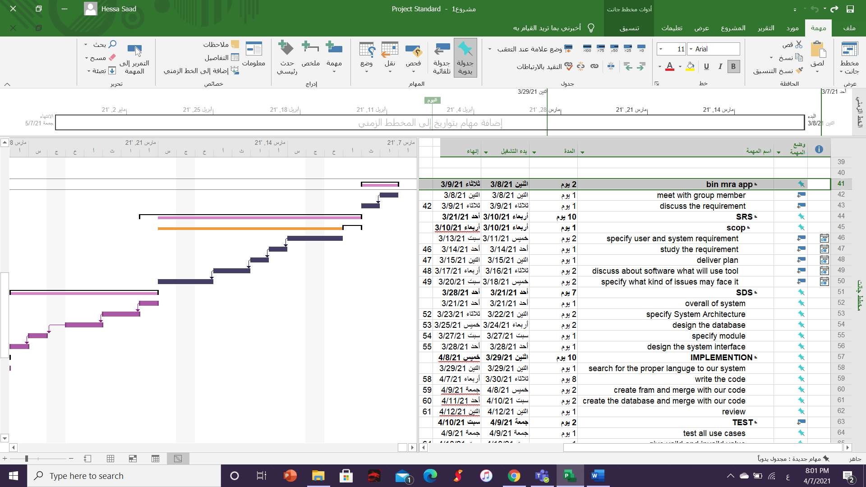

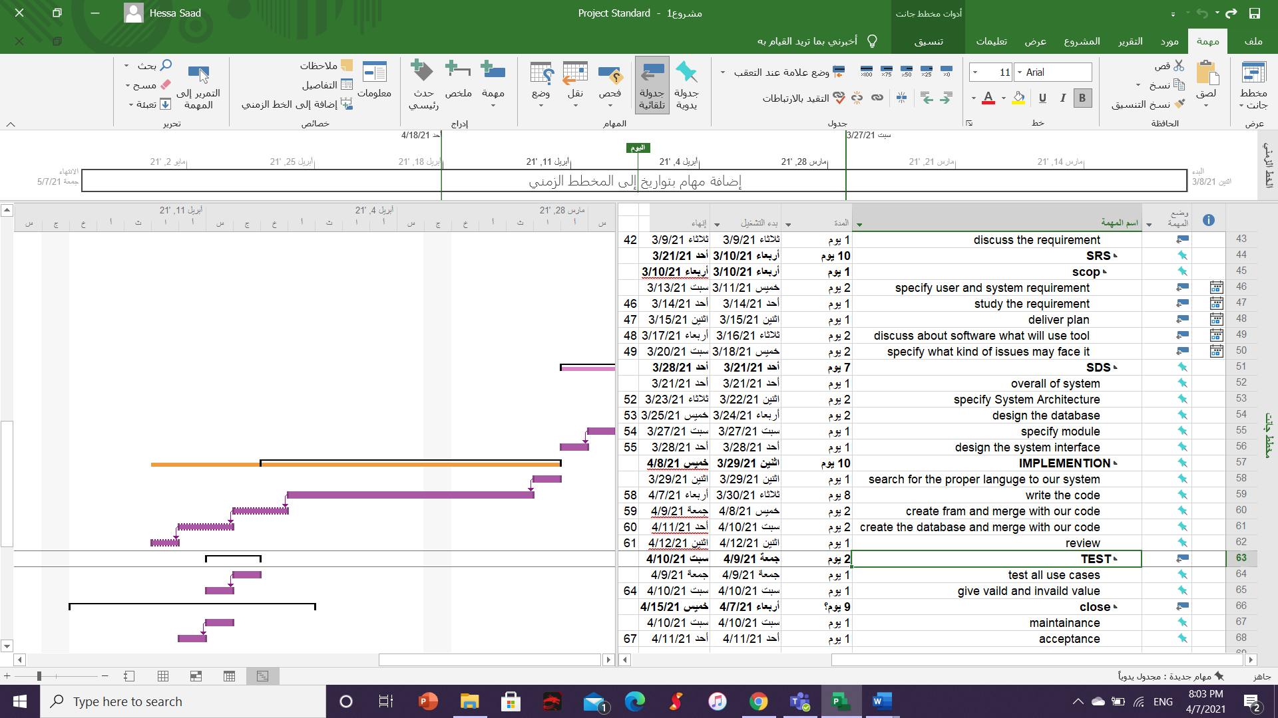

**Table of content**

**Section 1: Software Requirements Specification 1**

1.1 Introduction1

1.1.1 Purpose1

1.1.2 Document Conventions1

1.1.3 Intended Audience and Reading Suggestions1

1.1.4 Project Scope2

1.2 Overall Description2

1.2.1 Product Perspective3

1.2.2 Product Features3

1.2.3 User Classes and Characteristics3

1.2.4 Operating Environment3

1.2.5 Design and Implementation Constraints3

1.2.6 User Documentation4

1.2.7 Assumptions and Dependencies4

1.3 System Features4

1.3.1 Login4

1.3.2 Registration5

1.3.3 Payment6

1.3.4 Manage overall system6

1.3.5 Logout7

1.4 External Interface Requirements8

1.4.1 User Interfaces8

1.4.2 Hardware Interfaces9

1.4.3 Software Interfaces9

1.4.4 Communications Interfaces9

1.5 Other Nonfunctional Requirements9

1.5.1 Performance Requirements9

1.5.2 Safety Requirements10

1.5.3 Security Requirements10

1.5.4 Software Quality Attributes10

1.6 Other Requirements10

**Section 2: System Design Specification11**

2.1 Introduction11

2.1.1 Purpose11

2.1.2 System Overview11

2.2 Overall System Design12

2.2.1 Design Constraints12

2.2.2 System Architecture12

2.2.3 Database Design12

2.2.4 Hardware and Software Design18

2.2.5 Graphical User Interface Design19

2.2.6 System Quality Attributes20

**Section 3: Screen Shots of The Project Program**20

**Section 4: Testing Cases39**

References46

Appendix A: Glossary47

Appendix B: Source Code48

Appendix C: Issues List156

**List of Table**

Table 1 Test case #139

Table 2 Test case #240

Table 3 Test case #341

Table 4 Test case #442

Table 5 Test case #543

Table 6 Test case #644

Table 7 Test case #745

# **Section 1: Software Requirements Specification**

# **Introduction**

Bin mra online shopping system is a system for those who interested on sell the plant and all detail about that plant.

# **Purpose**

This is software requirement specific for bin mra online shopping system. this store is designed to allow the owner for bin mar shop (is the agricultural shop )to perform the process of buying and selling easily over the internet. this document will cover all requirements and functions for version 1 of shopping online system..

# **Document Conventions**

Bold text refers to higher priority level requirements. Using Times New Roman font and size 12, or 14 for the text and using Bold for main section and subsections title. The document text is 1.5 spaced.

# **Intended Audience and Reading Suggestions**

The goal of this document to represent and cover all the requirements for the customer.the customer can review this document to ensure that satisfy their user’s needs.the tester can use this document to ensure that every requirements are being meet for the customer.the developers can use it to help them in design and implementation of online shopping system.this document cover every thing to make different types of readers to understand this system.

.

# **Project Scope**

○ Confirm orders.

○ Manage customer accounts .

○ Manage shopping carts.

○ Manage the inventory for the products.

○ Browsing the products depend on their category

The system will make owners sell 15 items.Five items for each category (5 items for seeds, 5 items for tools for agriculture and 5 items for seeding).Each product will identify by special name to distinguish the items.

# **Overall Description**

# **Product Perspective**

It is bin mra online shopping system is a new system for bin mra shop.

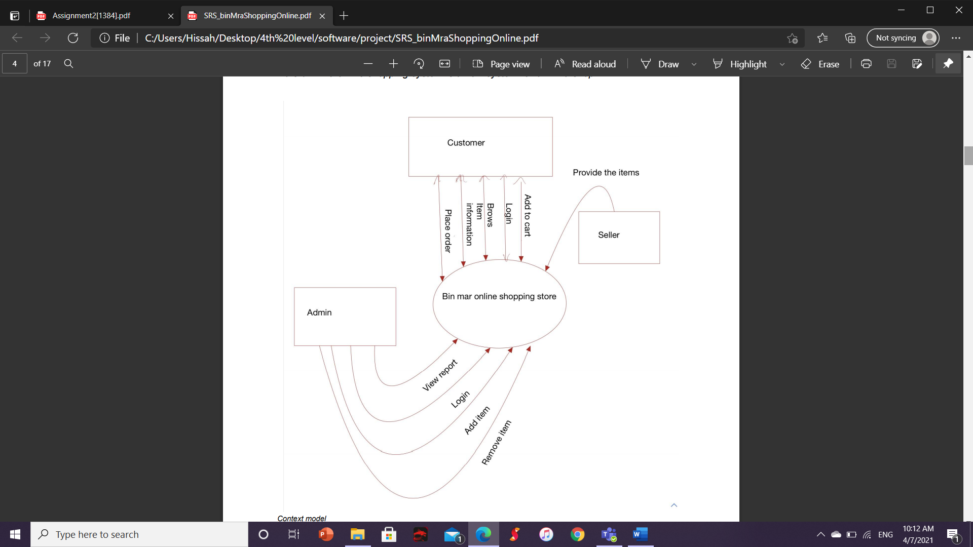

# **Product Features**

The product features can be described as follows:

* Product management: manage the product in the system based on their categories.
* Shopping cart: the customer can add to the shopping cart the selected items until the customer is being sure to make the purchase.
* Payment: the customer can make payment only on cash after reviewing the items in the shopping cart.
* Account management: allows users to create an account.

# **User Classes and Characteristics**

Customers can create an account and login. also, Customers can view items, make purchases, view the shopping cart, add /remove the items in the shopping cart and view the information for each product.

Admin: having all right to add /remove items and view reports. also, admin can have a right to show users information.

Seller: the seller who provides the items to be available in the shop to add them by the admin.

# **Operating Environment**

The system shall use a mysql database provided by Heidisql server to store the information for the products. also, it is used to store the information about the customers and admins.

# **Design and Implementation Constraints**

# **User Documentation**

Online help is very important component of this system. It should provide specific guidelines to the user for using the system.

# **Assumptions and Dependencies**

* Following assumptions are made for the system:
* This system has to complete it in two months as a maximum time.
* The system is supposed to work with minimum percentage of errors.

# **System Features**

# **Login**

* Description and Priority The customer can log in to the login page and enter his / her information to log into the system. The priority is high.
* Stimulus/Response Sequences

- The customer clicks the login button

- The system goes to the login page

- The customer enters the username and password

- The customer clicks the login button

- If the username and password are correct

- The system goes to the main page of the site

- If the username and password are wrong

- The system displays an error message

* Functional Requirements The system must make the user login with user id and password.

# **Registration**

**Use case:**

Description and Priority

New customers can register in the system using the input user ID, password, first name, last name, date of birth, phone number and address that includes the name of the city, country, state and postal number for the first time to open an account in the system. The priority is high.

Stimulus/Response Sequences

- The customer clicks the Register button.

- The system goes to the registration page.

- The customer enters the username and password, first name, last name, date of birth, phone number and address includes city name, country, state and zip number.

- The customer clicks the Register button.

- If the username is unique.

- The system maintains customer data in the database.

- The system goes to the main page of the site.

- If the username is not unique.

- The system displays an error message.

# **Functional requirement**

The system must open a new account for the user with user id, password ,first name, last name ,date of birth , phone number and address including city name, country ,state and zip number

# **View items**

3.3.1 Description and Priority

The customer can browse system pages according to the required category and view product information such as name, price and plant care method. The priority is high.

3.3.2 Stimulus/Response Sequences

- The customer clicks on the sections icon.

- The system displays all available sections.

- The customer clicks on one of the sections.

- The system moves to the required section page.

- The system displays the products available with their information.

- The customer determines the number of products.

3.3.3 Functional Requirements The system must display the items in various page according to the category of the product like seedlings page ,seeds page and tools agriculture and provide the information about the items including the name and price and .And for each selected items the system shall provide the instructions of items and the user can be able to select the amount of the items.

1.3.5 Shopping Cart

3.4.1 Description and Priority.

Customers can click the button to add the selected item to the shopping cart, and view all of their selected products on the shopping cart page. The priority is high.

3.4.2 Stimulus/Response Sequences

- The customer clicks on the (Add to Cart) button.

- The system adds the required product to the shopping cart page.

- The customer clicks on the shopping cart icon.

- The system goes to the shopping cart page.

- The system displays all added products.

3.4.3 Functional Requirements The system must place all the products selected by the customer on the shopping cart page.

○ 3.5 Billing

3.5.1 Description and Priority

The customer can view the bill with the name of each product, its price, and the number of items. The priority is high.

3.5.2 Stimulus/Response Sequences

- The customer clicks the bill button.

- The system moves to the bill page.

- The system displays the name of each product, its price, the number of items, the total price, and the customer information.

3.5.3 Functional Requirements The system must display the bill to the user including the name , amount and price of each item and the total price. also ,the information of the user including user name and id and order number.

○ 3.6 Checkout

3.6.1 Description and Priority

When the order is completed and they want to buy, customers can pay cash only. The priority is high.

3.6.2 Stimulus/Response Sequences

- The customer clicks on the end order button.

- The system goes to the payment page.

- The system displays the total amount, available payment method, and payment instructions.

3.6.3 Functional Requirements the system must provide only a cash payment method when the user would like to place the order.

○ 3.7 Manage items

3.7.1 Description and Priority

Admins can view sales reports and add more items. The priority is high.

3.7.2 Stimulus/Response Sequences

- The administrator clicks on the Manage Items button.

- The system goes to the item management page.

- The administrator clicks on the Reports button.

- The system moves to the reports page.

- The system displays sales reports.

- The administrator clicks on the Add Items button.

- The system moves to the page of adding items.

- The administrator adds new product data.

- The administrator clicks the Add button.

- The system adds the product to the required section page.

- The administrator clicks the View Products button.

- The system goes to the product display page.

- The administrator clicks the remove product button.

- The system removes the product from the page and from the database.

3.7.3 Functional Requirements The system must be able to generate the reports for the selling products and make admin to add more items or remove items.

# **External Interface Requirements**

# **User Interfaces**

Start page interface login interface

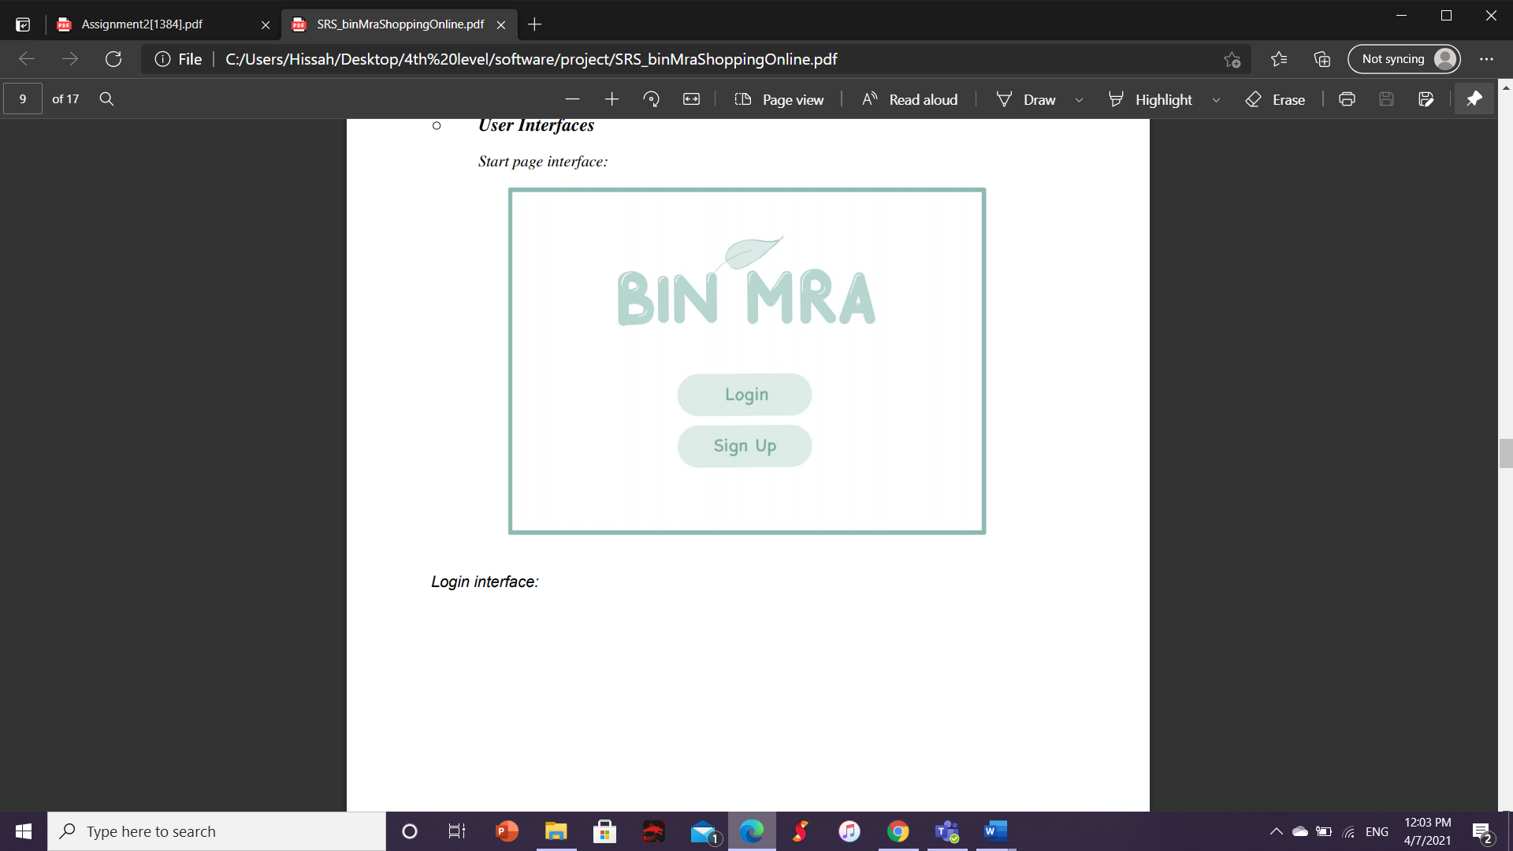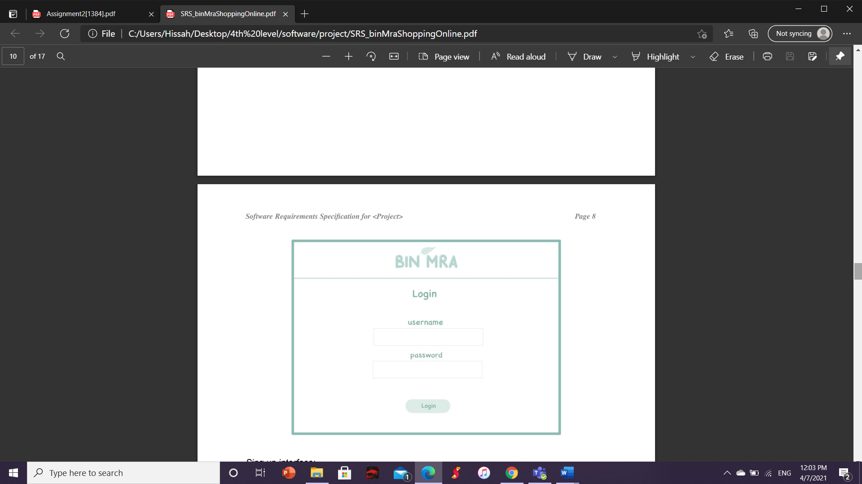

Sign up interface main page interface

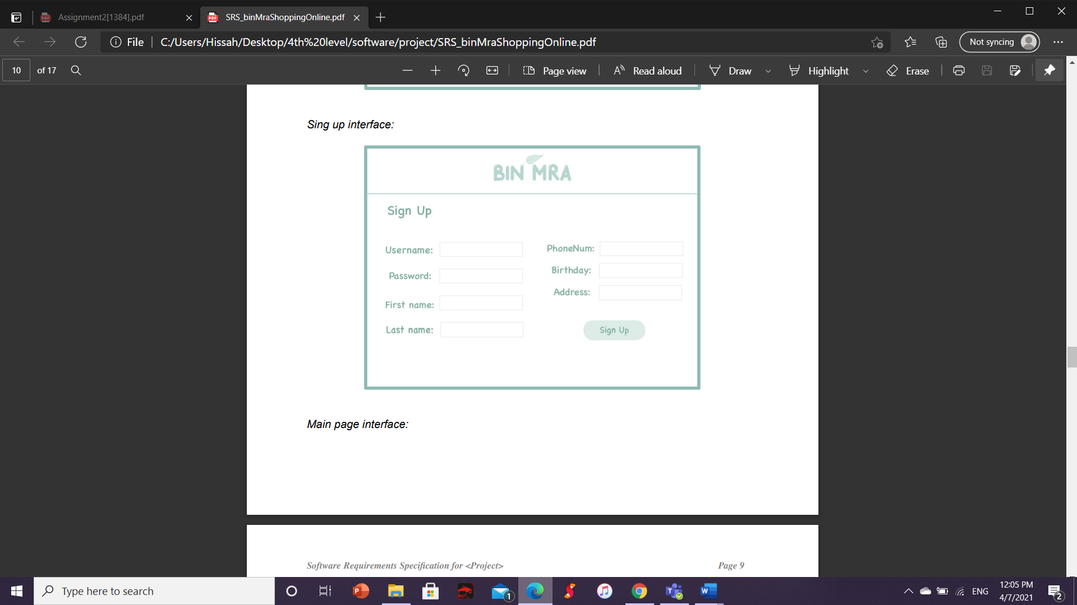 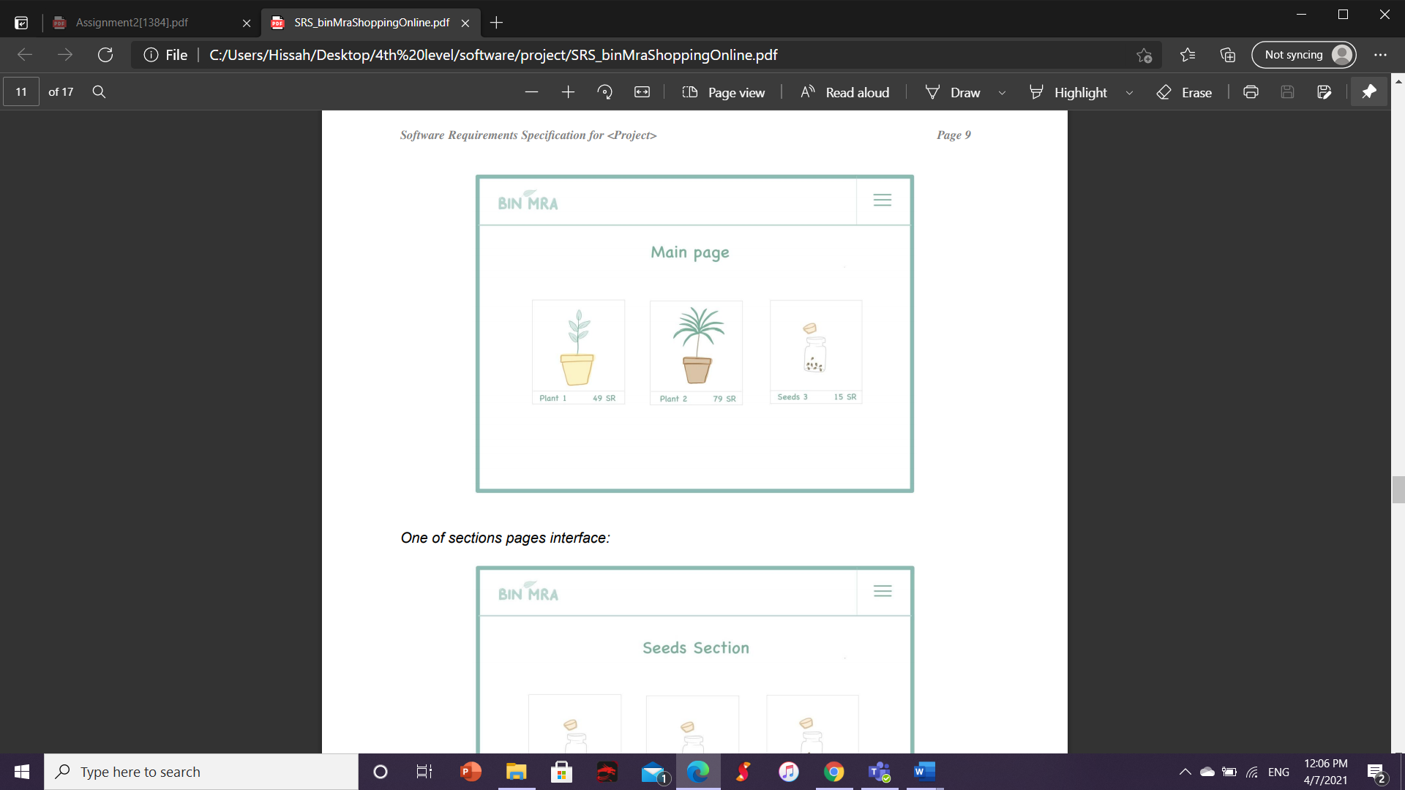

One of sections pages interface Shopping cart interface

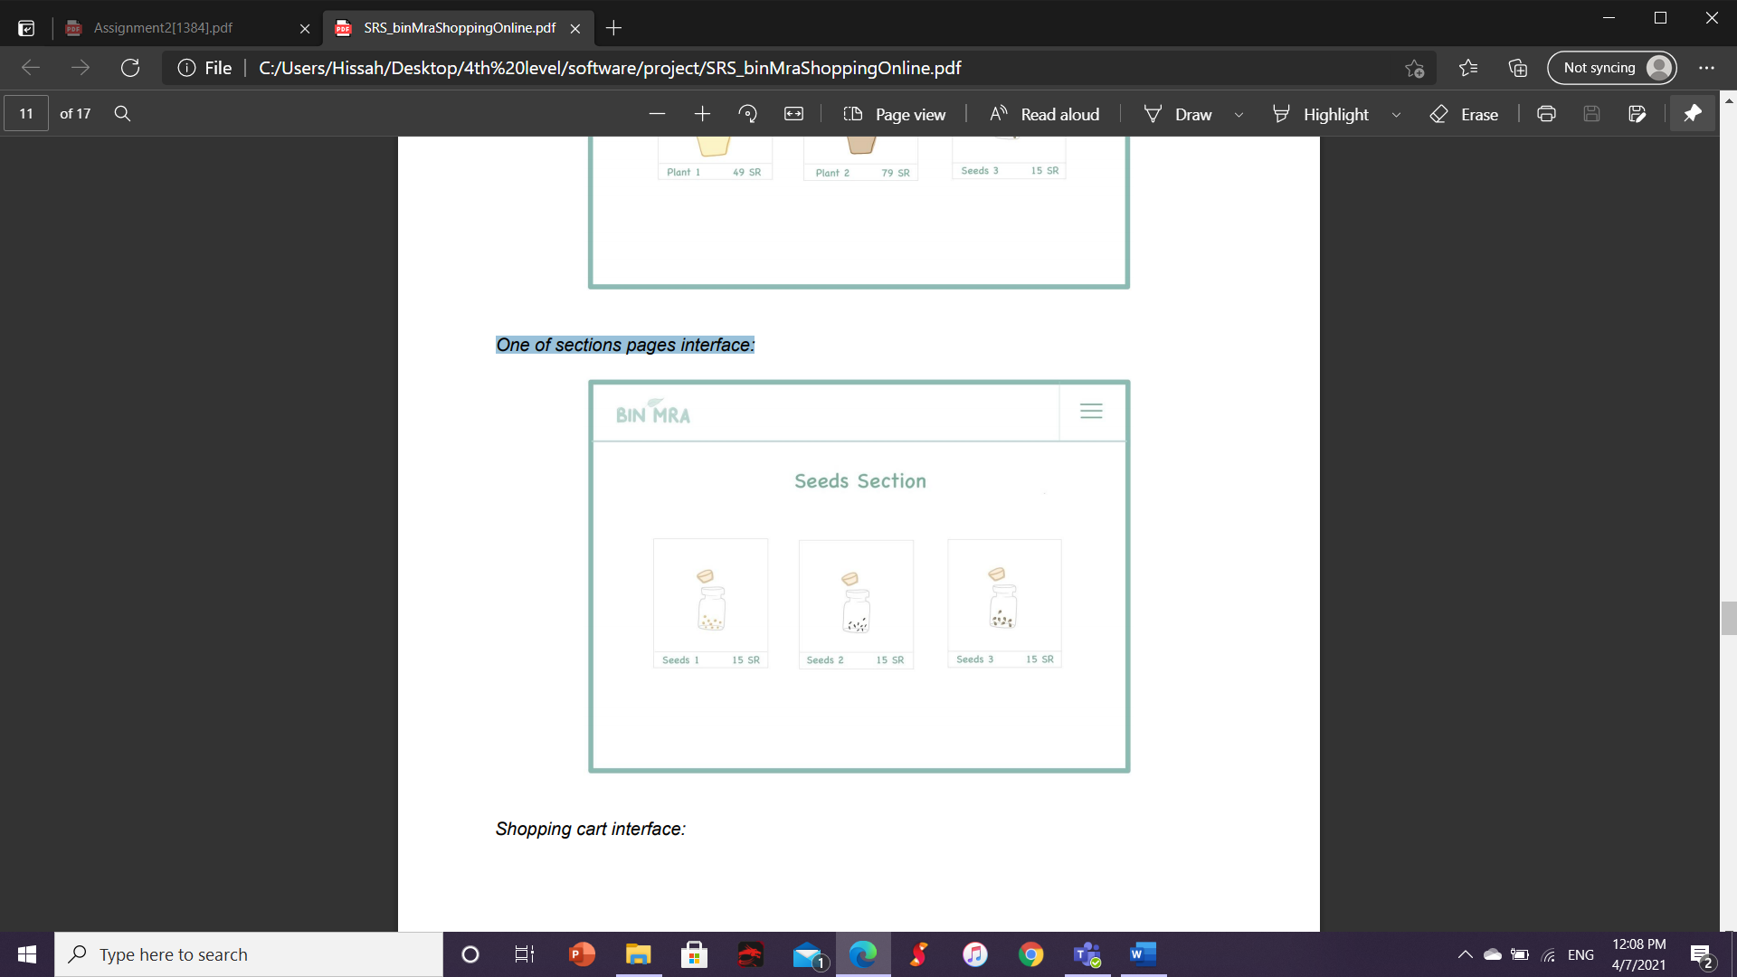 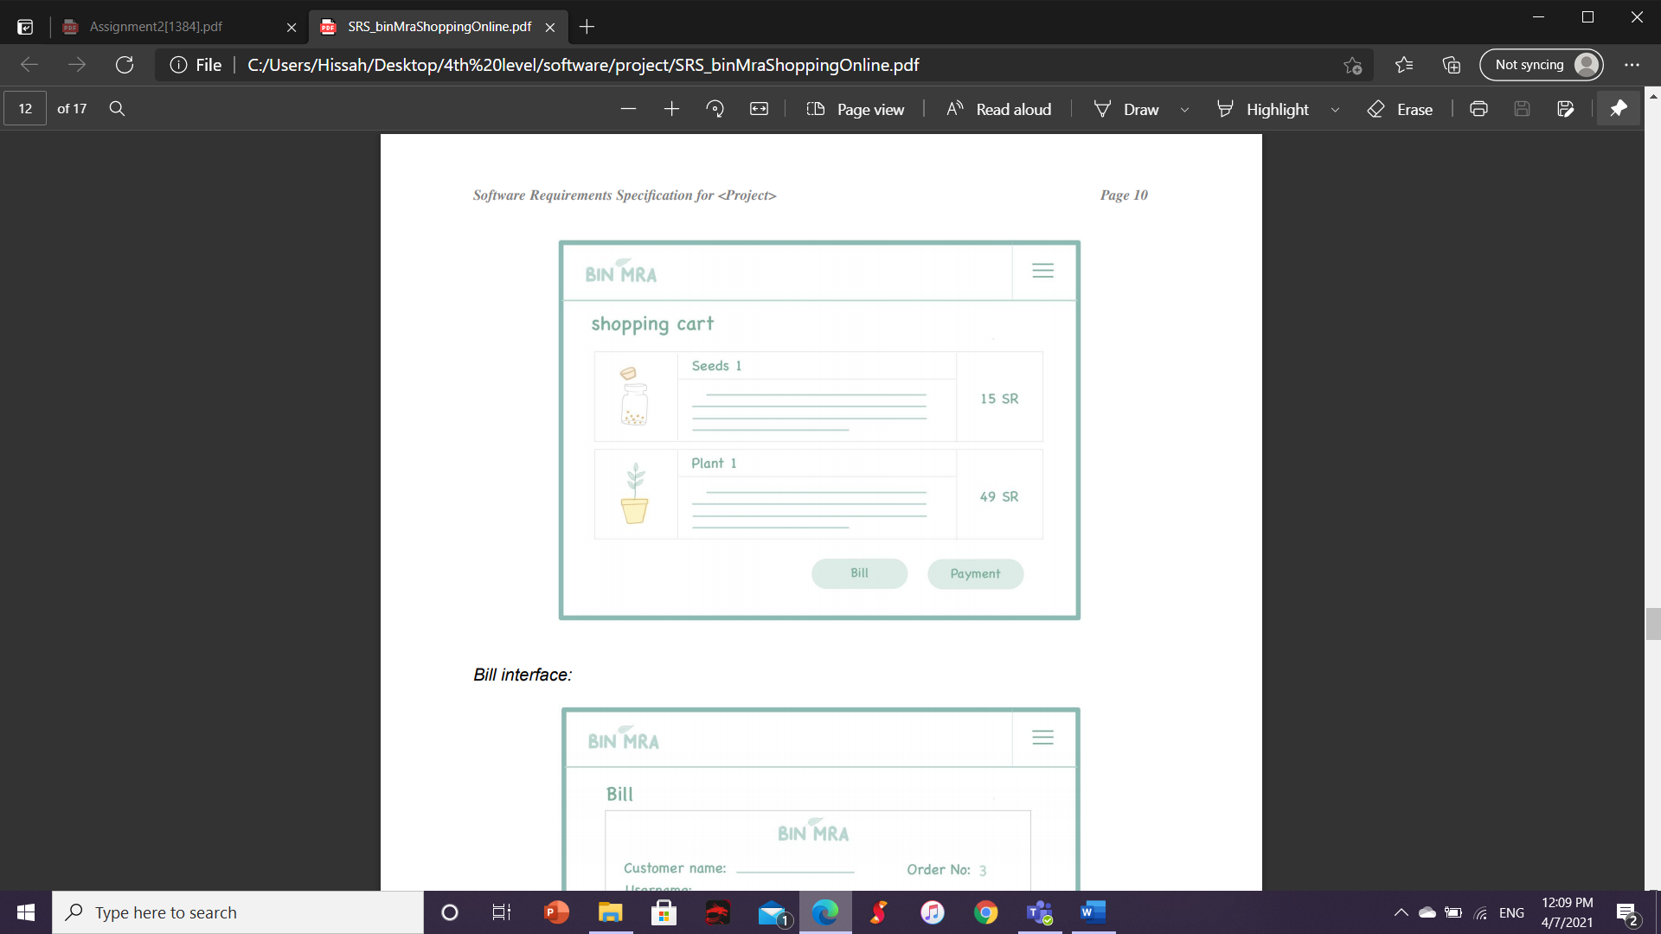

Bill interface Payment interface

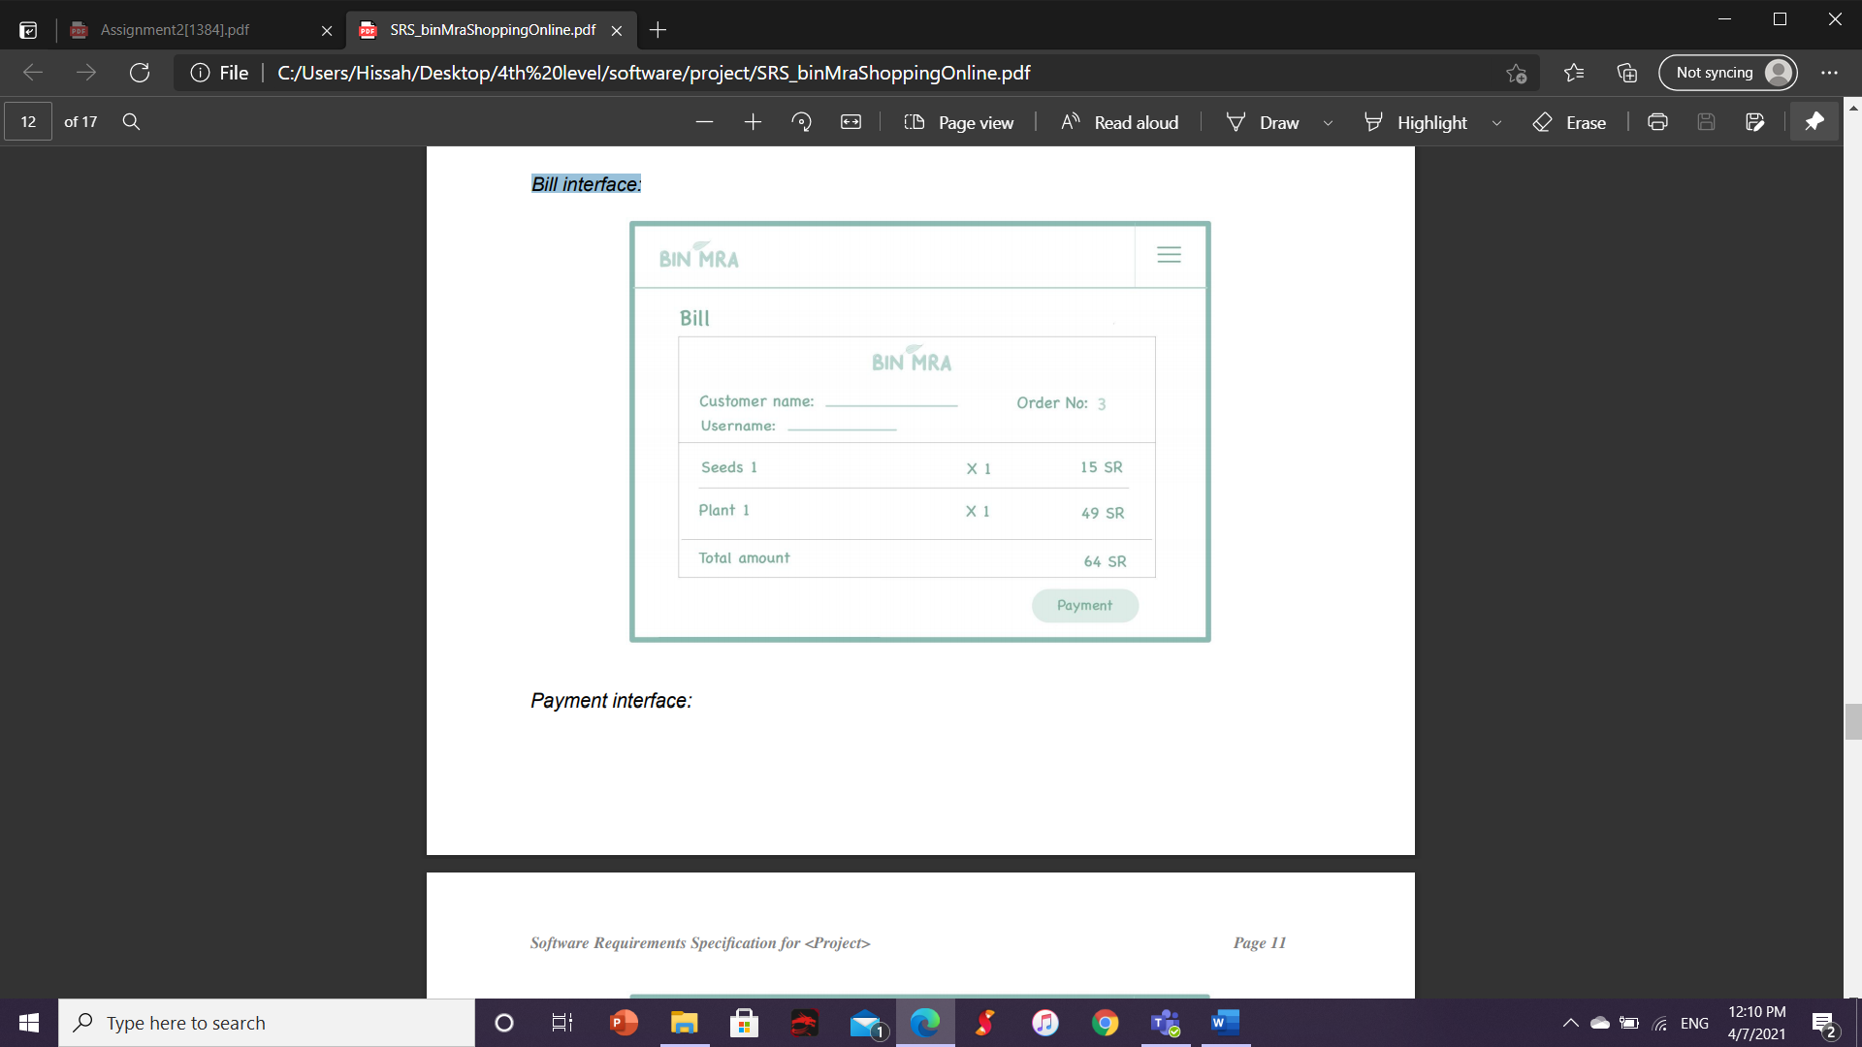 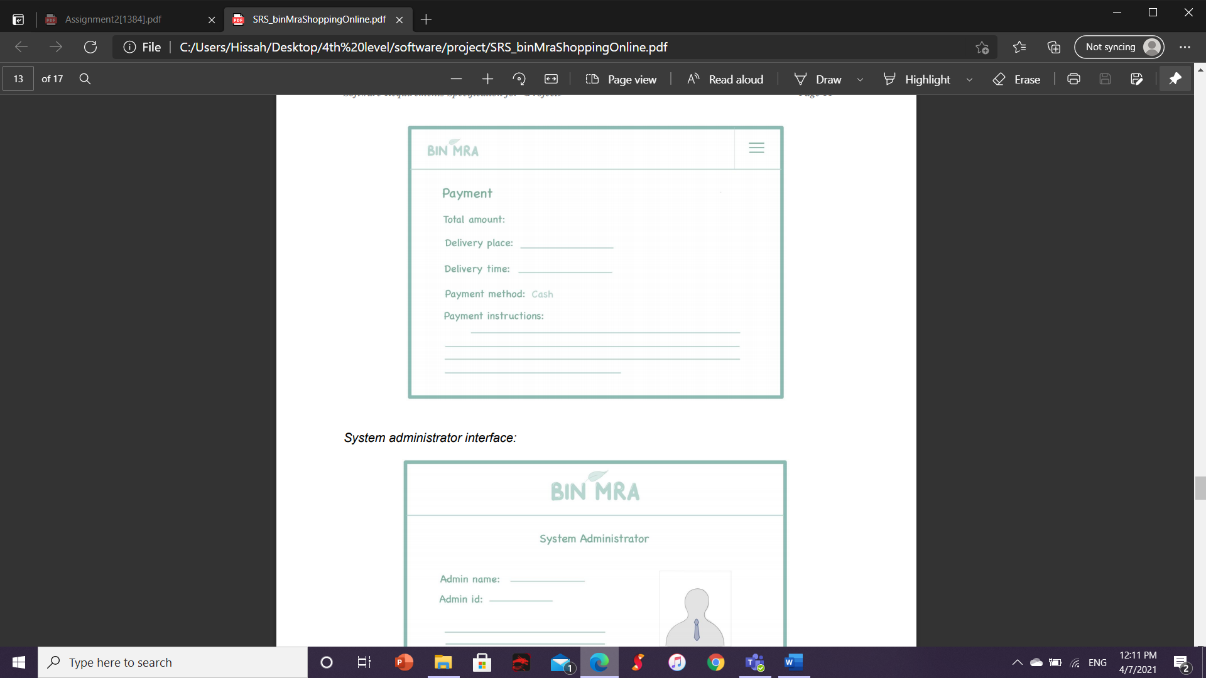

System administrator interface

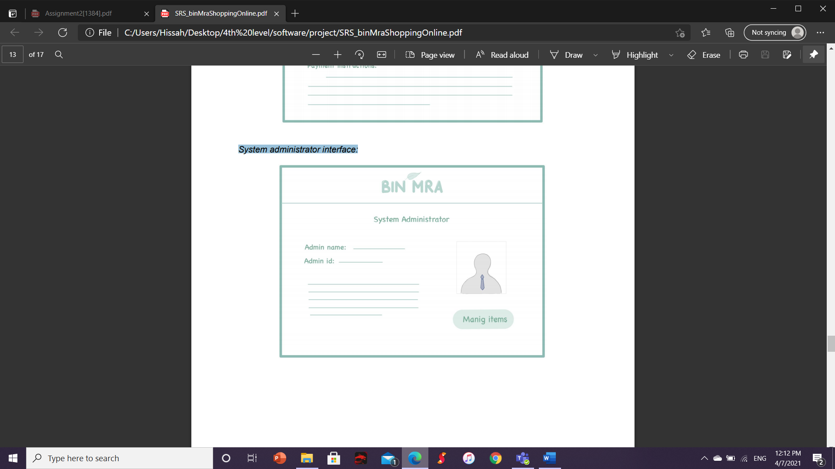

# **Hardware Interfaces**

not applicable.

# **Software Interfaces**

SI.1: A software interface that communicates with the database to collect the products selected by the customer and send them to the billing process.

SI.2: A software interface that sends product information to the inventory management system machine.

# **Communications Interfaces**

CI.1: The system sends an email to confirm the registration process.

CI.2: The system sends an email to confirm the order completion process.

# **Other Nonfunctional Requirements**

# **Performance Requirements**

- The system shall respond to requests no longer than 10 sec.

- The system shall be able to handle 1000 customers logged in concurrently at the same time.

- The system shall be able to add items to the shopping cart in less than 2 second.

- The system shall be able to cancel the order in less than 3 second.

- The system shall be able to store 100 customer records per second.

- The system shall be able to prepare the bill for customers in less than 5 second.

- The system shall be able to prepare the item to pick up from the customer in less than 3 days.

- The system shall be able to view the item and its information for customers in less than 1 second.

- The system shall be able to manage the item including add more items and generate reports for selling items.

- The system shall be able to respond to customer inquiries by calling.

# **Safety Requirements**

- The system will do periodic backups for customer records and their bills through a live internet connection.

# **Security Requirements**

- The system shall detect consecutive failed login attempts.

- The system shall be able to encrypt all sensitive information.

- The system shall keep the user's privacy and information secure.

# **Software Quality Attributes**

- Availability: The system shall have an availability of 99.99%.

- Usability: system shall be easy to use, system shall write an error message in way that customers understand it.

- Maintainability: The system shall be easily updatable for fixes and patches and create files to record all changes, updated, fixes that happen on the system.

- Testability: system shall be able to run under any circumstance.

- Efficiency: The system shall validate user id existence if it will prevent it from registering again.

# **Other Requirements**

- System use: The system should contain laws for using the system to protect the system from any breaches or infringement of user privacy.

- Database: The system should have a database to contain all information in the system such as product information, customer information and admins information.

# **Section 2: System Design Specification**



# **Introduction**

# **Purpose**

The software which is going to be presented in this System Design Specification document (SDS) is called bin mra online shopping system. It enables users who have interest in plants and sell them to sell them via the internet with all information about plant care method.The purpose of this SDS document is to describe a detailed overview of the system design including functionality and system architecture of the bin mra system. In addition, it gives detailed information about database design, hardware and software design, graphical user interface design, and system quality attributes.

# **System Overview**

Designing the system is a very important step which helps the developer to understand the system for the implementation. The main goal of the system is to enable the shop owner of the agricultural shop to sell all products that are related with plants with information about how to care for the plant. It will be used by a customer who is interested in plants and they don’t have time to go to shop or they don’t want to waste their time. In our system we have only one available payment method which is cash. In addition, it requires a database to allow the administrator to manage the overall system and customers’ orders. The database will be created by the graph editor and the system will be implemented by NetBeans IDE 8.2 program.

# **Overall System Design**

# **Design Constraints**

bin mra online shopping system doesn't require any design constraints.

# **System Architecture**

The system consists of customers, administrators, an internet connection, and a browser such as Chrome, Firefox, etc. On the user's machine. Customers and administrators are the main components of the system. The customer and the administrator must use the browser and connect to the Internet to access the system. The customer can add products to the shopping cart and delete them. While the administrator can manage the system, such as adding new products, deleting products, editing them, etc. As in the following figure.

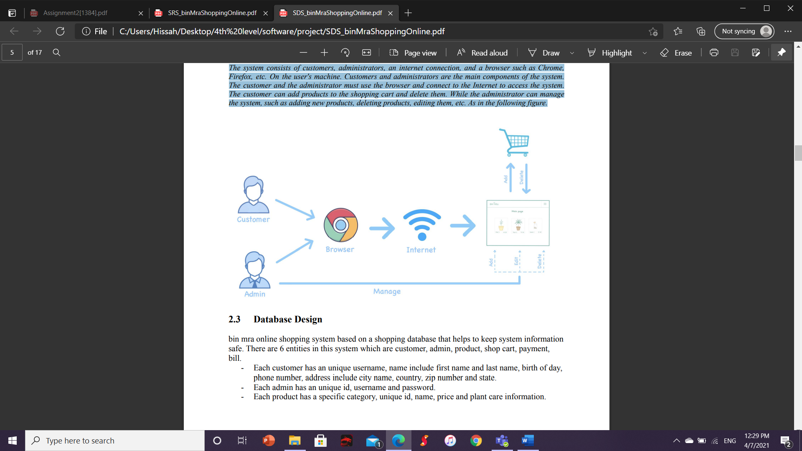

# **Database Design**

bin mra online shopping system based on a shopping database that helps to keep system information safe. There are 6 entities in this system which are customer, admin, product, shop cart, payment, bill.

- Each customer has an unique username, name include first name and last name, birth of day, phone number, address include city name, country, zip number and state.

- Each admin has an unique id, username and password.

- Each product has a specific category, unique id, name, price and plant care information.

- each bill has an unique id, product name, product price, amount of product, total price, and customer information which include customer username and order number.

- payment has bill number, customer username, total amount and price, payment method which include cash and payment instruction.

- a shop cart has an unique order number, quantity and total price.

- Each customer can view the product, submit the order to the shop cart, checkout to pay for her/his order and view the bill.

- products can be added to the shop cart.

- Each admin can manage the product including add, delete, create report.

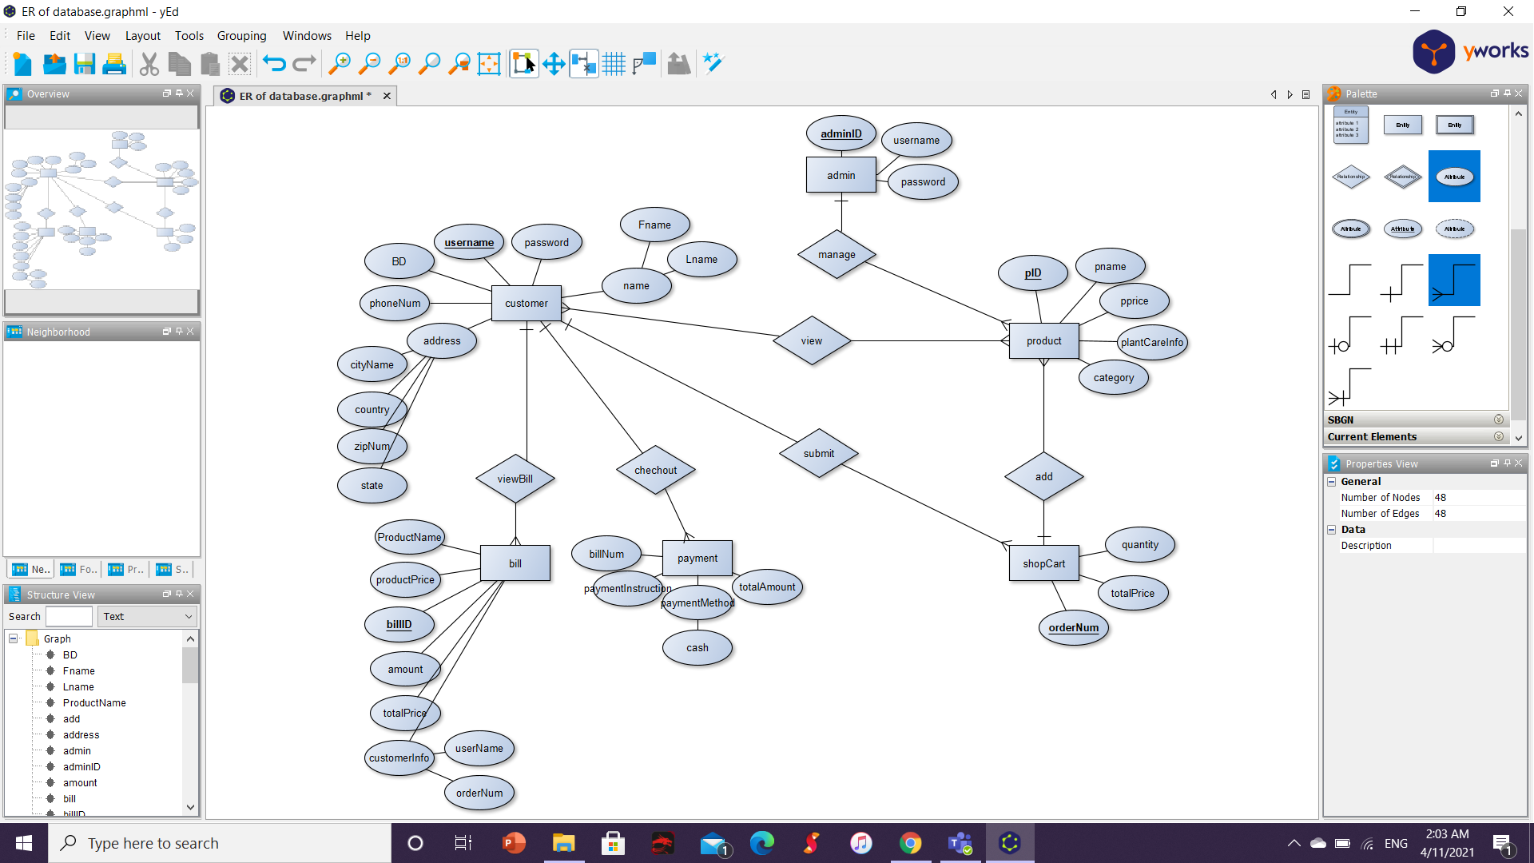

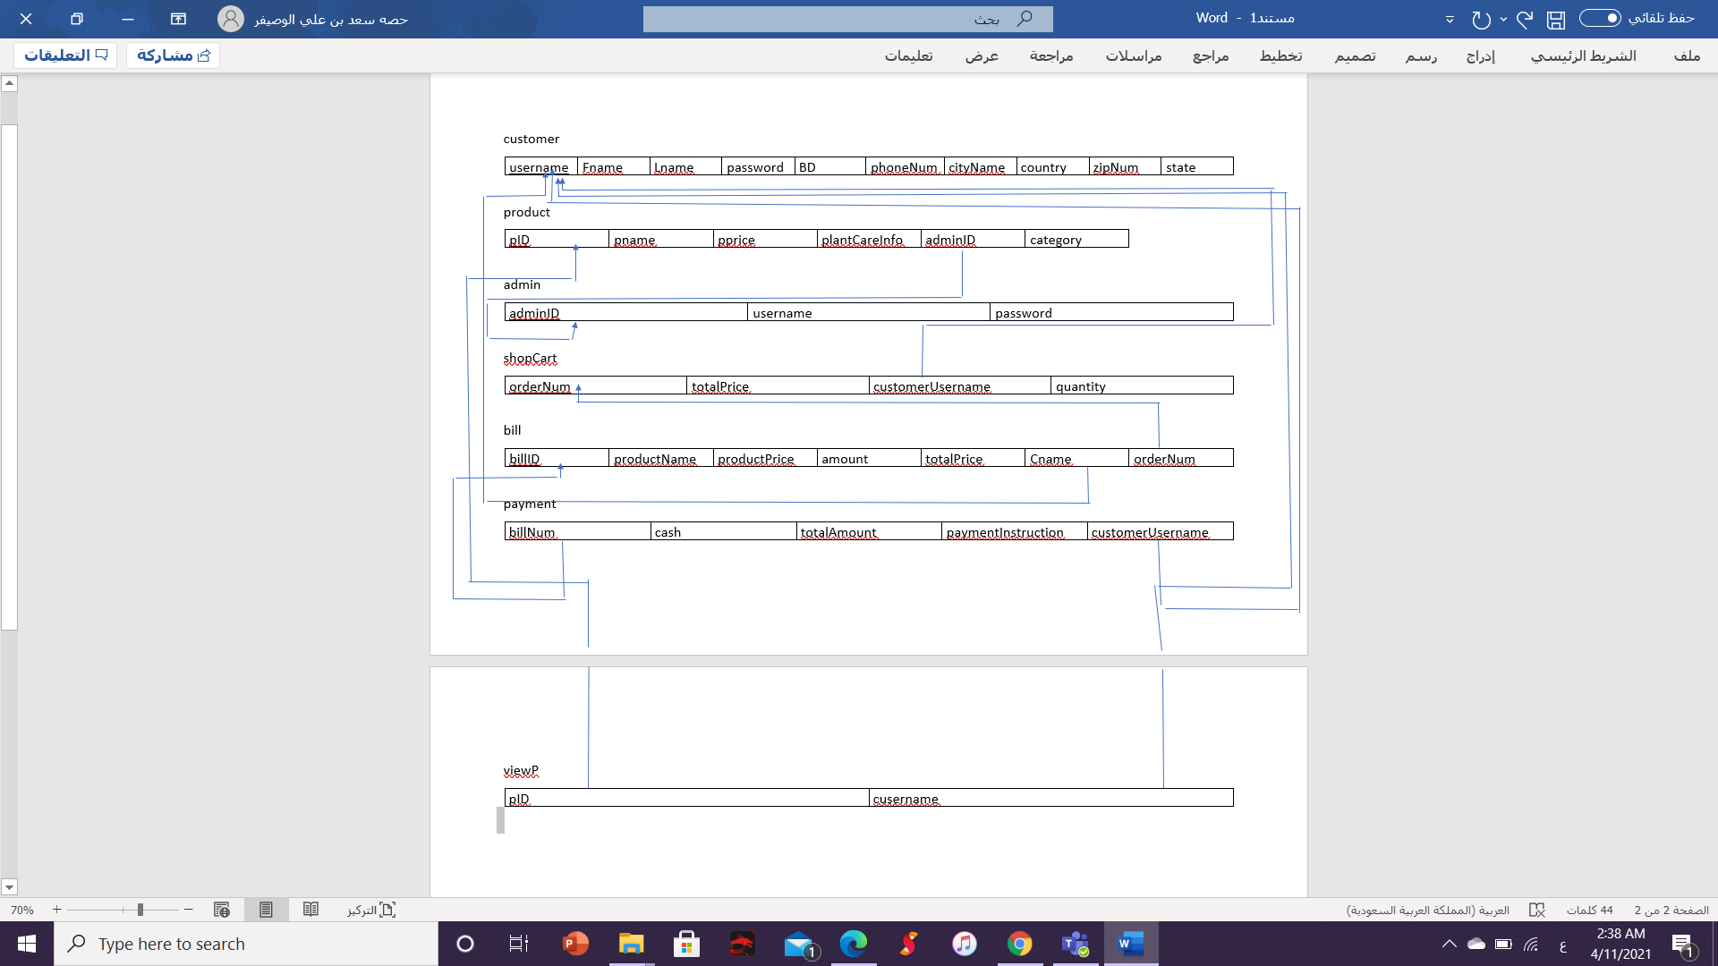

# **Software Design**

Sequence diagram:

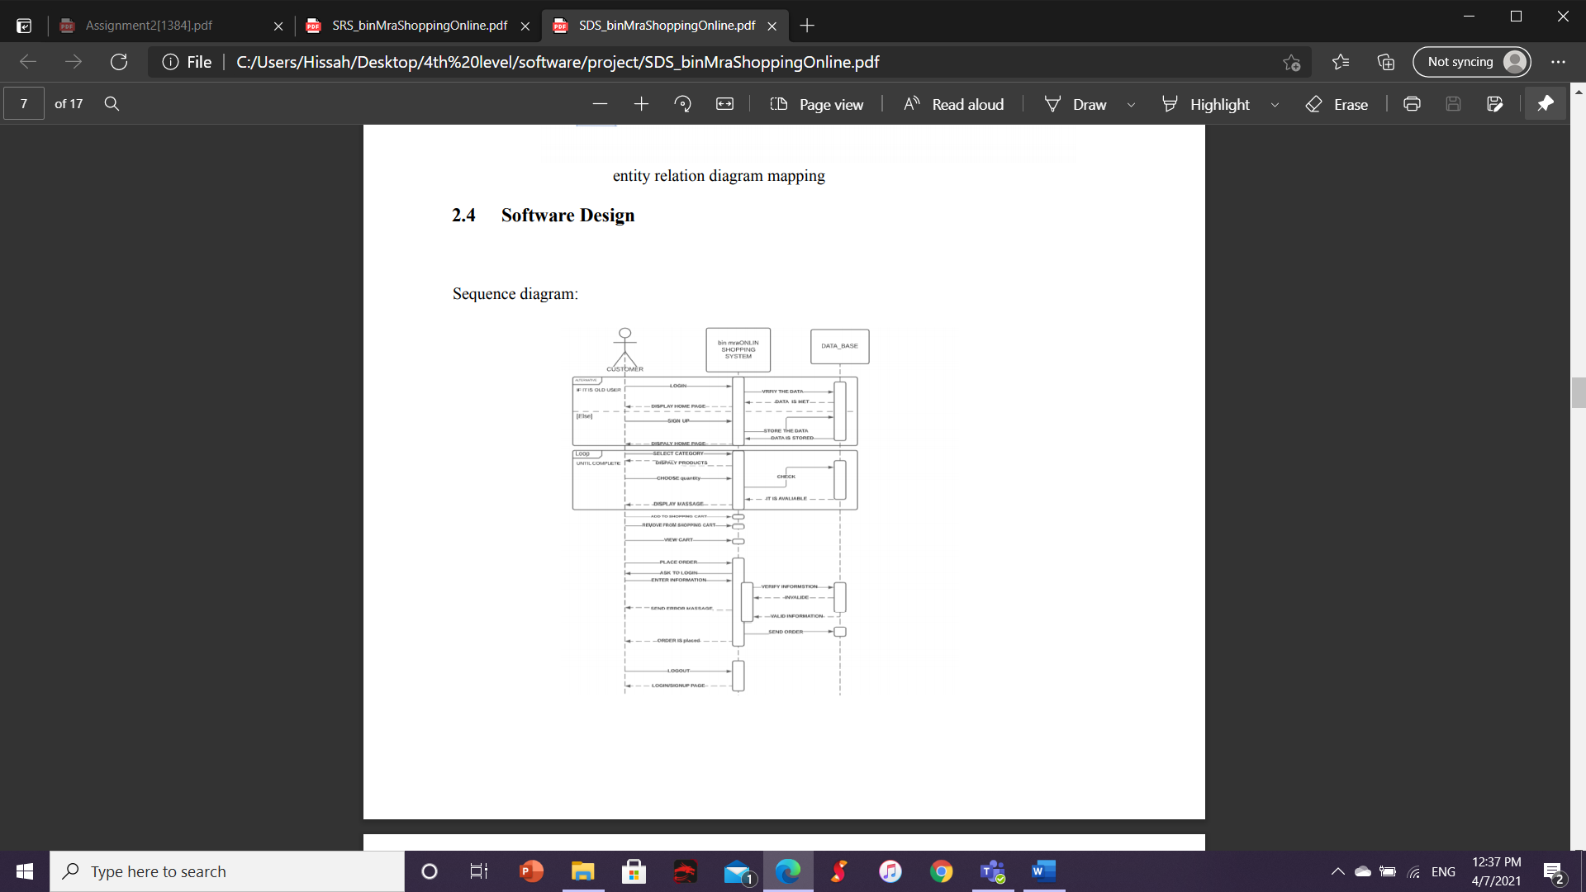

here the sequence diagram for the user it shows the customer who will interact with the system. There are bin mra online shopping system and database. The process the customers can login to the system if the user is old system the system will check the user information is stored in database or not. If it is there ,they can login successfully and the system will display the homepage else the system will ask the user to sign up. After login and sign up are done , the customer can select the category for the specified product such as seeds category .then, the system will display the list of the products related to that category .the customer will be able to choose the quantity of the product . then , the system will check if there is enough quantity in database and display a message to the user about all information of the product quantity and the procces will repeat when the user ask about the quantity until the user complete the searching and spesified the quantity.then,the user can view the shopping cart , remove and add to shopping cart .then, if the user would like to place the order the system will inform the user that the payment only on cash .the system will check the user information by ask the user to login if the user did not .the system will store the order in database. then, the order will be placed.the user can logout.then, system will display the login/sign up page.

Sequence diagram for admin:

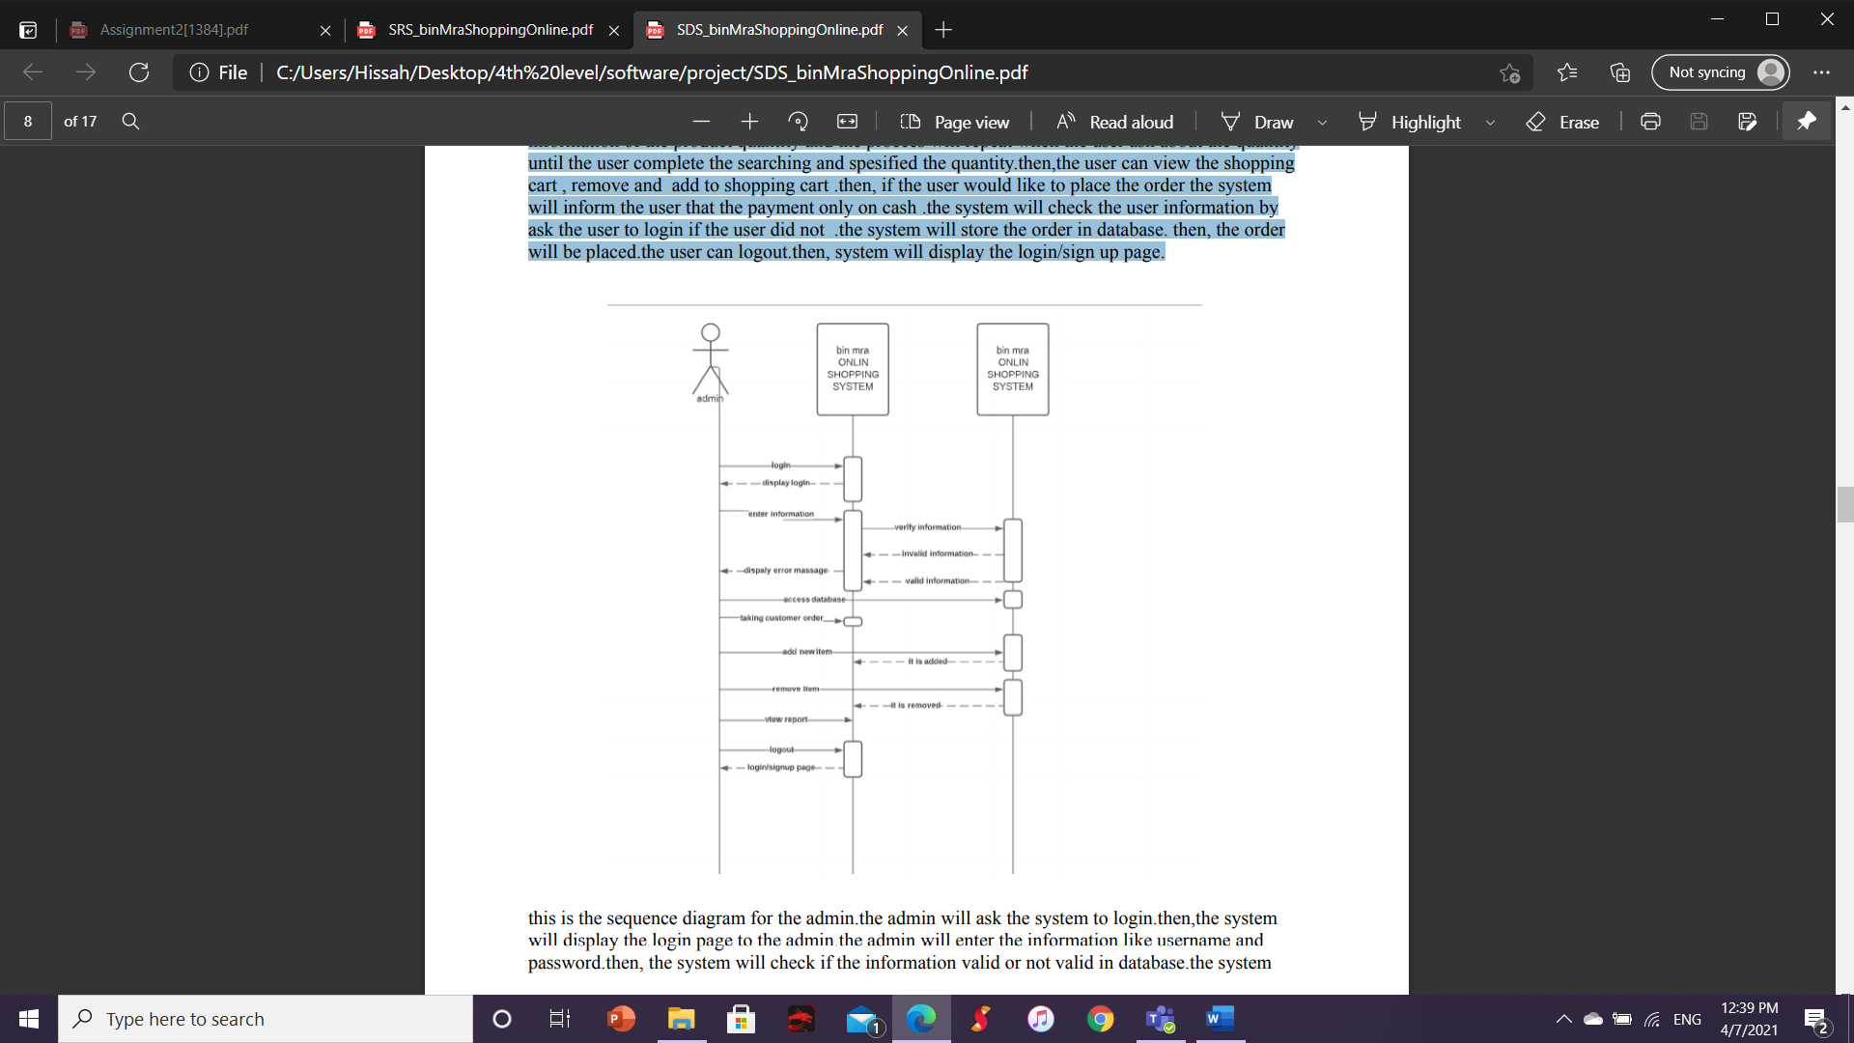

this is the sequence diagram for the admin.the admin will ask the system to login.then,the system will display the login page to the admin.the admin will enter the information like username and password.then, the system will check if the information valid or not valid in database.the system will make the admin to add and remove items.the system will make the change to the database either in adding or removing product.also,generate the report.the admin can logout.the system will display the login/signup page again.

Activity diagram:

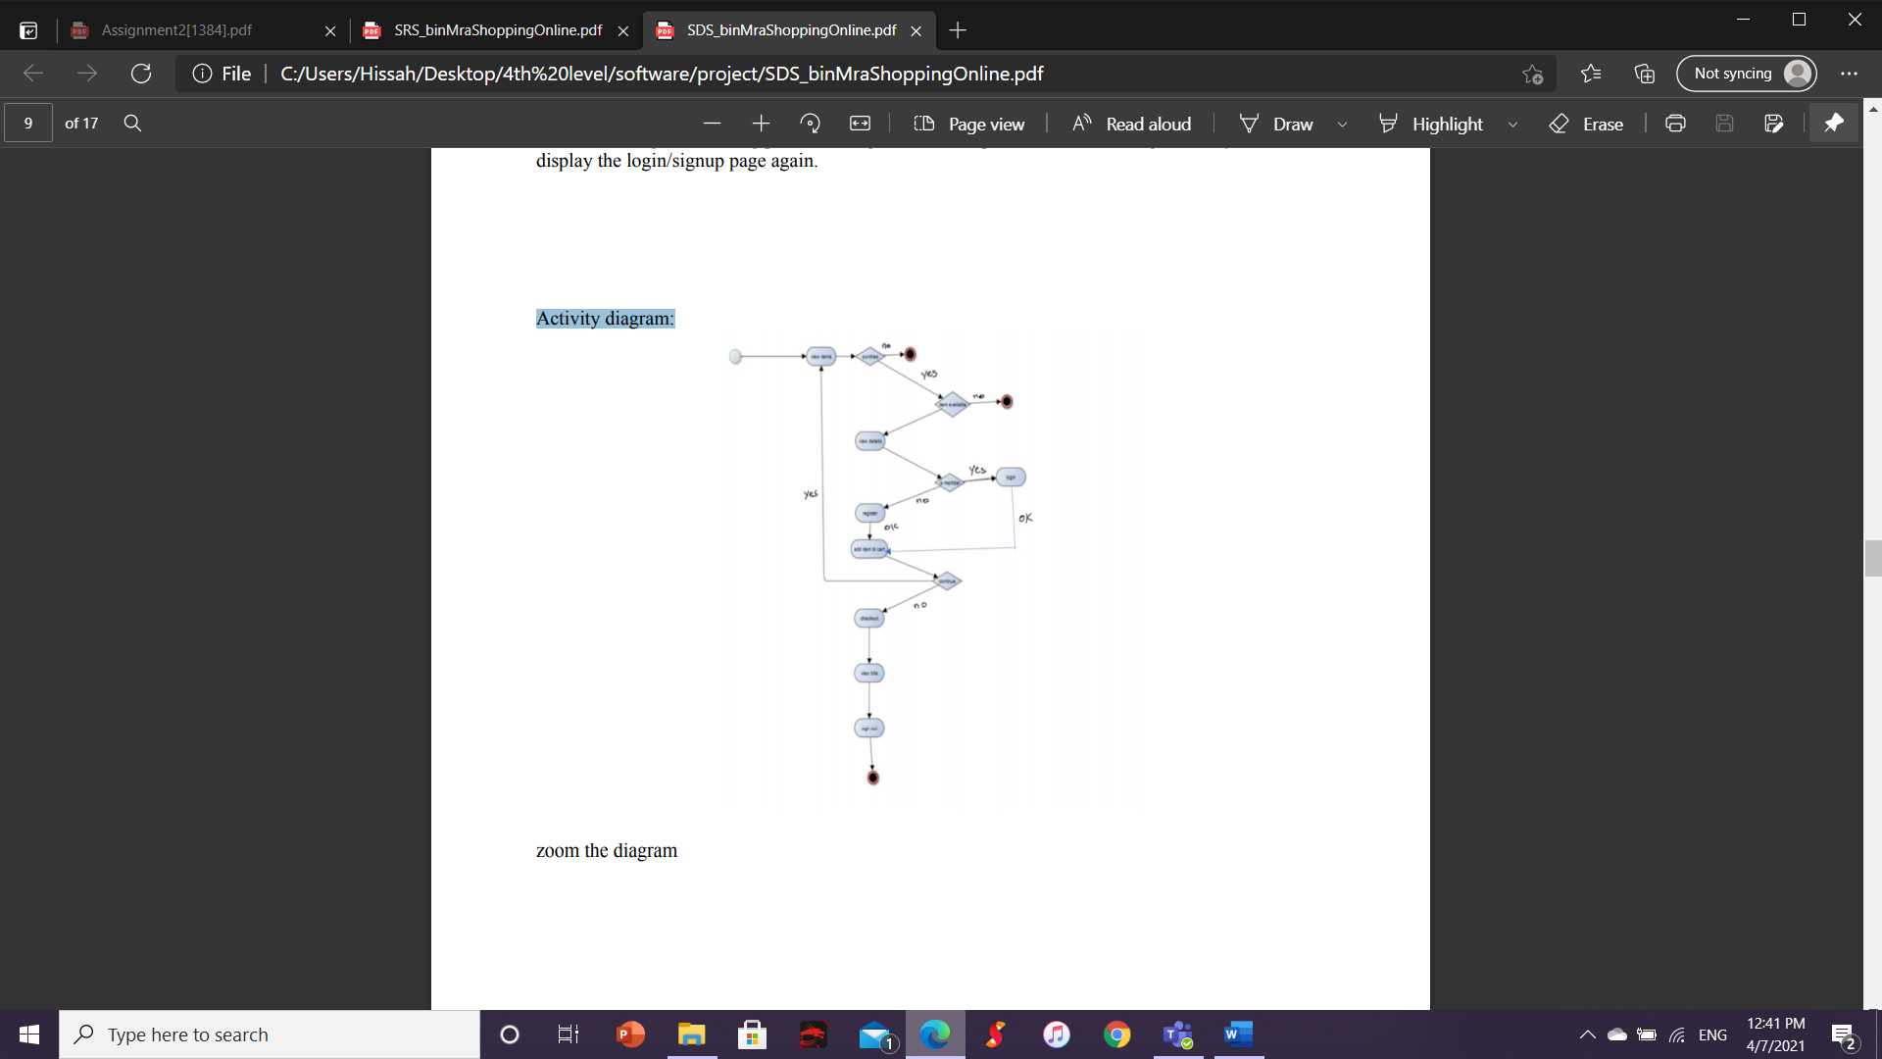

zoom the diagram:

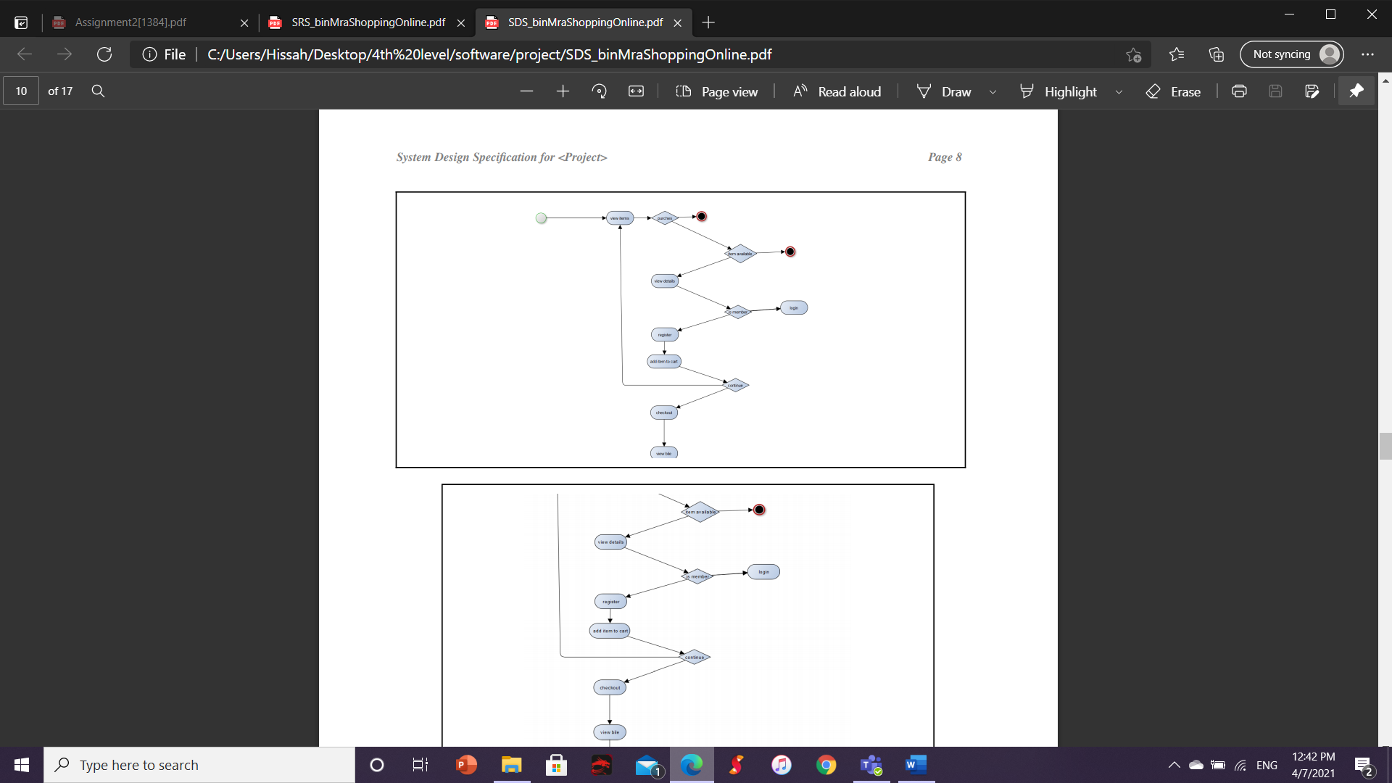

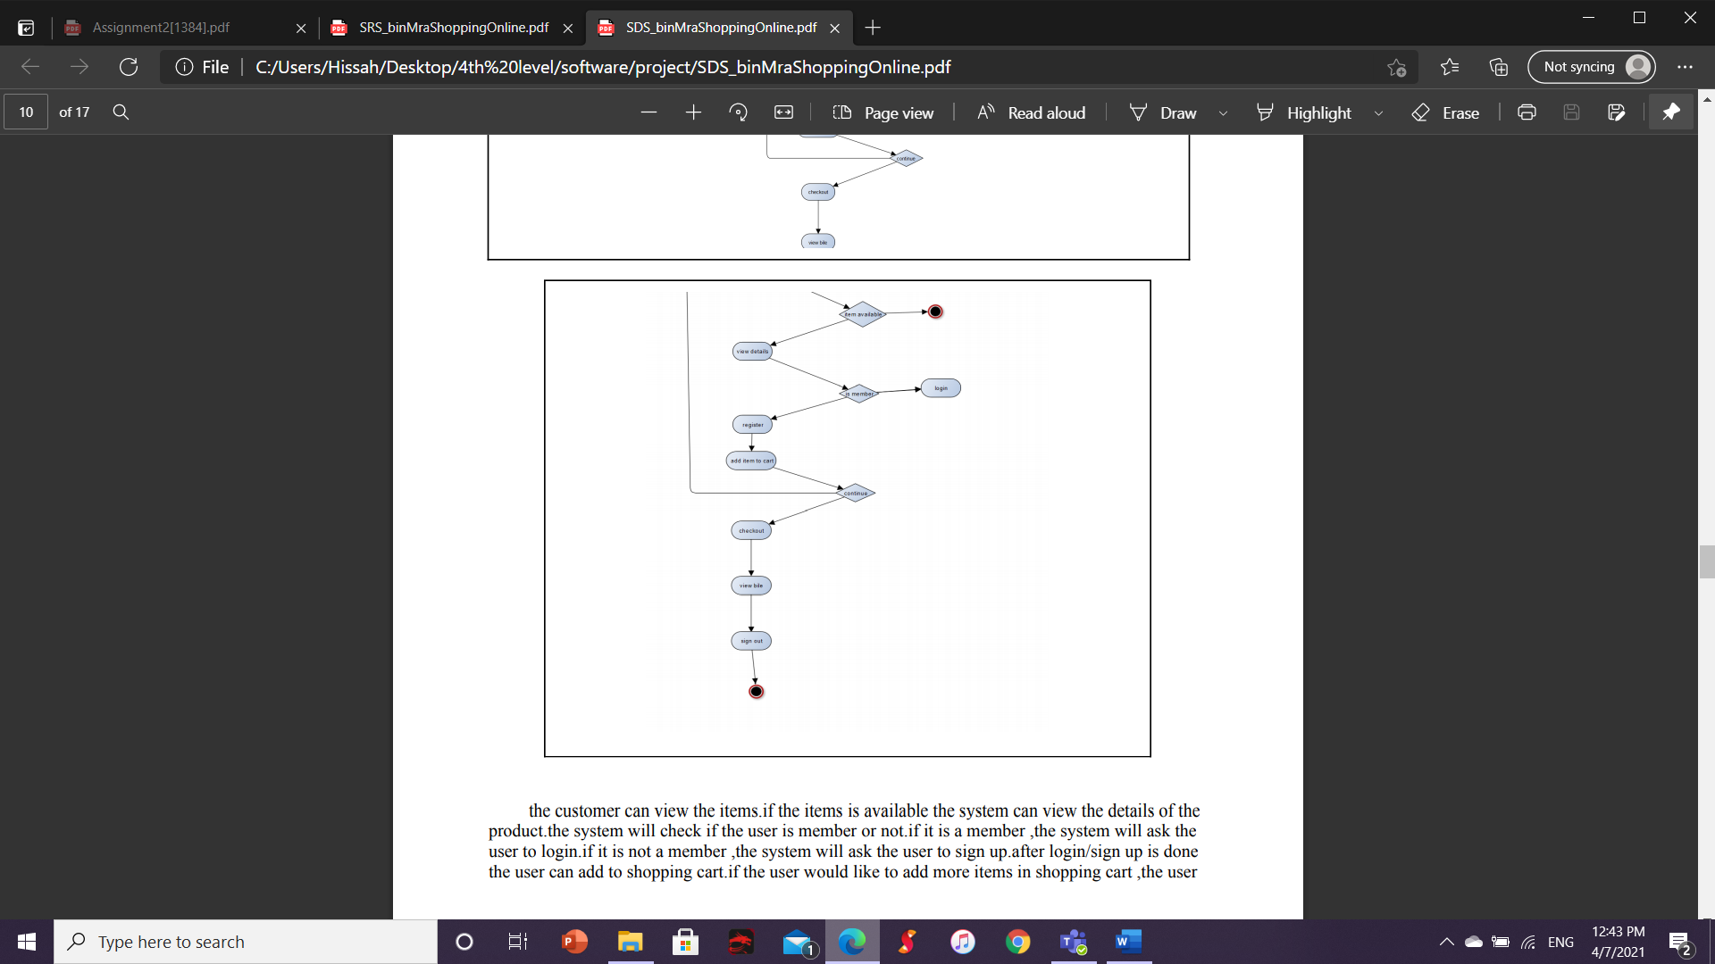

the customer can view the items.if the items is available the system can view the details of the product.the system will check if the user is member or not.if it is a member ,the system will ask the user to login.if it is not a member ,the system will ask the user to sign up.after login/sign up is done the user can add to shopping cart.if the user would like to add more items in shopping cart ,the userSystem can again view the items .if the user is done of viewing the products.He/She can go the checkout to view the bill.the payment will be only on cash.after all that the user can log out.

use case:

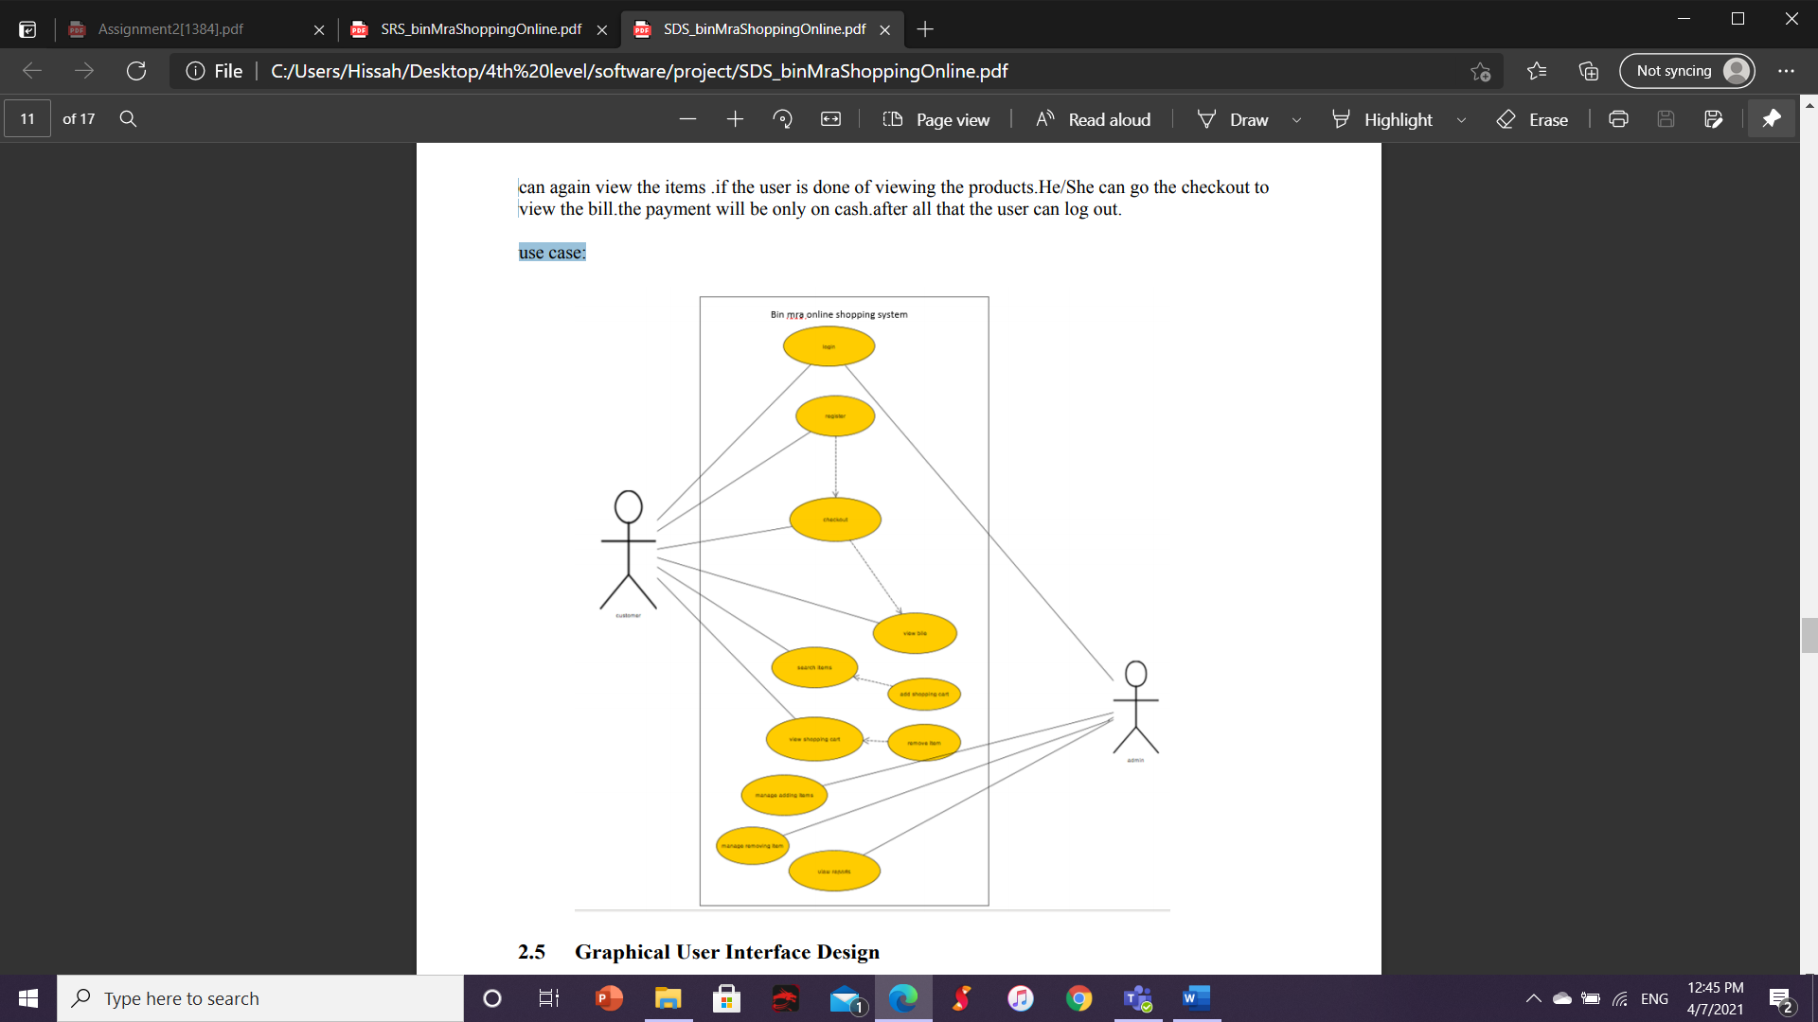

# **Graphical User Interface Design**

The prototype will show the overall of our system from the user either login or sign up in our system to the last step which is payment.

Prototype:

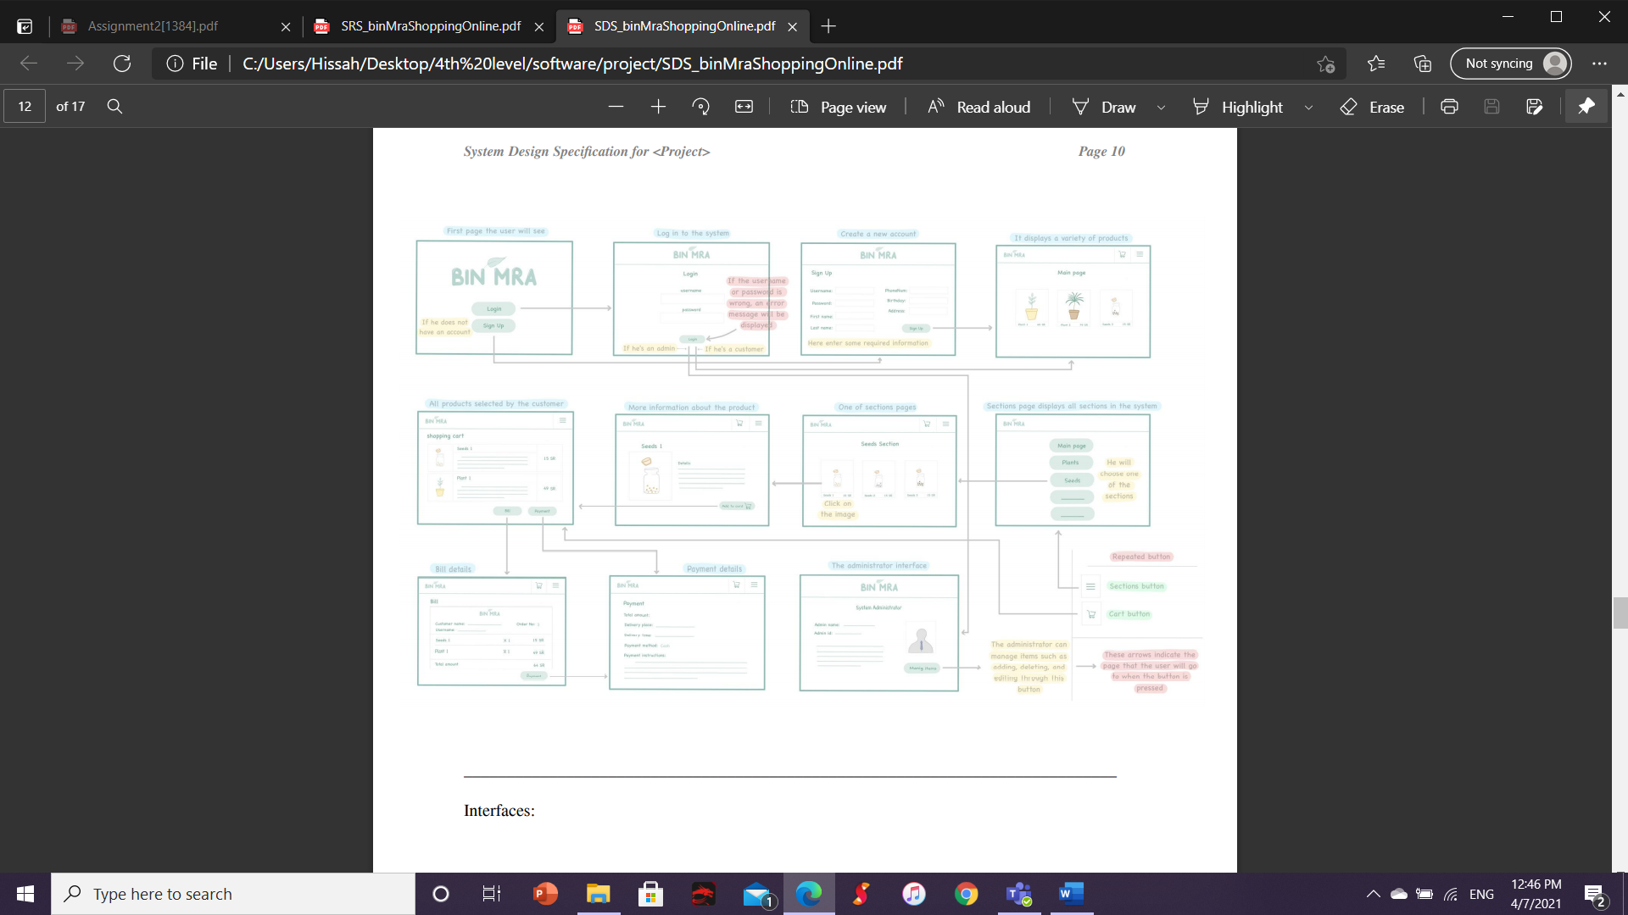

Interfaces:

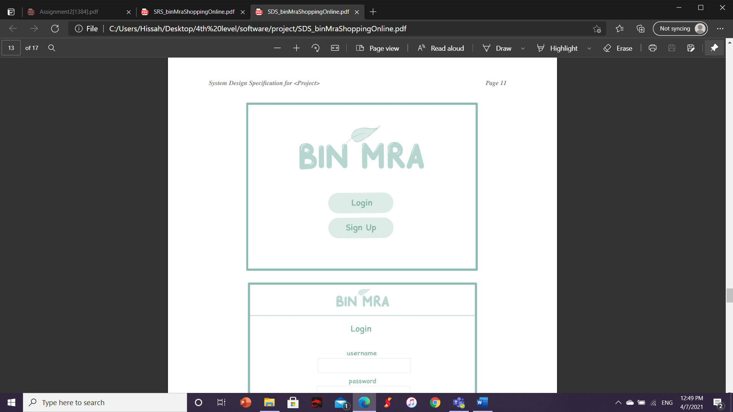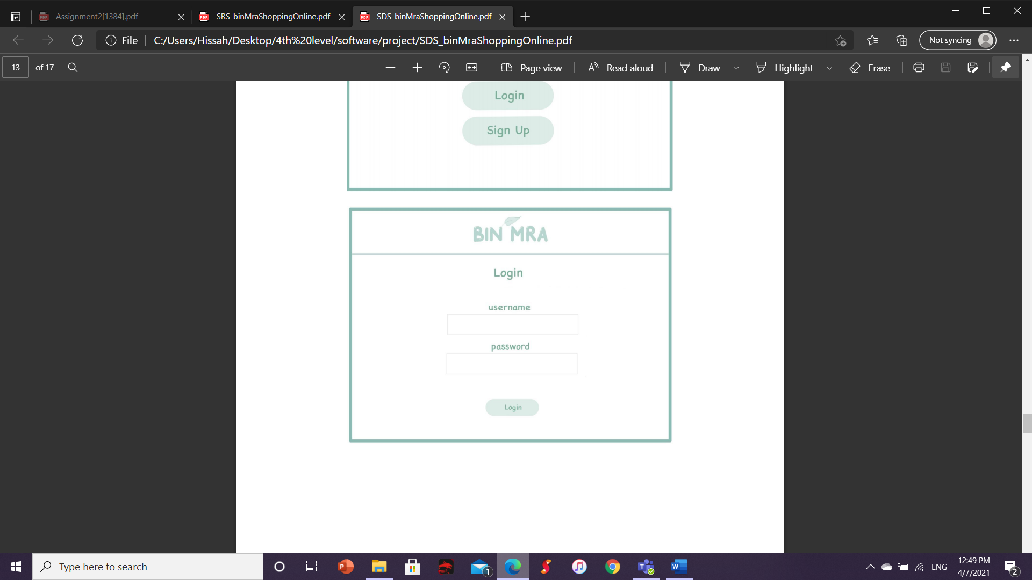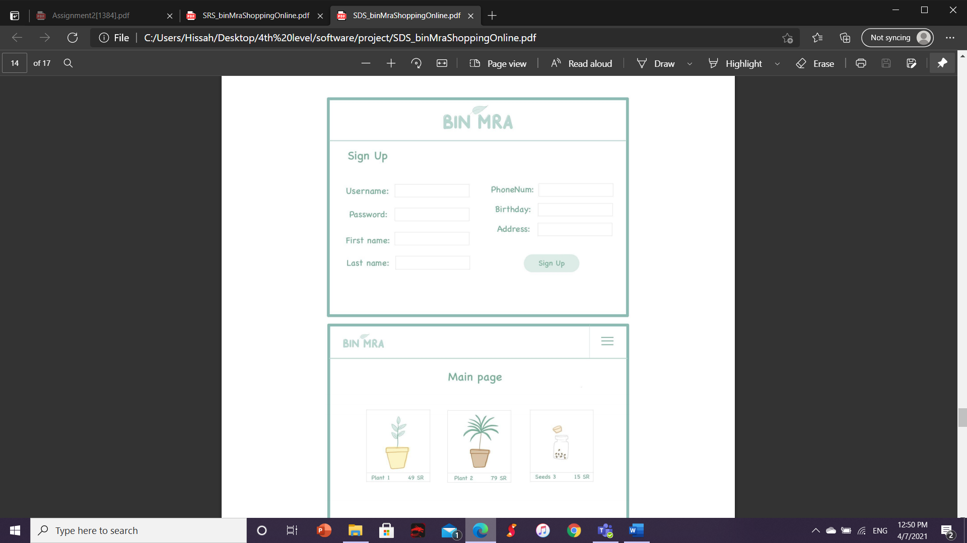

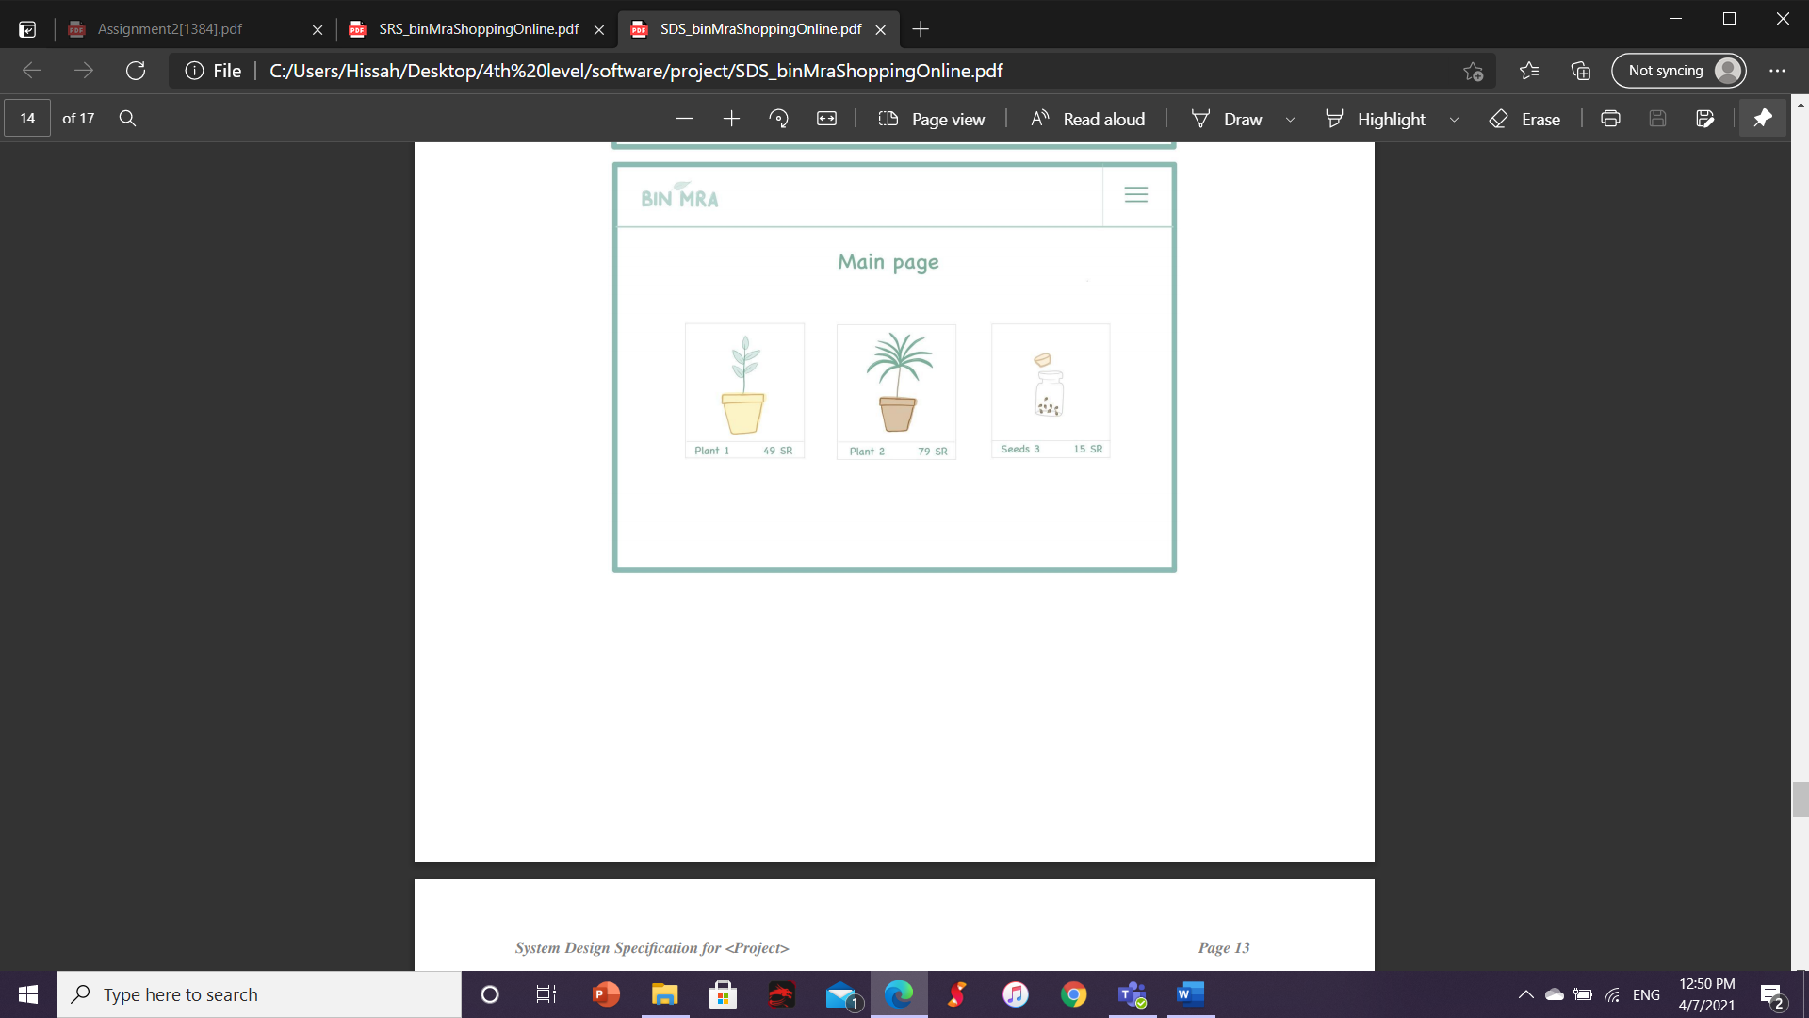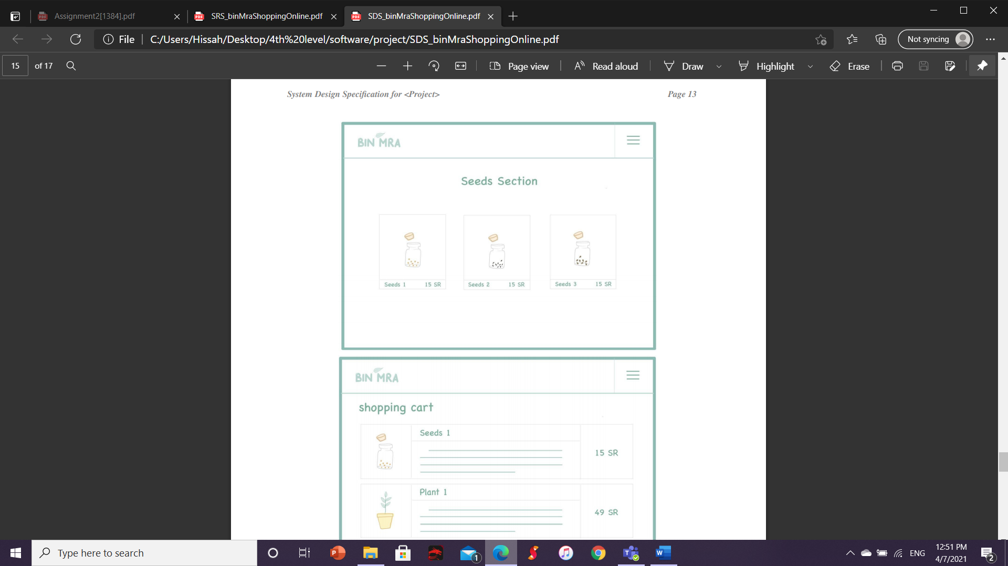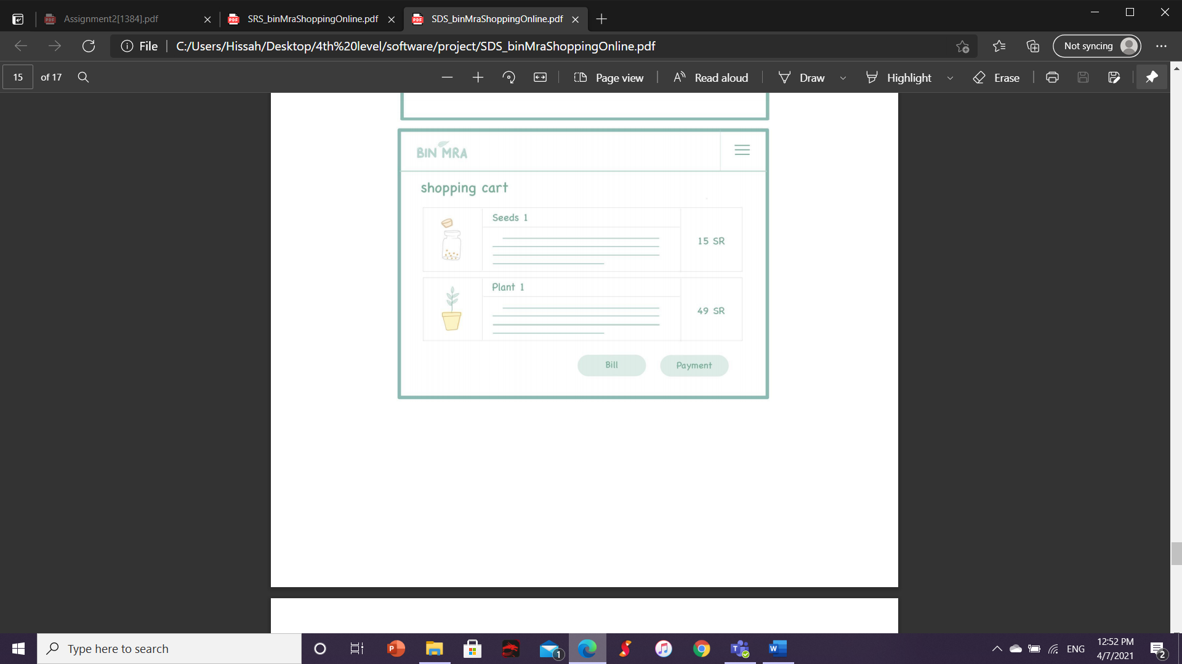

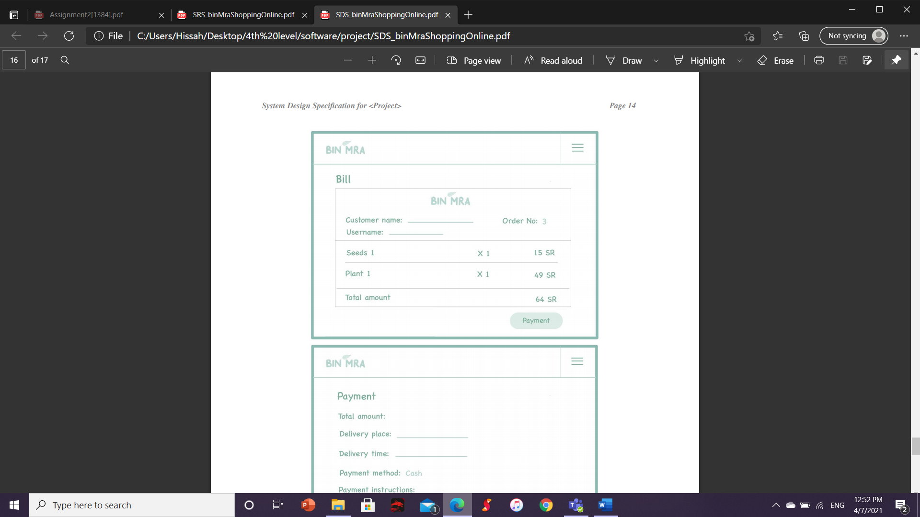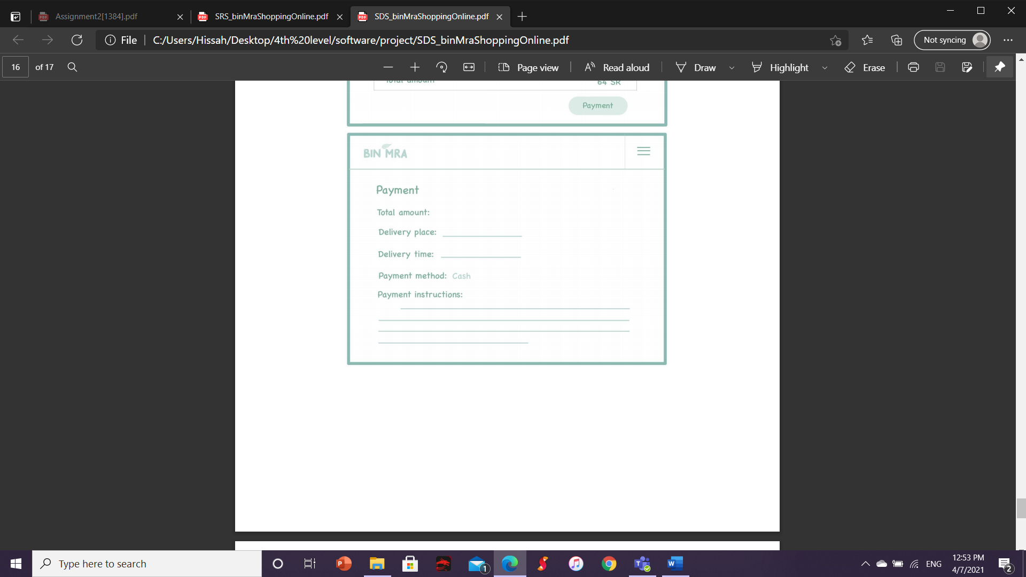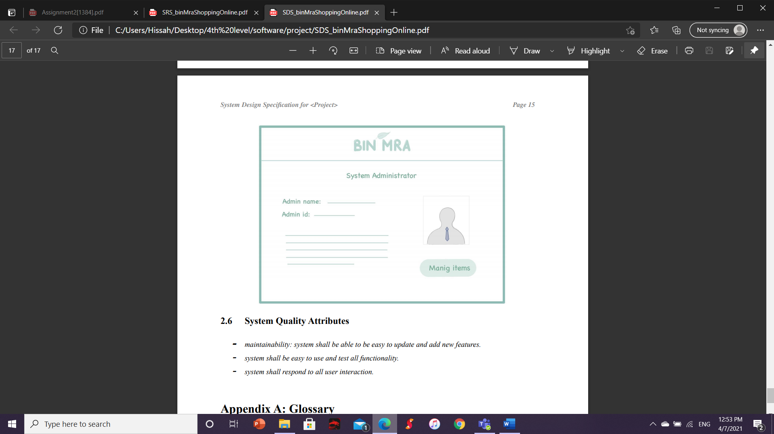

# **System Quality Attributes**

- maintainability: system shall be able to be easy to update and add new features.

- system shall be easy to use and test all functionality.

- system shall respond to all user interaction.

**Section 3: Screen Shots of The Project Program**

User Interface testing (Usability Testing)

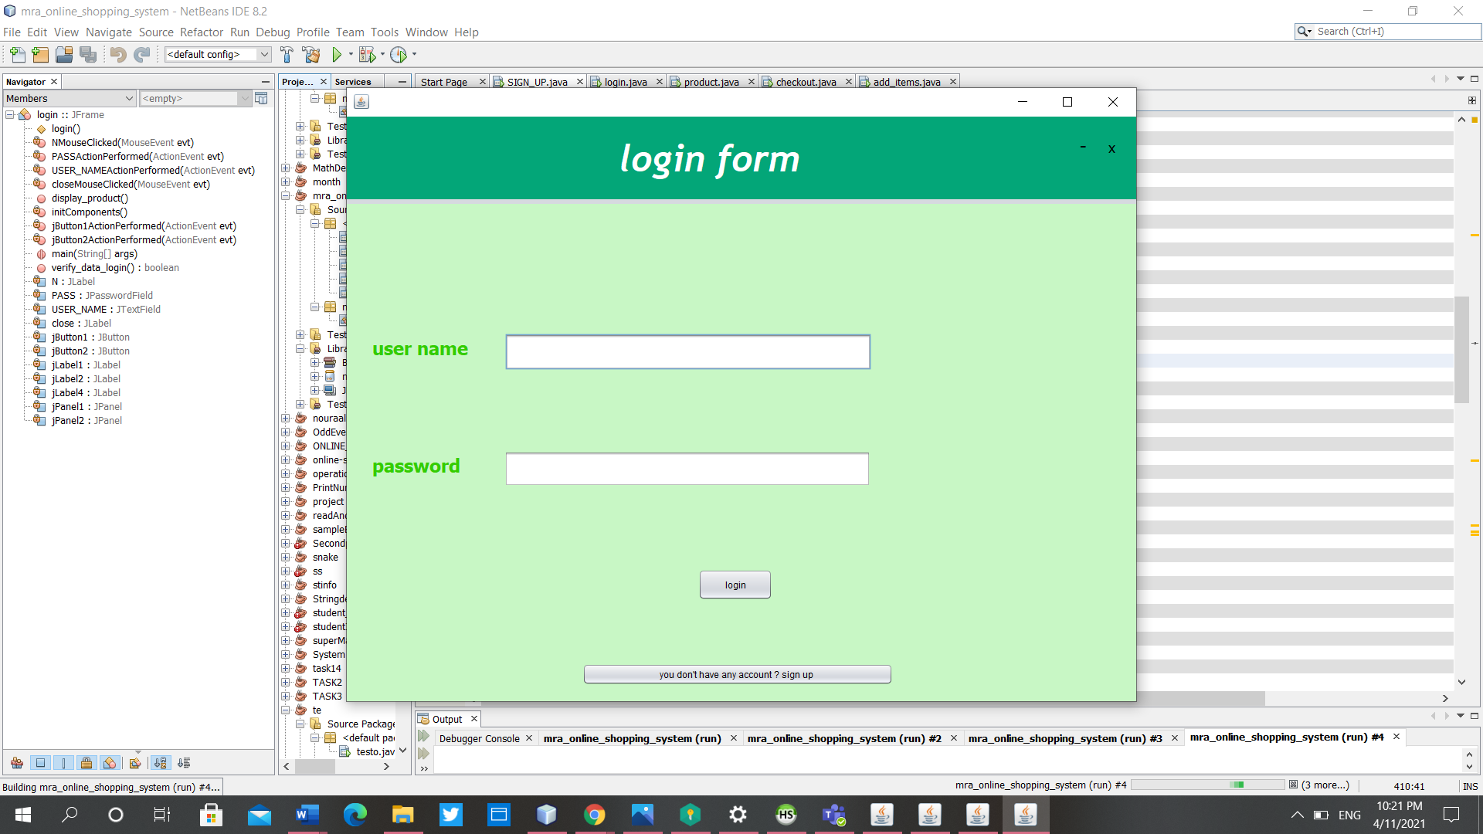

**Figure.3.1 Login page**

**If the user clicks to sign up the system is going to display the sign up page.**

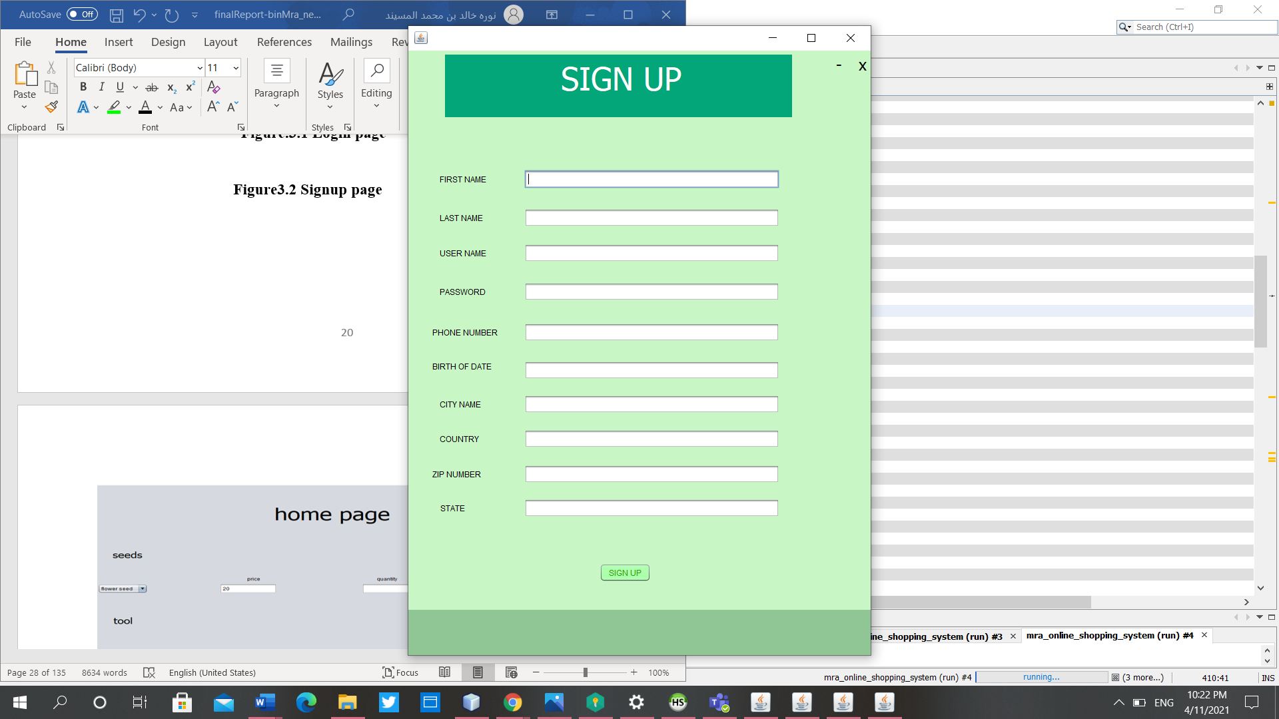

**Figure3.2 Signup page**

**If the user clicks to sign up button the system is going to display the home Page to display the products.**

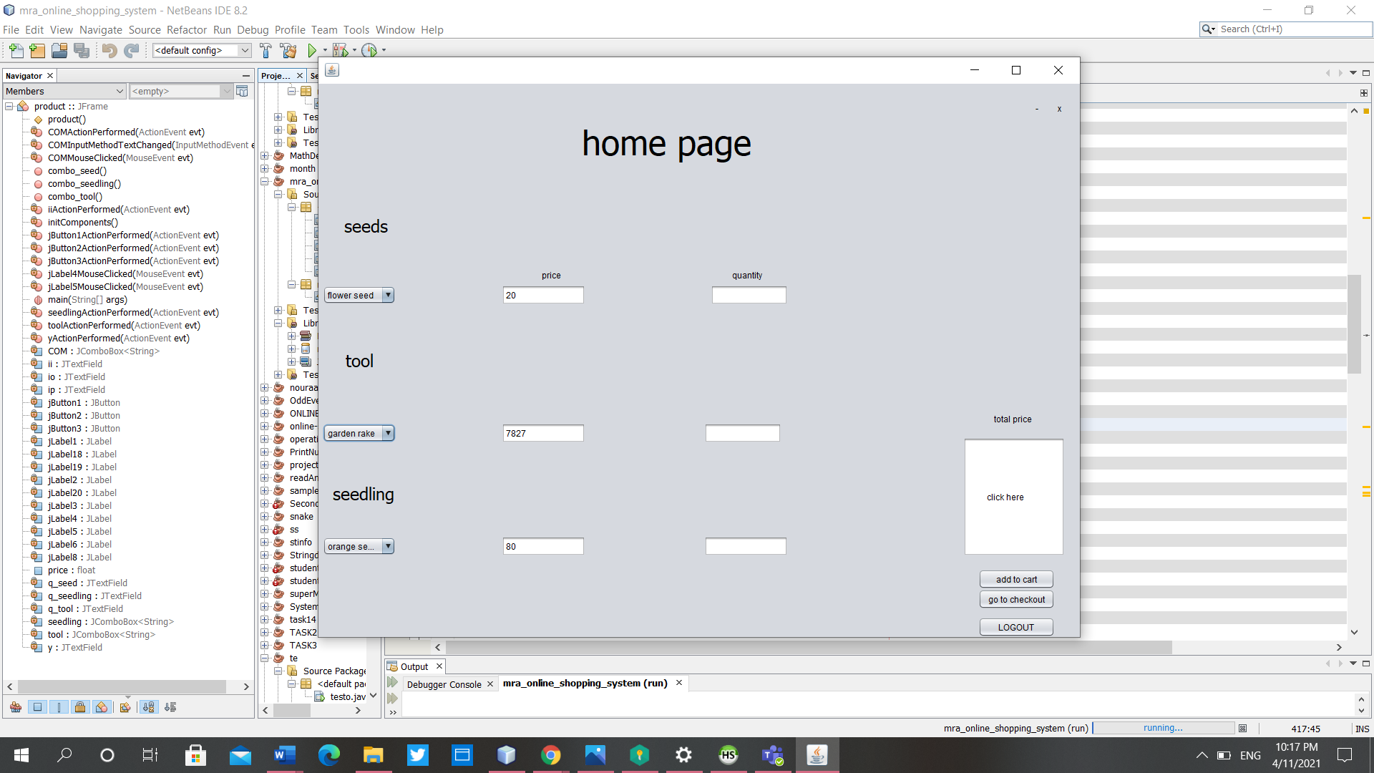

**Figure3.3 home page.**

**Here the home page if the user clicks to add to cart the system will show a massage. if the user click to checkout button the system is going to display the checkout page. if the user clicks to logout the system is going to take the user back to login page.**

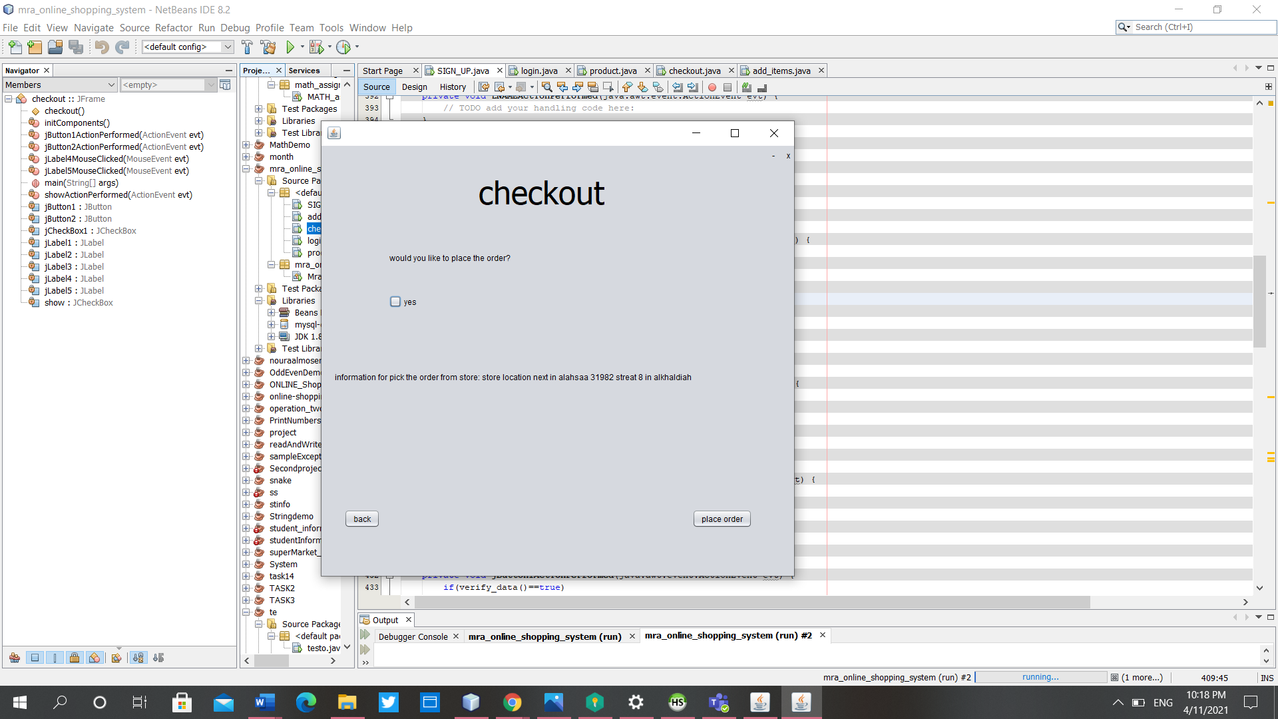

**Figure 3.4 checkout page**

**Here the checkout page. If the user clicks to place order button the system will show a massage. If the user clicks to back button the system is going to take the user back to home page.**

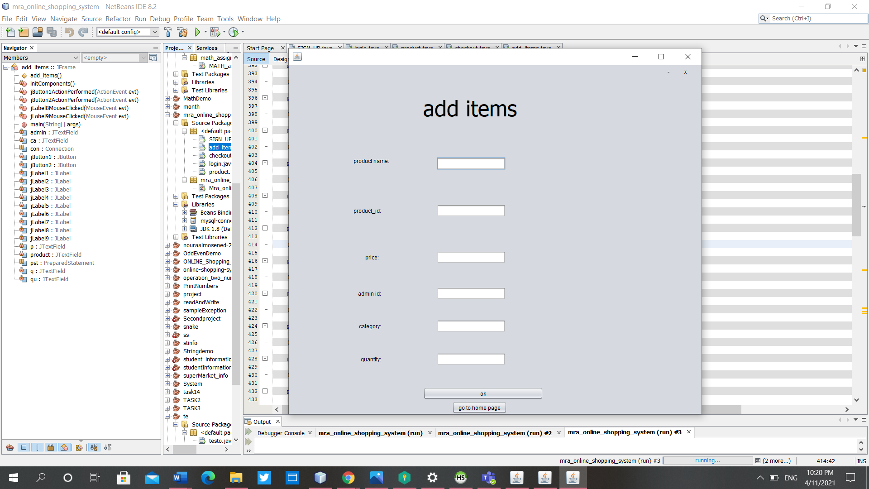

**Figure3.5 Adding item for admin**

**The admin can add the item in this page. If the admin click to ok button the system will store the data in database. If the admin click to home page the system is going to take the admin to home page.**

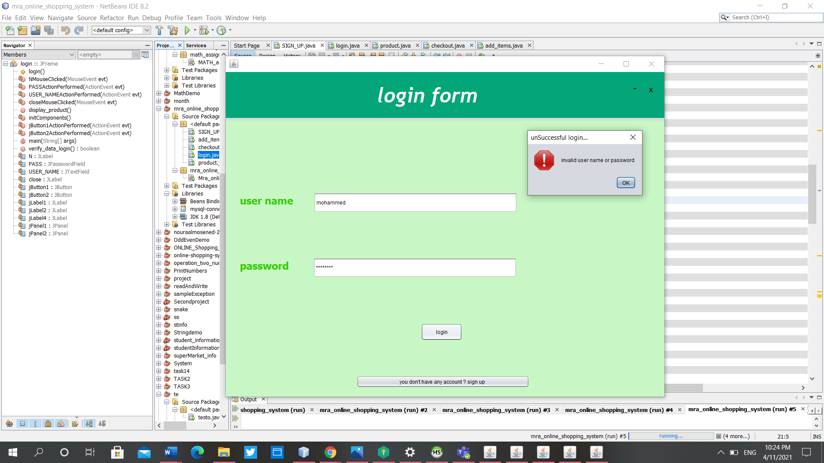Black box testing (Functionality testing – Front end)

In this part will explain each function we have provide on our system one by one.

**Figure 3.6 invalid login page**

**if user forget to enter a value on either username or password the system will generate an error message ' one or more field are empty'. if the who wants to log to our system don't have a record in the system database will never log to the system.**

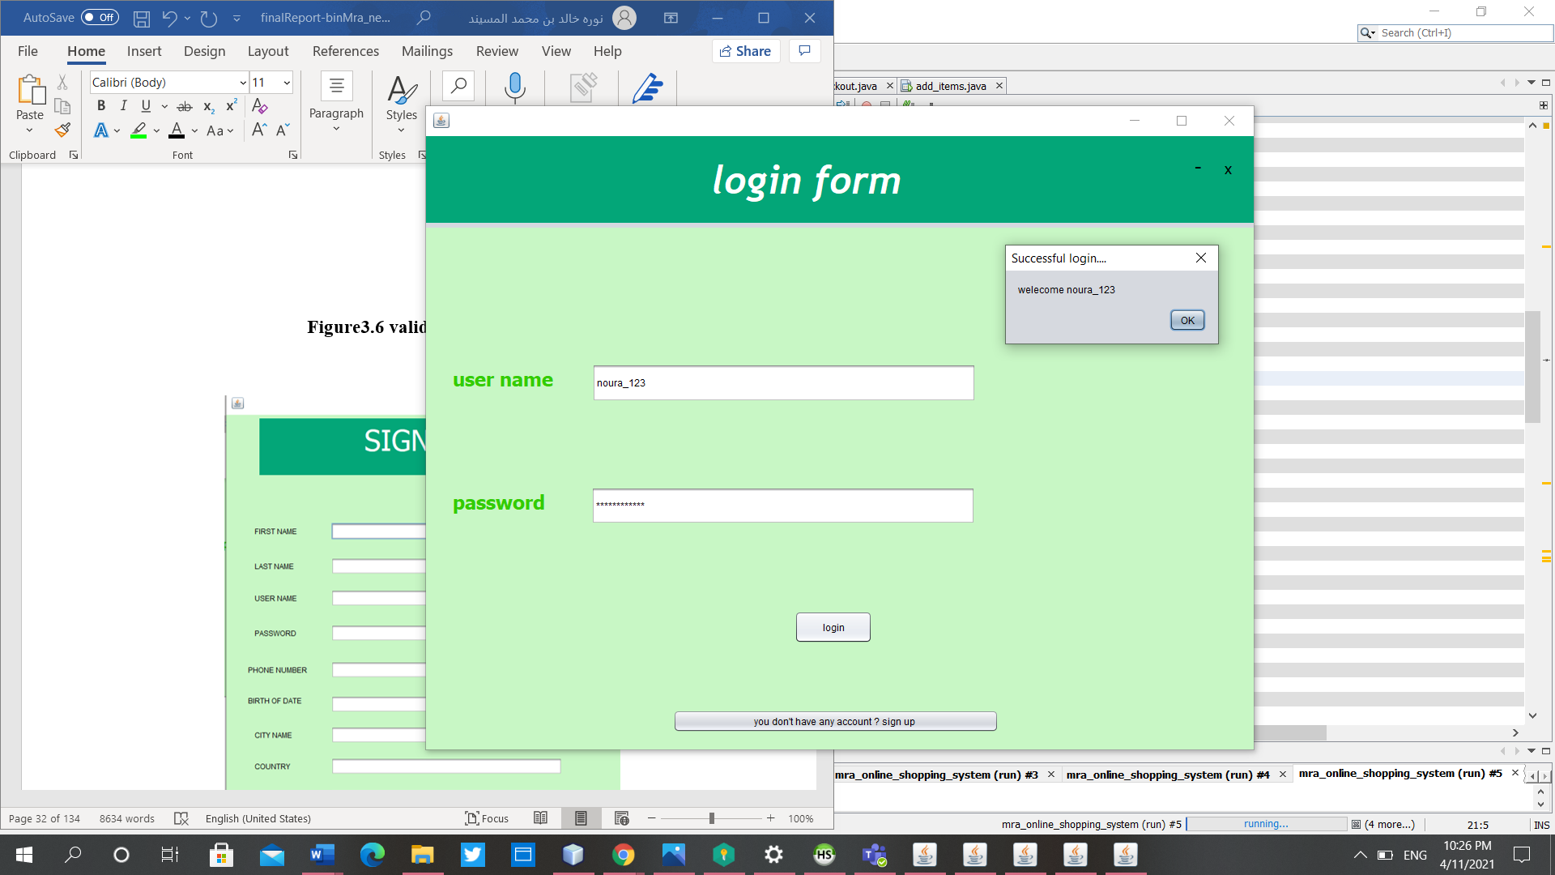

**Figure3.7 valid login page**

**if user enters username and password the system will generate successful message welcome “username”.** **Also, we have special case if the user enters 'Admin' as a username and '123' as a password the system will know this user is admin and we have just one admin in our system.**

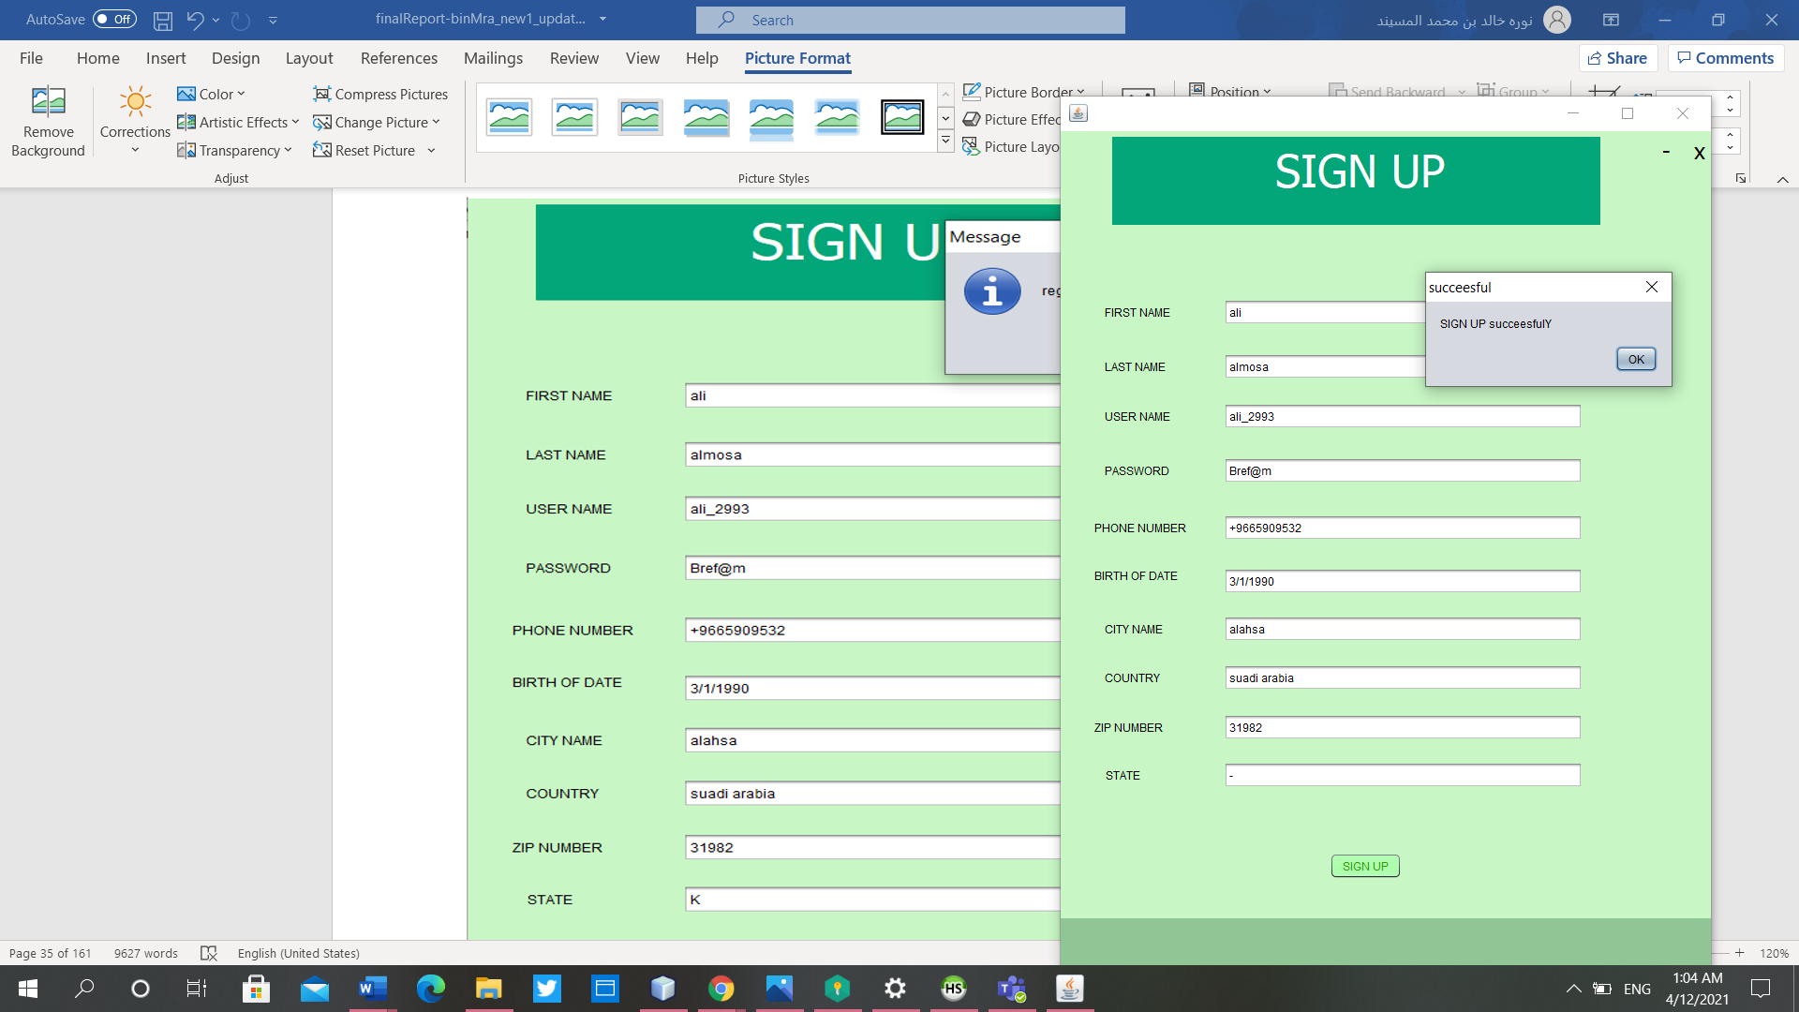

**Figure 3.8 valid sign up**

**Sign up: if the user enters the username, password, first name, last name, zip number and phone number the system will generate a message ' sign up successfully'.**

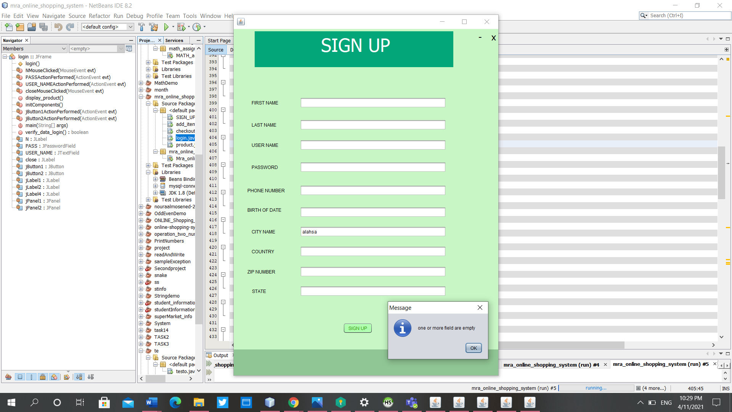

3.9Invalid sign up page

**Sign up: if the user misses to enter the username, password, first name, last name, zip number or phone number the system will generate an error message ' one or more field are empty'.**

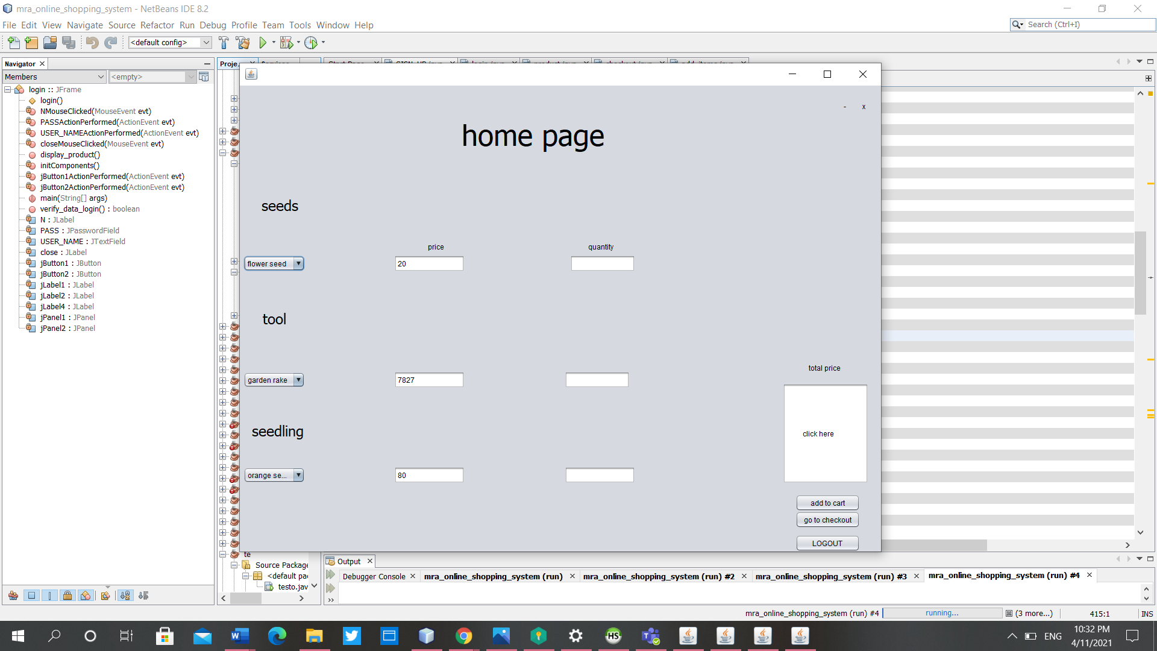

**Figure 3.10 home page**

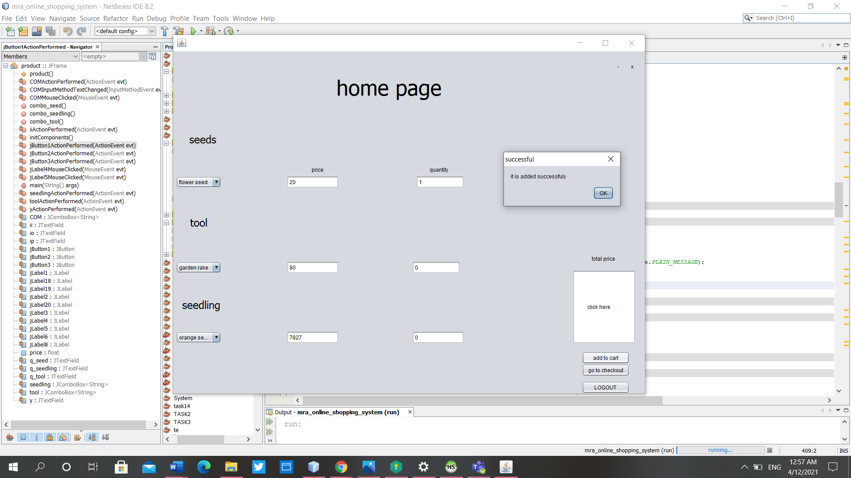

**Figure 3.11 adding to shopping cart**

**Home page. the user can select the products and enter the quantity for each products and click add to cart**

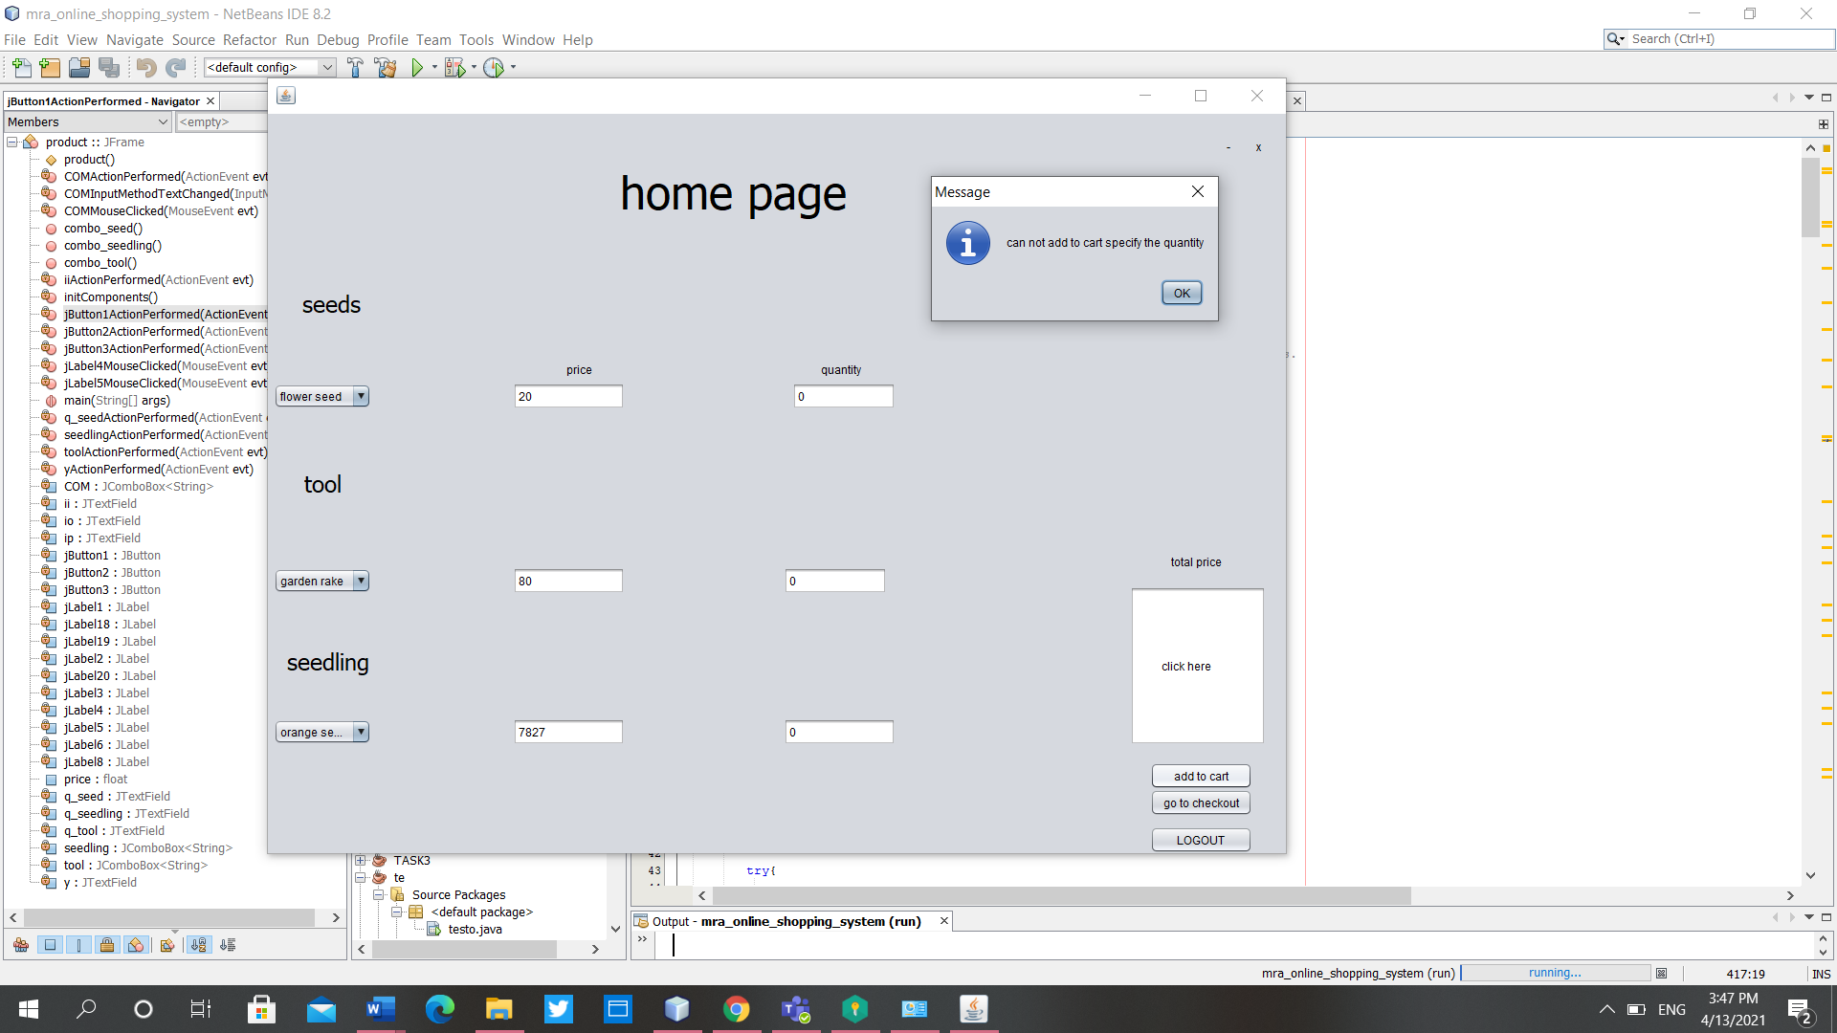

**3.12Invalid adding to cart**

**If the user doesn’t determine the quantity for the product it will be never adding to cart.**

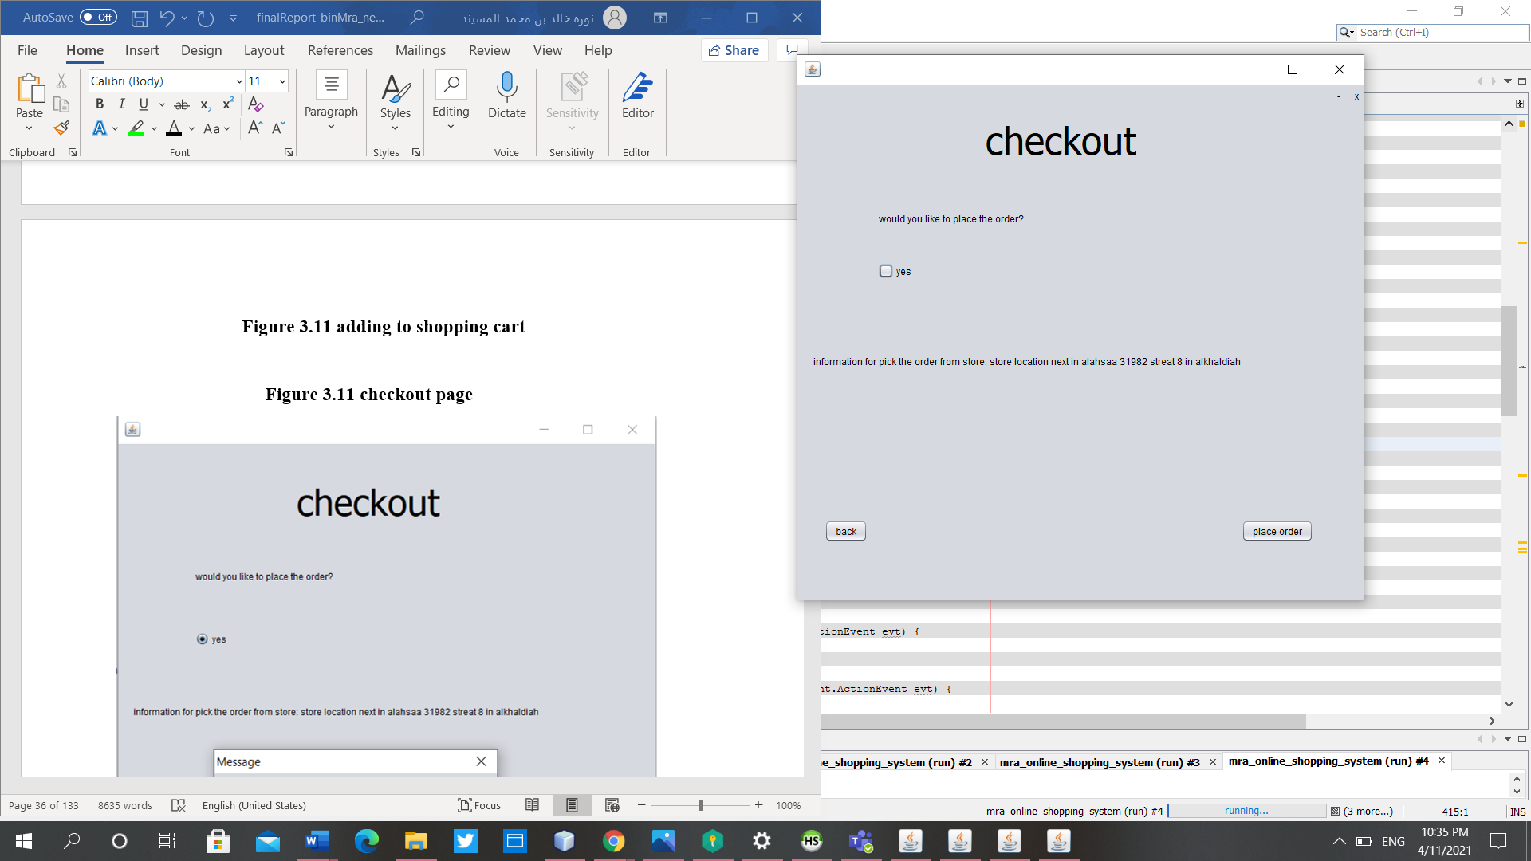

**Figure 3.13 checkout page**

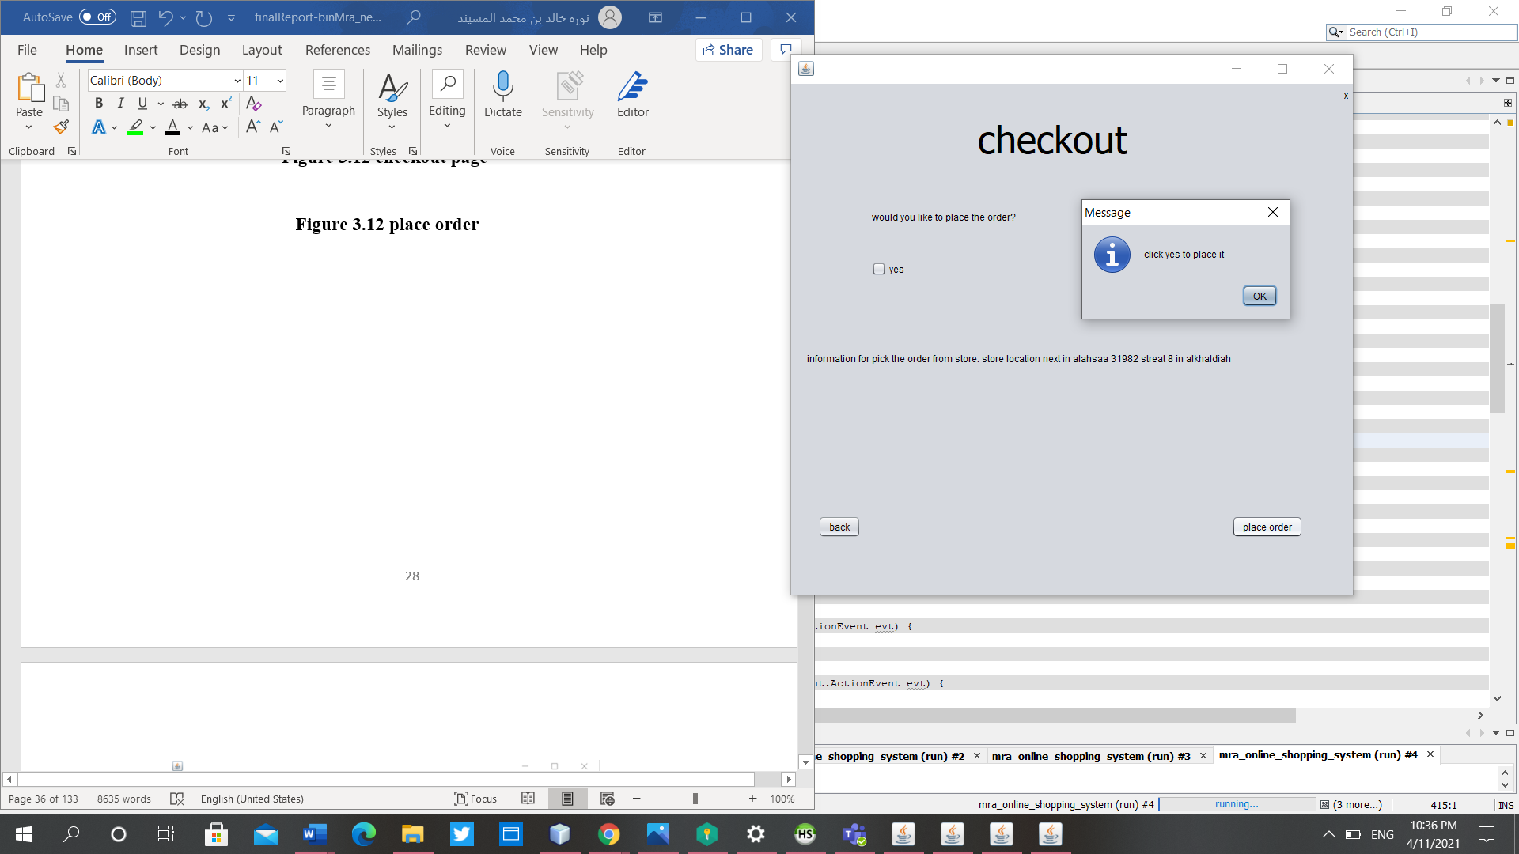

**Figure 3.14 invalid place order**

**Checkout: if the user don't click yes on pledge, the user cannot place the order and the system will generate an error message.**

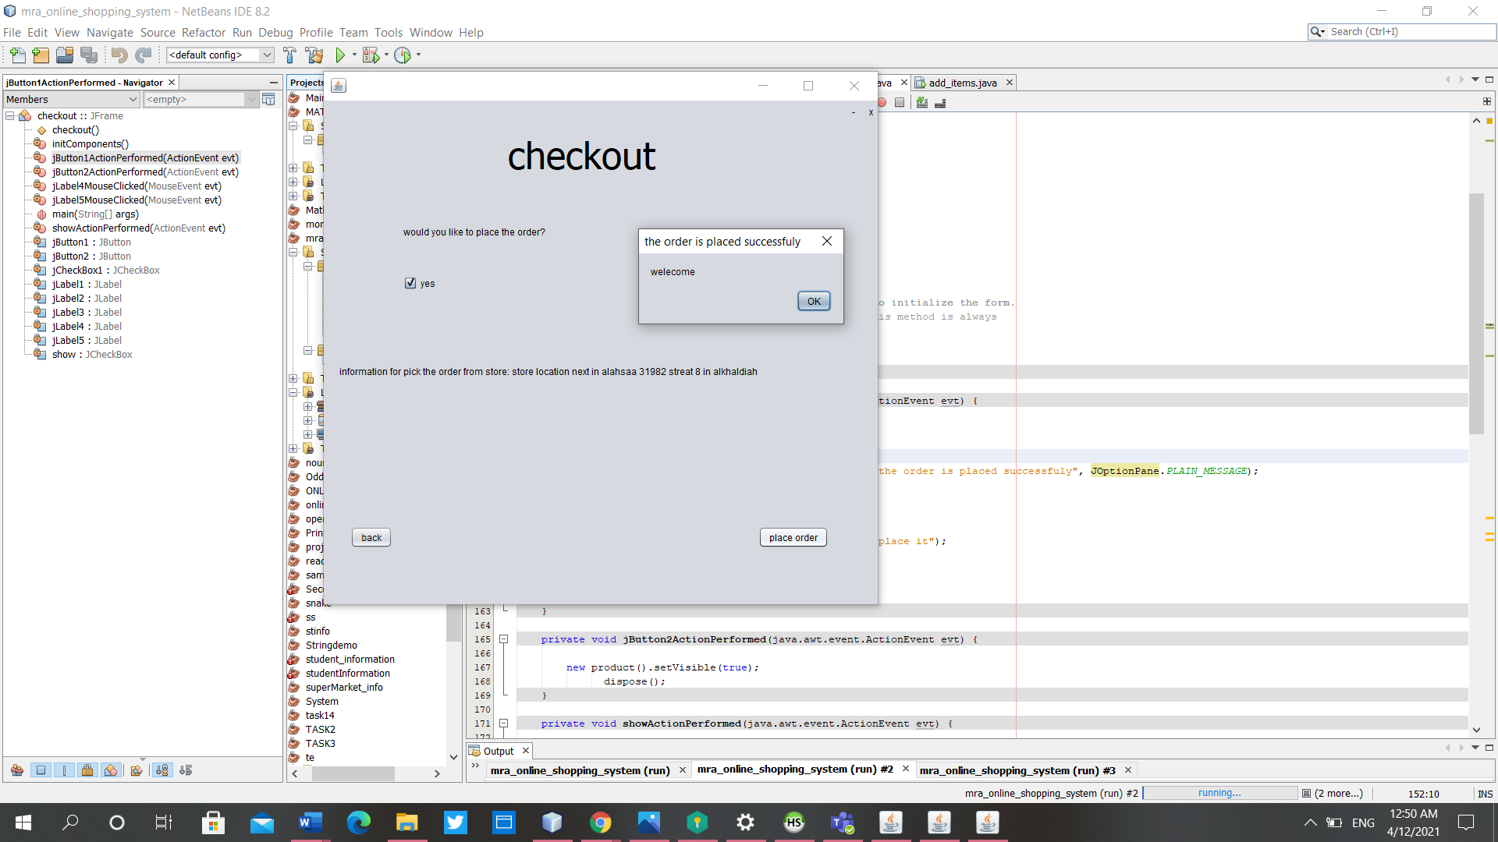

**Figure 3.15 valid place order**

**Checkout: if the user clicks yes on pledge, the user can place the order and the system will generate an successful message.**

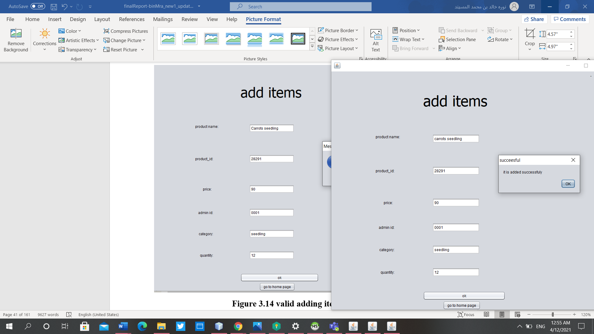

**Figure 3.16 valid adding item**

**Only the admin can manage the product. the admin enter the data on the filed that it must be not empty the system will generate the successful massage.**

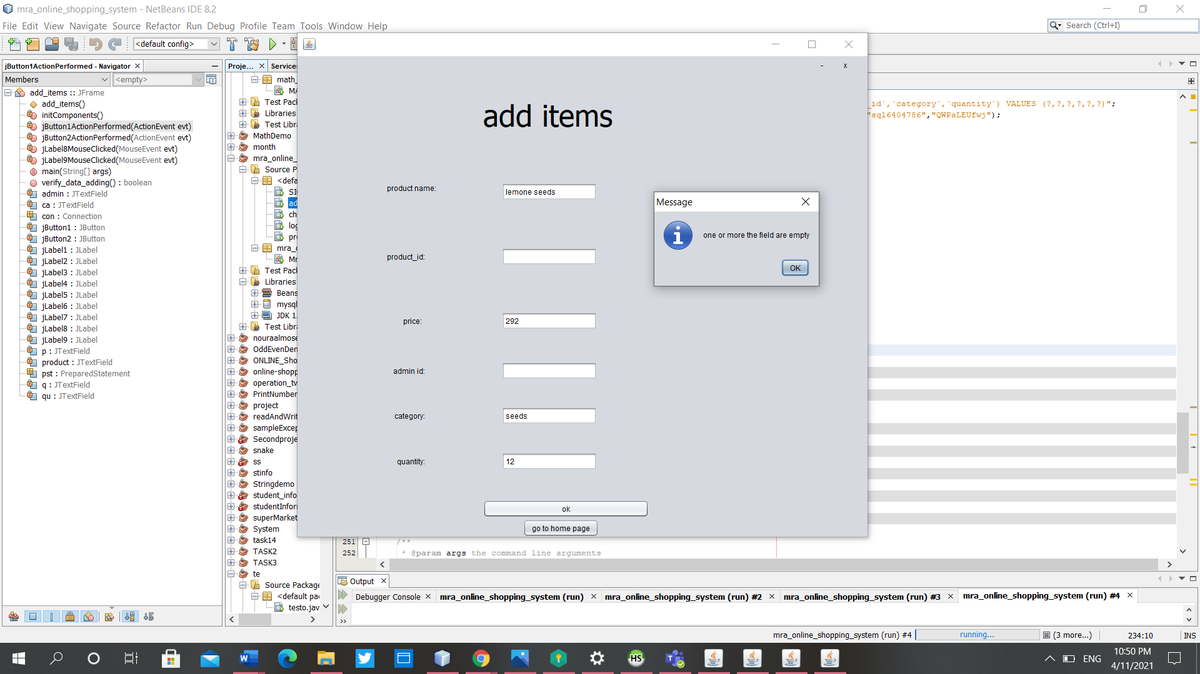

**Figure 3.17 Invalid adding item**

**Only the admin can manage the product. the admin does not enter the data on the filed that it must be not empty like admin id ,category and product id the system will generate the error massage.**

**White box testing (Coding concepts – Back end)**

-database(user data table)

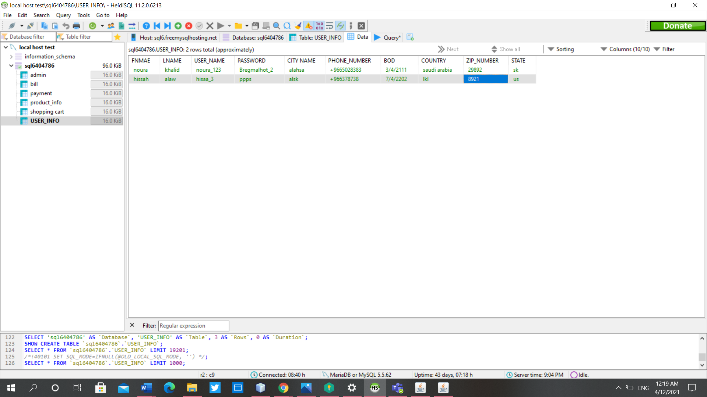

**Figure 3.18 database user information table**

**-sign up**

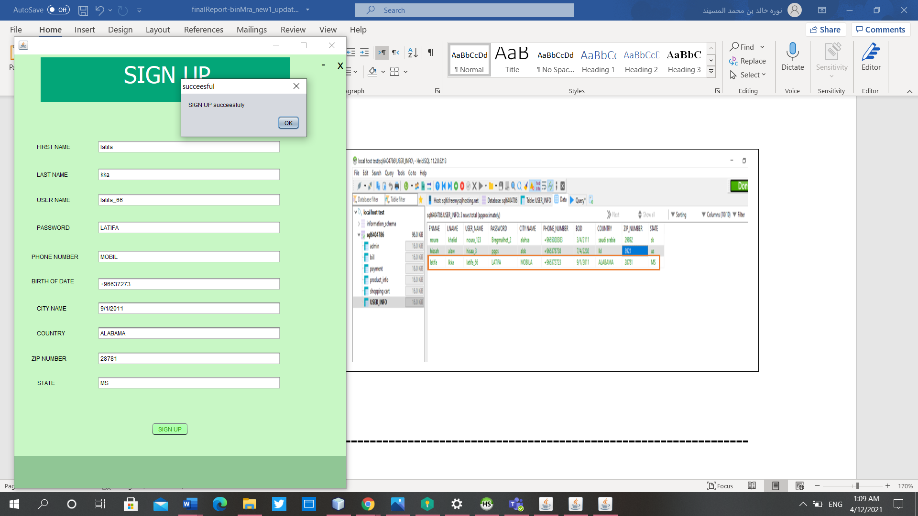

**Figure 3.19 insert a row in a table**

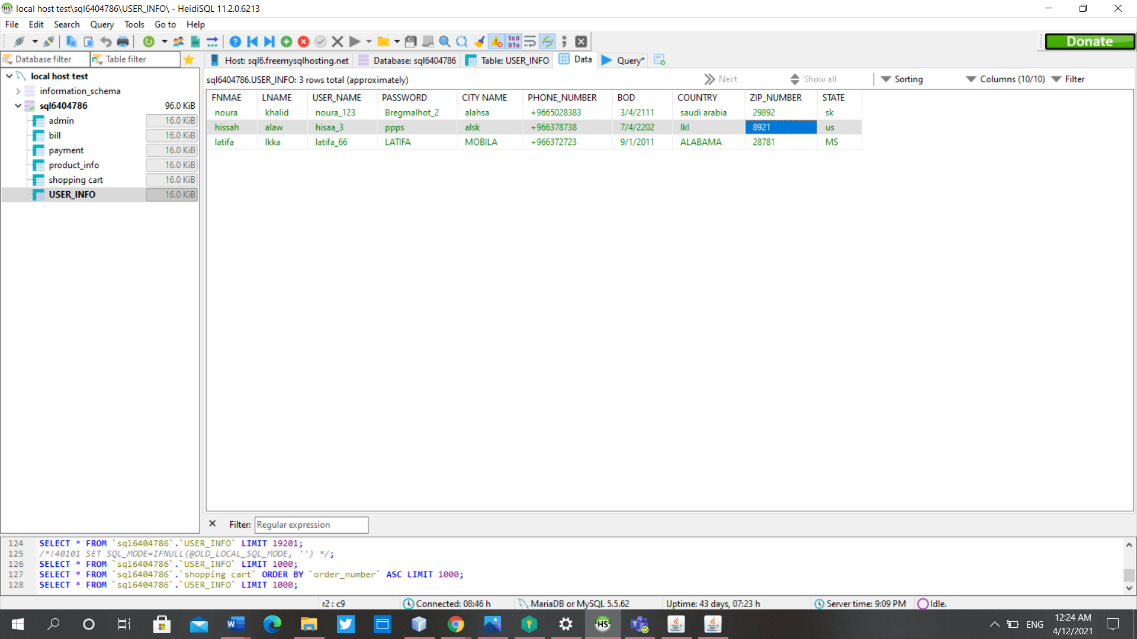

IN CODE:

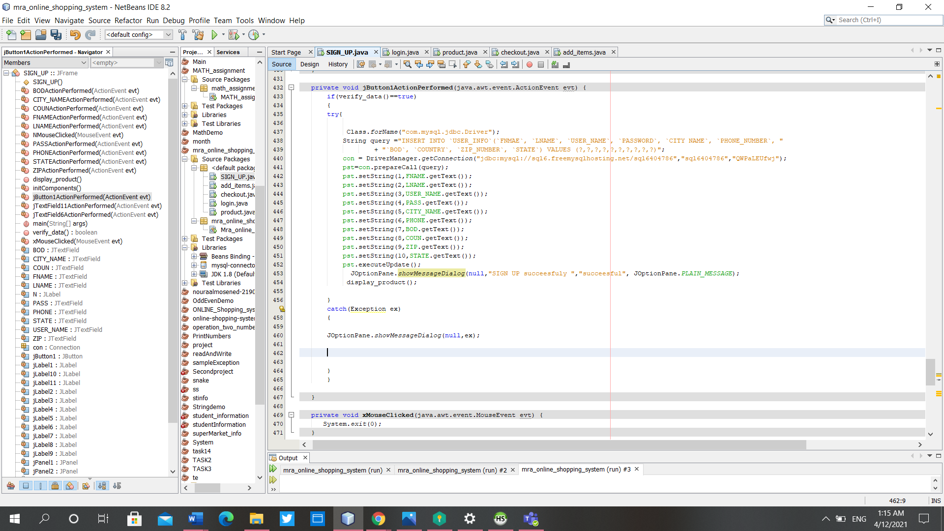

**Figure 3.20 code for insert a code.**

**product table:**

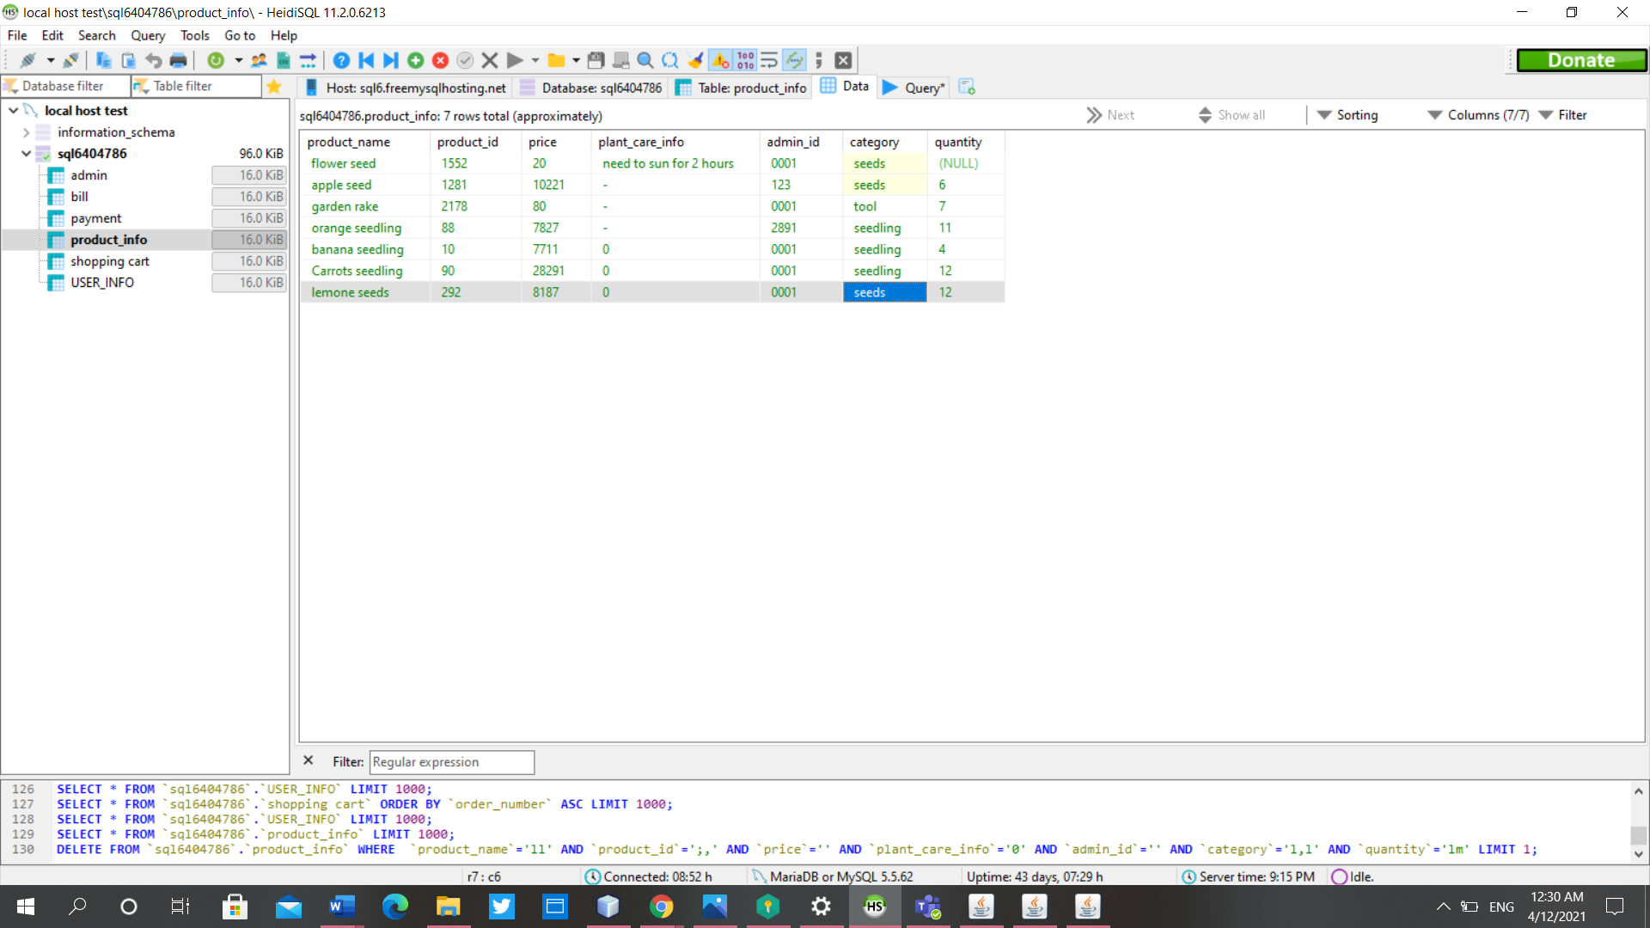

**Figure 3.21 product information table**

**Figure 3.22 insert a row in the table**

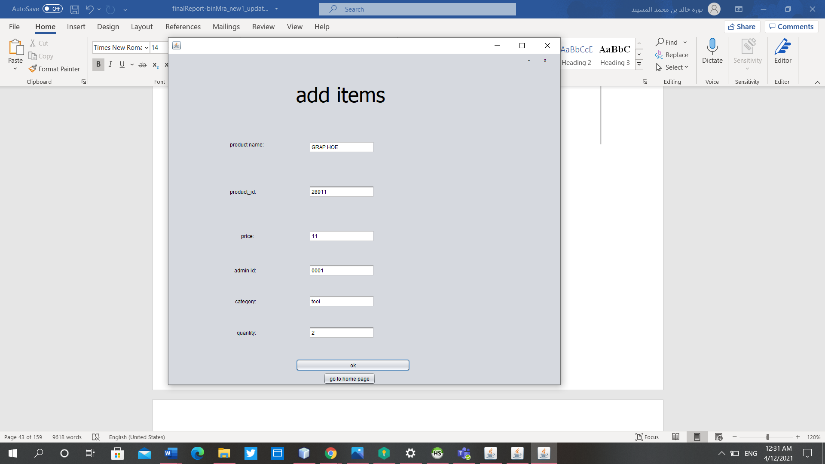 **image (1)**

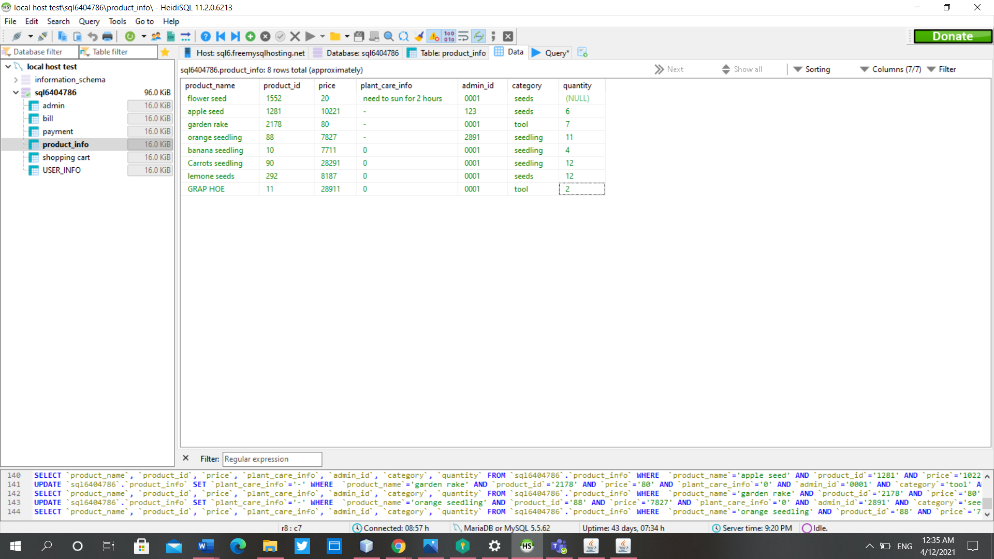

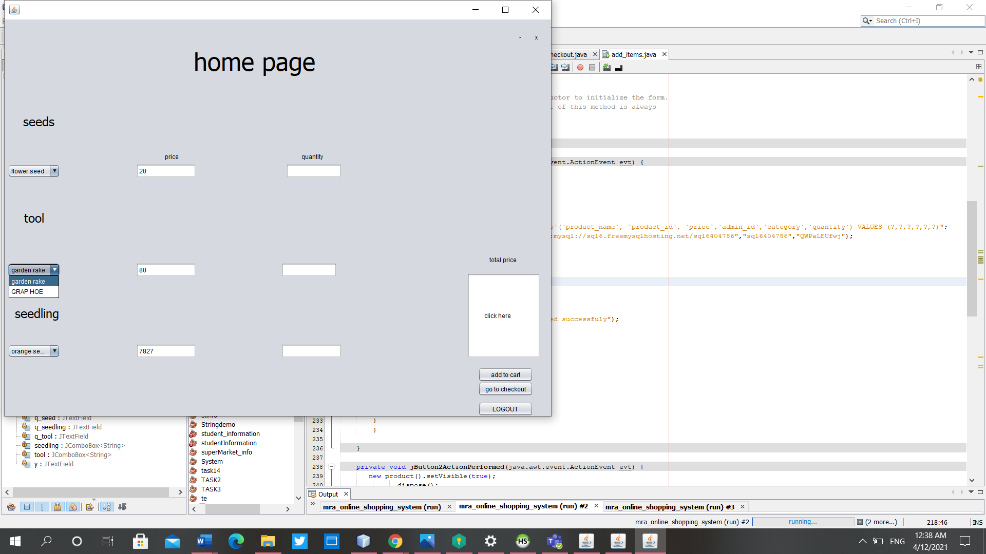

**image(2)**

**Remove a row**

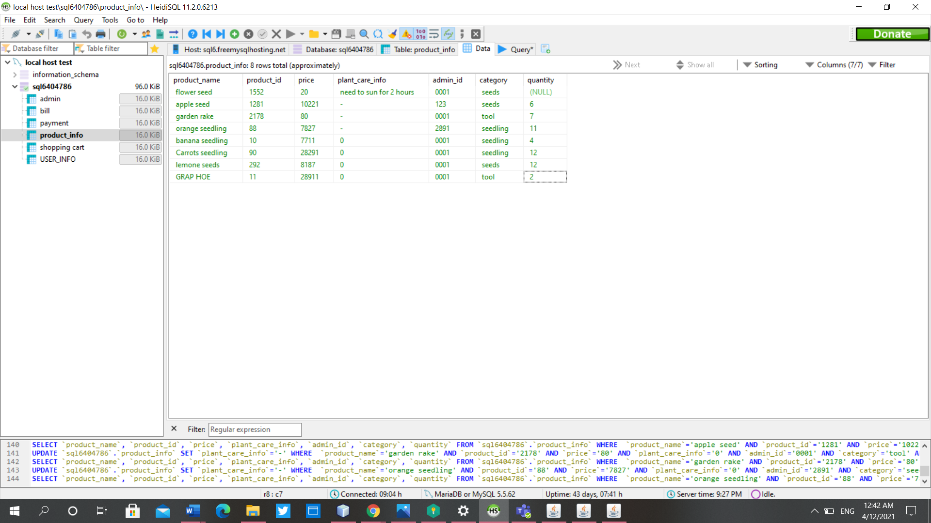

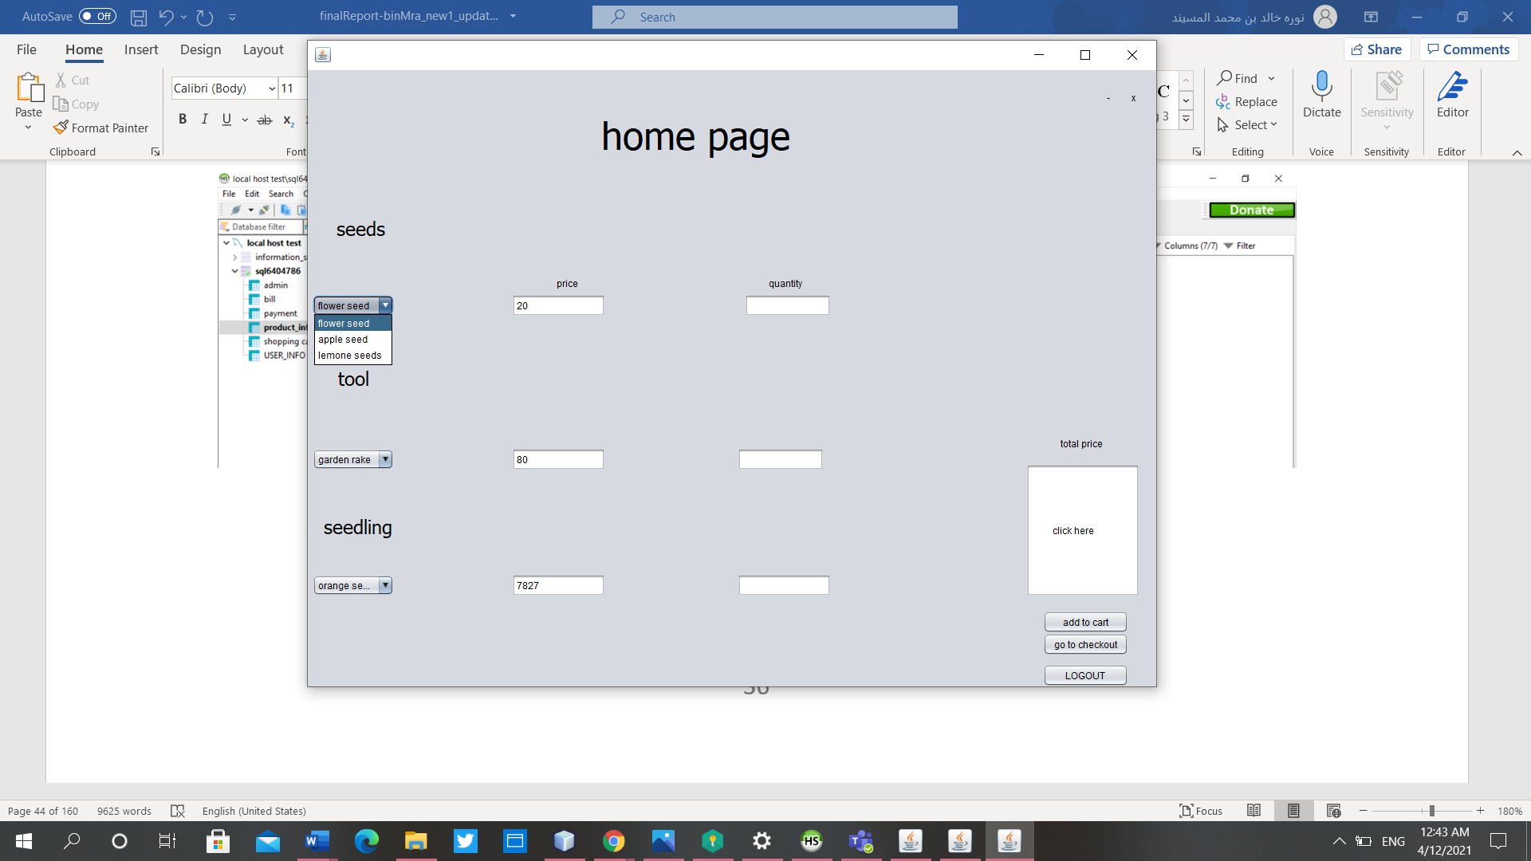

**After removing**

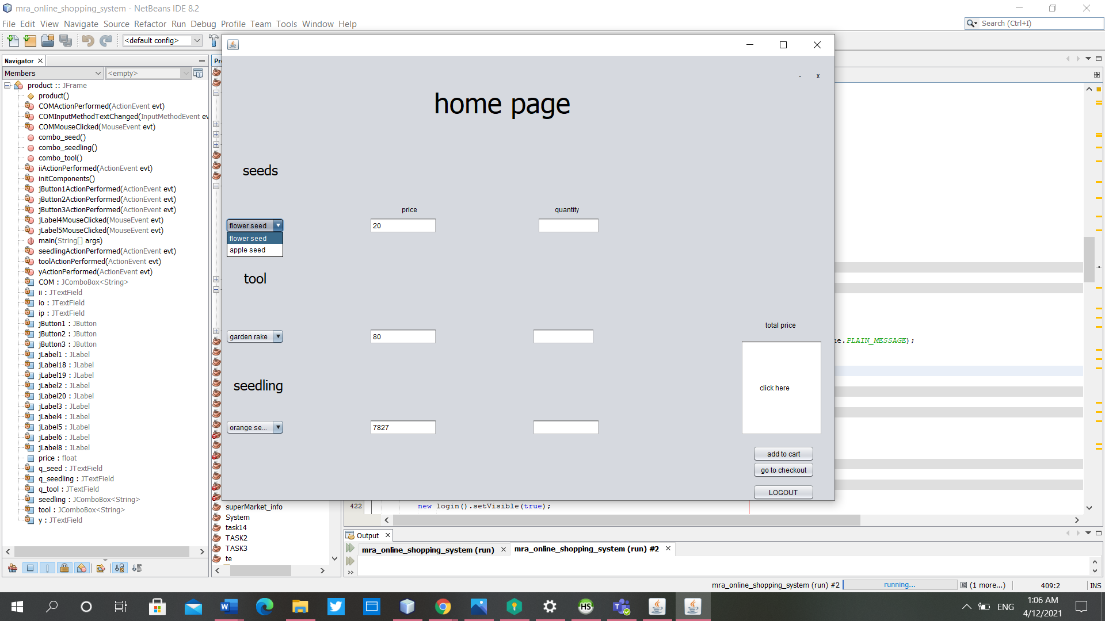

**Section 4: Testing Cases**

|  |  |
| --- | --- |
| **Table 1** Test Case # 1 | |
| **Project Name:** Online Designing and Shopping | |
| **Test Case ID:** Login 1-1 | **Test Designed by:** All the member of the project |
| **Test Priority:** High | **Test Designed date:** |
| **Module Name:** Login Screen | **Test Executed by:** All the member of the project |
| **Test Title:** Verify login with valid username and password | **Test Execution date:** |
| **Description:** Test the login page | |
| **Pre-conditions:** User has valid username and password | |
| **Dependencies:**   |  |  |  |  |  |  |  | | --- | --- | --- | --- | --- | --- | --- | | **Step** | **Test Steps** | **Test Data** | **Expected**  **Result** | **Actual**  **Result** | **Status (Pass/Fail)** | | | 1 | Navigate to login page |  |  |  |  | | | 2 | Provide valid username | noura_123 | Login successfully |  |  | | | 3 | Provide valid password | Bregmalhot_2 |  |  |  | | | 4 | Click on login button |  | User should be able to login | User is navigated to home page | Pass | | | **Post-conditions:** User is validated with database and successfully login to account. The account session details are logged in database. | | | | | | | |

|  |  |
| --- | --- |
| **Table 2** Test Case # 2 | |
| **Project Name:** Online Designing and Shopping | |
| **Test Case ID:** Login1-2 | **Test Designed by:** All the member of the project |
| **Test Priority:** High | **Test Designed date:** |
| **Module Name:** Login Screen | **Test Executed by:** All the member of the project |
| **Test Title:** Verify login with valid username and password | **Test Execution date:** |
| **Description:** Test the login page | |
| **Pre-conditions:** User has valid username and password | |
| **Dependencies:**   |  |  |  |  |  |  |  | | --- | --- | --- | --- | --- | --- | --- | | **Step** | **Test Steps** | **Test Data** | **Expected**  **Result** | **Actual**  **Result** | **Status (Pass/Fail)** | | | 1 | Navigate to login page |  |  |  |  | | | 2 | Provide valid username | mohammed |  |  |  | | | 3 | Provide valid password | 78331 |  |  |  | | | 4 | Click on login button |  | Not login | Display massage "invalid username or password" | Fail | | | Post-conditions: User is validated with database and unable login to account. The account session are not logged in database. | | | | | | | |

|  |  |
| --- | --- |
| **Table 3** Test Case # 3 | |
| **Project Name:** Online Designing and Shopping | |
| **Test Case ID:** Login1-3 | **Test Designed by:** All the member of the project |
| **Test Priority:** High | **Test Designed date:** |
| **Module Name:** Login Screen | **Test Executed by:** All the member of the project |
| **Test Title:** Verify login with valid username and password for admin | **Test Execution date:** |
| **Description:** Test the login page | |
| **Pre-conditions:** Admin has valid username and password | |
| **Dependencies:**   |  |  |  |  |  |  |  | | --- | --- | --- | --- | --- | --- | --- | | **Step** | **Test Steps** | **Test Data** | **Expected**  **Result** | **Actual**  **Result** | **Status (Pass/Fail)** | | | 1 | Navigate to login page |  |  |  |  | | | 2 | Provide valid username | admin |  |  |  | | | 3 | Provide valid password | 123 |  |  |  | | | 4 | Click on login button |  | Admin should be able to login | Admin is navigated to add item page | Pass | | | Post-conditions: Admin is validated with database and successfully login to account. The account session details are logged in database. | | | | | | | |

|  |  |
| --- | --- |
| **Table 4** Test Case # 4 | |
| **Project Name:** Online Designing and Shopping | |
| **Test Case ID:** Sign up 2-1 | **Test Designed by:** All the member of the project |
| **Test Priority:** High | **Test Designed date:** |
| **Module Name:** Sign up Screen | **Test Executed by:** All the member of the project |
| **Test Title:** Verify sign up with first name, last name, username, password, phone number, birth of date, city name, country, zip number, and state. | **Test Execution date:** |
| **Description:** Test the sign up page | |
| **Pre-conditions:** User not has account in database means username not duplicated | |
| **Dependencies:**   |  |  |  |  |  |  |  | | --- | --- | --- | --- | --- | --- | --- | | **Step** | **Test Steps** | **Test Data** | **Expected**  **Result** | **Actual**  **Result** | **Status (Pass/Fail)** | | | 1 | Navigate to sign up page |  |  |  |  | | | 2 | Provide first name | ali |  |  |  | | | 3 | Provide last name | almosa |  |  |  | | | 4 | Provide username | ali_2993 |  |  |  | | | 5 | Provide password | Bref@m |  |  |  | | | 6 | Provide phone number | +9665909532 |  |  |  | | | 7 | Provide birth of date | 3/1/1990 |  |  |  | | | 8 | Provide city name | alahsa |  |  |  | | | 9 | Provide country | suadi arabia |  |  |  | | | 10 | Provide zip number | 31982 |  |  |  | | | 11 | Provide state | K |  |  |  | | | 12 | Click on sign up button |  | User should have a new account in this website | User is registered successfully then navigate to home page | Pass | | | **Post-conditions:** Account information is recorded in the database. | | | | | | | |

|  |  |
| --- | --- |
| **Table 5** Test Case # 5 | |
| **Project Name:** Online Designing and Shopping | |
| **Test Case ID:** Add to cart 3-1 | **Test Designed by:** All the member of the project |
| **Test Priority:** High | **Test Designed date:** |
| **Module Name:** Add to cart | **Test Executed by:** All the member of the project |
| **Test Title:** Verify adding to cart | **Test Execution date:** |
| **Description:** Test the button (add to cart) | |
| **Pre-conditions:** User most login to add an item to cart | |
| **Dependencies:**   |  |  |  |  |  |  |  | | --- | --- | --- | --- | --- | --- | --- | | **Step** | **Test Steps** | **Test Data** | **Expected**  **Result** | **Actual**  **Result** | **Status (Pass/Fail)** | | | 1 | Start with home page |  |  |  |  | | | 2 | Select the item by add the number of item he want | 1 |  |  |  | | | 3 | Click on add to cart button |  | Add item to cart | Display massage "it is added to cart successfully" | Pass | | | **Post-conditions:** Record the order detailsin the database as incomplete. | | | | | | | |

|  |  |
| --- | --- |
| **Table 6** Test Case # 6 | |
| **Project Name:** Online Designing and Shopping | |
| **Test Case ID:** Checkout 4-1 | **Test Designed by:** All the member of the project |
| **Test Priority:** High | **Test Designed date:** |
| **Module Name:** CheckoutScreen | **Test Executed by:** All the member of the project |
| **Test Title:** Verify checkout | **Test Execution date:** |
| **Description:** test checkout page | |
| **Pre-conditions:** User most login to add an item to cart | |
| **Dependencies:**   |  |  |  |  |  |  |  | | --- | --- | --- | --- | --- | --- | --- | | **Step** | **Test Steps** | **Test Data** | **Expected**  **Result** | **Actual**  **Result** | **Status (Pass/Fail)** | | | 1 | Start with home page |  |  |  |  | | | 2 | Click on Checkout button |  | Move to checkout page | Opened checkout page | Pass | | | 3 | Would you like to place the order? | yes |  |  |  | | | 4 | Click on place order button |  | Place order successfully | Display massage "your order is placed thank you for using out website" | Pass | | | **Post-conditions:** Record the order detailsin the database as complete. | | | | | | | |

|  |  |
| --- | --- |
| **Table 7** Test Case # 7 | |
| **Project Name:** Online Designing and Shopping | |
| **Test Case ID:** Add item 5-1 | **Test Designed by:** All the member of the project |
| **Test Priority:** High | **Test Designed date:** |
| **Module Name:** Add item to system | **Test Executed by:** All the member of the project |
| **Test Title:** Verify add item to system | **Test Execution date:** |
| **Description:** Test add item page | |
| **Pre-conditions:** Admin most login to add an item | |
| **Dependencies:**   |  |  |  |  |  |  |  | | --- | --- | --- | --- | --- | --- | --- | | **Step** | **Test Steps** | **Test Data** | **Expected**  **Result** | **Actual**  **Result** | **Status (Pass/Fail)** | | | 1 | Start with add item page |  |  |  |  | | | 2 | Provide product name | Carrot seedling |  |  |  | | | 3 | Provide quantity | 12 |  |  |  | | | 4 | Provide price | 90 |  |  |  | | | 5 | Product id | 28291 |  |  |  | | |  | Admin id | 0001 |  |  |  | | |  | category | seedling |  |  |  | | | 6 | Click on ok button |  | Added the item successfully to the system | Display massage "added successfully" | Pass | | | **Post-conditions:** Record the item detailsin the database and added it to the system. | | | | | | | |

## **References**

[1] IEEE Software Requirements Specification Template.

[2] Pick the website template you love. (n.d.). Retrieved November 04, 2017, from https://www.wix.com/website/templates/html/most-popular/1

Appendix A: Glossary

|  |  |
| --- | --- |
| **Term** | **Definition** |
| bin mra shop | It is the name of the shop that we build the system for. |
| SRS | Software Requirement*s* Specification. |
| SDS | System Design Specification. |
| User | Someone who interacts with the system. |
| Admin/Administrator | Someone who managing and controlling the system. |
| Software Quality Attributes | The features that make the program high quality and efficiency to achieve the best possible capabilities. |
| Database | A set of data that is stored in the system |
| User Interfaces | The interfaces or pages that are used by users and appear to them when using the system, and interact with them smoothly. |
| Owners | They are the owners of the system and those responsible for it. |
| Customers | They are the stakeholders who can browse the program, add the products they want in the shopping cart, and specify the quantity of products required and purchased. |
| Requirement | It is an expression of what the customer is asking for, meeting his needs, and aimins it. |
| Netbeans | It is a program and an integrated development environment that uses the Java language. |

Appendix B: Source Code

Login page

import javax.swing.JOptionPane;

/*

* To change this license header, choose License Headers in Project Properties.

* To change this template file, choose Tools | Templates

* and open the template in the editor.

*/

/**

*

* @author msi9

*/

import java.sql.*;

import javax.swing.JFrame;

import javax.swing.JOptionPane;

public class login extends javax.swing.JFrame {

/**

* Creates new form login

*/

public login() {

initComponents();

this.setLocationRelativeTo(null);

}

public void display_product()

{

new product().setVisible(true);

dispose();

}

public boolean verify_data_login()

{

if((USER_NAME.getText().equals(""))&&(String.valueOf(PASS.getPassword()).equals("")))

{

JOptionPane.showMessageDialog(null,"one or more field are empty");

return false;

}

else

{

return true;

}

}

/**

* This method is called from within the constructor to initialize the form.

* WARNING: Do NOT modify this code. The content of this method is always

* regenerated by the Form Editor.

*/

@SuppressWarnings("unchecked")

// <editor-fold defaultstate="collapsed" desc="Generated Code">

private void initComponents() {

jPanel1 = new javax.swing.JPanel();

jLabel4 = new javax.swing.JLabel();

close = new javax.swing.JLabel();

N = new javax.swing.JLabel();

jPanel2 = new javax.swing.JPanel();

jLabel1 = new javax.swing.JLabel();

USER_NAME = new javax.swing.JTextField();

jLabel2 = new javax.swing.JLabel();

jButton1 = new javax.swing.JButton();

jButton2 = new javax.swing.JButton();

PASS = new javax.swing.JPasswordField();

setDefaultCloseOperation(javax.swing.WindowConstants.EXIT_ON_CLOSE);

jPanel1.setBackground(new java.awt.Color(3, 166, 120));

jLabel4.setFont(new java.awt.Font("Trebuchet MS", 3, 48)); // NOI18N

jLabel4.setForeground(new java.awt.Color(255, 255, 255));

jLabel4.setText("login form");

close.setFont(new java.awt.Font("Tahoma", 0, 18)); // NOI18N

close.setText("x");

close.addMouseListener(new java.awt.event.MouseAdapter() {

public void mouseClicked(java.awt.event.MouseEvent evt) {

closeMouseClicked(evt);

}

});

N.setFont(new java.awt.Font("Tahoma", 0, 24)); // NOI18N

N.setText("-");

N.addMouseListener(new java.awt.event.MouseAdapter() {

public void mouseClicked(java.awt.event.MouseEvent evt) {

NMouseClicked(evt);

}

});

javax.swing.GroupLayout jPanel1Layout = new javax.swing.GroupLayout(jPanel1);

jPanel1.setLayout(jPanel1Layout);

jPanel1Layout.setHorizontalGroup(

jPanel1Layout.createParallelGroup(javax.swing.GroupLayout.Alignment.LEADING)

.addGroup(jPanel1Layout.createSequentialGroup()

.addGap(353, 353, 353)

.addComponent(jLabel4)

.addPreferredGap(javax.swing.LayoutStyle.ComponentPlacement.RELATED, javax.swing.GroupLayout.DEFAULT_SIZE, Short.MAX_VALUE)

.addComponent(N, javax.swing.GroupLayout.PREFERRED_SIZE, 25, javax.swing.GroupLayout.PREFERRED_SIZE)

.addPreferredGap(javax.swing.LayoutStyle.ComponentPlacement.UNRELATED)

.addComponent(close, javax.swing.GroupLayout.PREFERRED_SIZE, 30, javax.swing.GroupLayout.PREFERRED_SIZE)

.addContainerGap())

);

jPanel1Layout.setVerticalGroup(

jPanel1Layout.createParallelGroup(javax.swing.GroupLayout.Alignment.LEADING)

.addGroup(jPanel1Layout.createSequentialGroup()

.addGroup(jPanel1Layout.createParallelGroup(javax.swing.GroupLayout.Alignment.LEADING)

.addGroup(jPanel1Layout.createSequentialGroup()

.addGap(20, 20, 20)

.addGroup(jPanel1Layout.createParallelGroup(javax.swing.GroupLayout.Alignment.BASELINE)

.addComponent(close, javax.swing.GroupLayout.PREFERRED_SIZE, 41, javax.swing.GroupLayout.PREFERRED_SIZE)

.addComponent(N)))

.addGroup(jPanel1Layout.createSequentialGroup()

.addGap(25, 25, 25)

.addComponent(jLabel4)))

.addContainerGap(25, Short.MAX_VALUE))

);

jPanel2.setBackground(new java.awt.Color(200, 247, 197));

jLabel1.setFont(new java.awt.Font("Tahoma", 1, 24)); // NOI18N

jLabel1.setForeground(new java.awt.Color(51, 204, 0));

jLabel1.setText("user name");

USER_NAME.addActionListener(new java.awt.event.ActionListener() {

public void actionPerformed(java.awt.event.ActionEvent evt) {

USER_NAMEActionPerformed(evt);

}

});

jLabel2.setFont(new java.awt.Font("Tahoma", 1, 24)); // NOI18N

jLabel2.setForeground(new java.awt.Color(51, 204, 0));

jLabel2.setText("password");

jButton1.setText("login");

jButton1.addActionListener(new java.awt.event.ActionListener() {

public void actionPerformed(java.awt.event.ActionEvent evt) {

jButton1ActionPerformed(evt);

}

});

jButton2.setText("you don't have any account ? sign up ");

jButton2.addActionListener(new java.awt.event.ActionListener() {

public void actionPerformed(java.awt.event.ActionEvent evt) {

jButton2ActionPerformed(evt);

}

});

PASS.addActionListener(new java.awt.event.ActionListener() {

public void actionPerformed(java.awt.event.ActionEvent evt) {

PASSActionPerformed(evt);

}

});

javax.swing.GroupLayout jPanel2Layout = new javax.swing.GroupLayout(jPanel2);

jPanel2.setLayout(jPanel2Layout);

jPanel2Layout.setHorizontalGroup(

jPanel2Layout.createParallelGroup(javax.swing.GroupLayout.Alignment.LEADING)

.addGroup(jPanel2Layout.createSequentialGroup()

.addGroup(jPanel2Layout.createParallelGroup(javax.swing.GroupLayout.Alignment.LEADING)

.addGroup(jPanel2Layout.createSequentialGroup()

.addGap(33, 33, 33)

.addGroup(jPanel2Layout.createParallelGroup(javax.swing.GroupLayout.Alignment.LEADING)

.addGroup(jPanel2Layout.createSequentialGroup()

.addComponent(jLabel1, javax.swing.GroupLayout.PREFERRED_SIZE, 166, javax.swing.GroupLayout.PREFERRED_SIZE)

.addPreferredGap(javax.swing.LayoutStyle.ComponentPlacement.RELATED)

.addComponent(USER_NAME, javax.swing.GroupLayout.PREFERRED_SIZE, 474, javax.swing.GroupLayout.PREFERRED_SIZE))

.addGroup(jPanel2Layout.createSequentialGroup()

.addComponent(jLabel2)

.addGap(57, 57, 57)

.addComponent(PASS, javax.swing.GroupLayout.PREFERRED_SIZE, 474, javax.swing.GroupLayout.PREFERRED_SIZE))))

.addGroup(jPanel2Layout.createSequentialGroup()

.addGap(455, 455, 455)

.addComponent(jButton1, javax.swing.GroupLayout.PREFERRED_SIZE, 96, javax.swing.GroupLayout.PREFERRED_SIZE))

.addGroup(jPanel2Layout.createSequentialGroup()

.addGap(305, 305, 305)

.addComponent(jButton2, javax.swing.GroupLayout.PREFERRED_SIZE, 402, javax.swing.GroupLayout.PREFERRED_SIZE)))

.addContainerGap(315, Short.MAX_VALUE))

);

jPanel2Layout.setVerticalGroup(

jPanel2Layout.createParallelGroup(javax.swing.GroupLayout.Alignment.LEADING)

.addGroup(jPanel2Layout.createSequentialGroup()

.addGap(160, 160, 160)

.addGroup(jPanel2Layout.createParallelGroup(javax.swing.GroupLayout.Alignment.BASELINE)

.addComponent(jLabel1, javax.swing.GroupLayout.PREFERRED_SIZE, 53, javax.swing.GroupLayout.PREFERRED_SIZE)

.addComponent(USER_NAME, javax.swing.GroupLayout.PREFERRED_SIZE, 47, javax.swing.GroupLayout.PREFERRED_SIZE))

.addGap(105, 105, 105)

.addGroup(jPanel2Layout.createParallelGroup(javax.swing.GroupLayout.Alignment.BASELINE)

.addComponent(jLabel2)

.addComponent(PASS, javax.swing.GroupLayout.PREFERRED_SIZE, 46, javax.swing.GroupLayout.PREFERRED_SIZE))

.addPreferredGap(javax.swing.LayoutStyle.ComponentPlacement.RELATED, 107, Short.MAX_VALUE)

.addComponent(jButton1, javax.swing.GroupLayout.PREFERRED_SIZE, 40, javax.swing.GroupLayout.PREFERRED_SIZE)

.addGap(82, 82, 82)

.addComponent(jButton2)

.addGap(21, 21, 21))

);

javax.swing.GroupLayout layout = new javax.swing.GroupLayout(getContentPane());

getContentPane().setLayout(layout);

layout.setHorizontalGroup(

layout.createParallelGroup(javax.swing.GroupLayout.Alignment.LEADING)

.addComponent(jPanel1, javax.swing.GroupLayout.DEFAULT_SIZE, javax.swing.GroupLayout.DEFAULT_SIZE, Short.MAX_VALUE)

.addGroup(layout.createSequentialGroup()

.addComponent(jPanel2, javax.swing.GroupLayout.PREFERRED_SIZE, javax.swing.GroupLayout.DEFAULT_SIZE, javax.swing.GroupLayout.PREFERRED_SIZE)

.addGap(0, 0, Short.MAX_VALUE))

);

layout.setVerticalGroup(

layout.createParallelGroup(javax.swing.GroupLayout.Alignment.LEADING)

.addGroup(layout.createSequentialGroup()

.addComponent(jPanel1, javax.swing.GroupLayout.PREFERRED_SIZE, javax.swing.GroupLayout.DEFAULT_SIZE, javax.swing.GroupLayout.PREFERRED_SIZE)

.addPreferredGap(javax.swing.LayoutStyle.ComponentPlacement.RELATED)

.addComponent(jPanel2, javax.swing.GroupLayout.DEFAULT_SIZE, javax.swing.GroupLayout.DEFAULT_SIZE, Short.MAX_VALUE))

);

pack();

}// </editor-fold>

private void USER_NAMEActionPerformed(java.awt.event.ActionEvent evt) {

// TODO add your handling code here:

}

private void jButton1ActionPerformed(java.awt.event.ActionEvent evt) {

String sql = "select * from USER_INFO where USER_NAME =? and PASSWORD=?";

if(verify_data_login())

{

try{

Class.forName("com.mysql.jdbc.Driver");

Connection con = DriverManager.getConnection("jdbc:mysql://sql6.freemysqlhosting.net/sql6404786","sql6404786","QWPaLEUfwj");

PreparedStatement pst =con.prepareStatement(sql);

pst.setString(1,USER_NAME.getText( ));

pst.setString(2,PASS.getText( ));

ResultSet rs = pst.executeQuery();

if(USER_NAME.getText( ).equals("admin")&&PASS.getText( ).equals("123"))

{

JOptionPane.showMessageDialog(null,"welecome "+USER_NAME.getText( )," Successful login....", JOptionPane.PLAIN_MESSAGE);

new add_items().setVisible(true);

dispose();

}

else

{

if(rs.next())

{

JOptionPane.showMessageDialog(null,"welecome "+USER_NAME.getText( )," Successful login....", JOptionPane.PLAIN_MESSAGE);

display_product();

}

else

{

JOptionPane.showMessageDialog(null, "invalid user name or password ", " unSuccessful login....", JOptionPane.ERROR_MESSAGE);

}

}

con.close();

}catch(Exception e)

{

JOptionPane.showMessageDialog(null, e);

}

}

}

private void jButton2ActionPerformed(java.awt.event.ActionEvent evt) {

this.setLocationRelativeTo(null);

new SIGN_UP().setVisible(true);

dispose();

}

private void closeMouseClicked(java.awt.event.MouseEvent evt) {

System.exit(0);

}

private void NMouseClicked(java.awt.event.MouseEvent evt) {

this.setState(JFrame.ICONIFIED);

}

private void PASSActionPerformed(java.awt.event.ActionEvent evt) {

// TODO add your handling code here:

}

/**

* @param args the command line arguments

*/

public static void main(String args[]) {

/* Set the Nimbus look and feel */

//<editor-fold defaultstate="collapsed" desc=" Look and feel setting code (optional) ">

/* If Nimbus (introduced in Java SE 6) is not available, stay with the default look and feel.

* For details see http://download.oracle.com/javase/tutorial/uiswing/lookandfeel/plaf.html

*/

try {

for (javax.swing.UIManager.LookAndFeelInfo info : javax.swing.UIManager.getInstalledLookAndFeels()) {

if ("Nimbus".equals(info.getName())) {

javax.swing.UIManager.setLookAndFeel(info.getClassName());

break;

}

}

} catch (ClassNotFoundException ex) {

java.util.logging.Logger.getLogger(login.class.getName()).log(java.util.logging.Level.SEVERE, null, ex);

} catch (InstantiationException ex) {

java.util.logging.Logger.getLogger(login.class.getName()).log(java.util.logging.Level.SEVERE, null, ex);

} catch (IllegalAccessException ex) {

java.util.logging.Logger.getLogger(login.class.getName()).log(java.util.logging.Level.SEVERE, null, ex);

} catch (javax.swing.UnsupportedLookAndFeelException ex) {

java.util.logging.Logger.getLogger(login.class.getName()).log(java.util.logging.Level.SEVERE, null, ex);

}

//</editor-fold>

/* Create and display the form */

java.awt.EventQueue.invokeLater(new Runnable() {

public void run() {

new login().setVisible(true);

}

});

}

// Variables declaration - do not modify

private javax.swing.JLabel N;

private javax.swing.JPasswordField PASS;

private javax.swing.JTextField USER_NAME;

private javax.swing.JLabel close;

private javax.swing.JButton jButton1;

private javax.swing.JButton jButton2;

private javax.swing.JLabel jLabel1;

private javax.swing.JLabel jLabel2;

private javax.swing.JLabel jLabel4;

private javax.swing.JPanel jPanel1;

private javax.swing.JPanel jPanel2;

// End of variables declaration

}

Signup page

import java.sql.Connection;

import java.sql.DriverManager;

import java.sql.PreparedStatement;

import javax.swing.JFrame;

import javax.swing.JOptionPane;

/*

* To change this license header, choose License Headers in Project Properties.

* To change this template file, choose Tools | Templates

* and open the template in the editor.

*/

/**

*

* @author msi9

*/

public class SIGN_UP extends javax.swing.JFrame {

Connection con =null;

PreparedStatement pst = null;

/**

* Creates new form SIGN_UP

*/

public SIGN_UP() {

initComponents();

this.setLocationRelativeTo(null);

}

public void display_product()

{

this.setLocationRelativeTo(null);

new product().setVisible(true);

dispose();

}

public boolean verify_data()

{

if((USER_NAME.getText().equals(""))&&(PASS.getText().equals(""))||(FNAME.getText().equals(""))

&&(LNAME.equals(""))||(PHONE.getText().equals(""))&&(ZIP.getText().equals("")))

{

JOptionPane.showMessageDialog(null,"one or more field are empty");

return false;

}

else

{

return true;

}

}

/**

* This method is called from within the constructor to initialize the form.

* WARNING: Do NOT modify this code. The content of this method is always

* regenerated by the Form Editor.

*/

@SuppressWarnings("unchecked")

// <editor-fold defaultstate="collapsed" desc="Generated Code">

private void initComponents() {

jPanel3 = new javax.swing.JPanel();

jTextField6 = new javax.swing.JTextField();

jTextField11 = new javax.swing.JTextField();

jPanel1 = new javax.swing.JPanel();

jPanel2 = new javax.swing.JPanel();

jPanel4 = new javax.swing.JPanel();

jLabel1 = new javax.swing.JLabel();

jLabel2 = new javax.swing.JLabel();

jLabel3 = new javax.swing.JLabel();

jLabel4 = new javax.swing.JLabel();

jLabel5 = new javax.swing.JLabel();

jLabel6 = new javax.swing.JLabel();

jLabel7 = new javax.swing.JLabel();

jLabel8 = new javax.swing.JLabel();

jLabel9 = new javax.swing.JLabel();

jLabel10 = new javax.swing.JLabel();

jLabel11 = new javax.swing.JLabel();

PHONE = new javax.swing.JTextField();

LNAME = new javax.swing.JTextField();

USER_NAME = new javax.swing.JTextField();

FNAME = new javax.swing.JTextField();

PASS = new javax.swing.JTextField();

ZIP = new javax.swing.JTextField();

COUN = new javax.swing.JTextField();

CITY_NAME = new javax.swing.JTextField();

STATE = new javax.swing.JTextField();

BOD = new javax.swing.JTextField();

jButton1 = new javax.swing.JButton();

x = new javax.swing.JLabel();

N = new javax.swing.JLabel();

jPanel3.setBackground(new java.awt.Color(144, 198, 149));

javax.swing.GroupLayout jPanel3Layout = new javax.swing.GroupLayout(jPanel3);

jPanel3.setLayout(jPanel3Layout);

jPanel3Layout.setHorizontalGroup(

jPanel3Layout.createParallelGroup(javax.swing.GroupLayout.Alignment.LEADING)

.addGap(0, 609, Short.MAX_VALUE)

);

jPanel3Layout.setVerticalGroup(

jPanel3Layout.createParallelGroup(javax.swing.GroupLayout.Alignment.LEADING)

.addGap(0, 68, Short.MAX_VALUE)

);

jTextField6.addActionListener(new java.awt.event.ActionListener() {

public void actionPerformed(java.awt.event.ActionEvent evt) {

jTextField6ActionPerformed(evt);

}

});

jTextField11.addActionListener(new java.awt.event.ActionListener() {

public void actionPerformed(java.awt.event.ActionEvent evt) {

jTextField11ActionPerformed(evt);

}

});

setDefaultCloseOperation(javax.swing.WindowConstants.EXIT_ON_CLOSE);

jPanel1.setBackground(new java.awt.Color(200, 247, 197));

jPanel2.setBackground(new java.awt.Color(144, 198, 149));

javax.swing.GroupLayout jPanel2Layout = new javax.swing.GroupLayout(jPanel2);

jPanel2.setLayout(jPanel2Layout);

jPanel2Layout.setHorizontalGroup(

jPanel2Layout.createParallelGroup(javax.swing.GroupLayout.Alignment.LEADING)

.addGap(0, 0, Short.MAX_VALUE)

);

jPanel2Layout.setVerticalGroup(

jPanel2Layout.createParallelGroup(javax.swing.GroupLayout.Alignment.LEADING)

.addGap(0, 68, Short.MAX_VALUE)

);

jPanel4.setBackground(new java.awt.Color(3, 166, 120));

jLabel1.setFont(new java.awt.Font("Tahoma", 0, 48)); // NOI18N

jLabel1.setForeground(new java.awt.Color(255, 255, 255));

jLabel1.setText("SIGN UP");

javax.swing.GroupLayout jPanel4Layout = new javax.swing.GroupLayout(jPanel4);

jPanel4.setLayout(jPanel4Layout);

jPanel4Layout.setHorizontalGroup(

jPanel4Layout.createParallelGroup(javax.swing.GroupLayout.Alignment.LEADING)

.addGroup(javax.swing.GroupLayout.Alignment.TRAILING, jPanel4Layout.createSequentialGroup()

.addContainerGap(174, Short.MAX_VALUE)

.addComponent(jLabel1)

.addGap(166, 166, 166))

);

jPanel4Layout.setVerticalGroup(

jPanel4Layout.createParallelGroup(javax.swing.GroupLayout.Alignment.LEADING)

.addGroup(javax.swing.GroupLayout.Alignment.TRAILING, jPanel4Layout.createSequentialGroup()

.addContainerGap(javax.swing.GroupLayout.DEFAULT_SIZE, Short.MAX_VALUE)

.addComponent(jLabel1)

.addGap(30, 30, 30))

);

jLabel2.setText("FIRST NAME");

jLabel3.setText("LAST NAME");

jLabel4.setText("USER NAME");

jLabel5.setText("PASSWORD");

jLabel6.setText("CITY NAME");

jLabel7.setText("PHONE NUMBER");

jLabel8.setText("BIRTH OF DATE");

jLabel9.setText("COUNTRY");

jLabel10.setText("ZIP NUMBER");

jLabel11.setText("STATE");

PHONE.addActionListener(new java.awt.event.ActionListener() {

public void actionPerformed(java.awt.event.ActionEvent evt) {

PHONEActionPerformed(evt);

}

});

LNAME.addActionListener(new java.awt.event.ActionListener() {

public void actionPerformed(java.awt.event.ActionEvent evt) {

LNAMEActionPerformed(evt);

}

});

FNAME.addActionListener(new java.awt.event.ActionListener() {

public void actionPerformed(java.awt.event.ActionEvent evt) {

FNAMEActionPerformed(evt);

}

});

PASS.addActionListener(new java.awt.event.ActionListener() {

public void actionPerformed(java.awt.event.ActionEvent evt) {

PASSActionPerformed(evt);

}

});

ZIP.addActionListener(new java.awt.event.ActionListener() {

public void actionPerformed(java.awt.event.ActionEvent evt) {

ZIPActionPerformed(evt);

}

});

COUN.addActionListener(new java.awt.event.ActionListener() {

public void actionPerformed(java.awt.event.ActionEvent evt) {

COUNActionPerformed(evt);

}

});

CITY_NAME.addActionListener(new java.awt.event.ActionListener() {

public void actionPerformed(java.awt.event.ActionEvent evt) {

CITY_NAMEActionPerformed(evt);

}

});

STATE.addActionListener(new java.awt.event.ActionListener() {

public void actionPerformed(java.awt.event.ActionEvent evt) {

STATEActionPerformed(evt);

}

});

BOD.addActionListener(new java.awt.event.ActionListener() {

public void actionPerformed(java.awt.event.ActionEvent evt) {

BODActionPerformed(evt);

}

});

jButton1.setBackground(new java.awt.Color(153, 255, 153));

jButton1.setForeground(new java.awt.Color(51, 153, 0));

jButton1.setText("SIGN UP");

jButton1.addActionListener(new java.awt.event.ActionListener() {

public void actionPerformed(java.awt.event.ActionEvent evt) {

jButton1ActionPerformed(evt);

}

});

x.setFont(new java.awt.Font("Tahoma", 0, 24)); // NOI18N

x.setText("x");

x.addMouseListener(new java.awt.event.MouseAdapter() {

public void mouseClicked(java.awt.event.MouseEvent evt) {

xMouseClicked(evt);

}

});

N.setFont(new java.awt.Font("Tahoma", 0, 24)); // NOI18N

N.setText("-");

N.addMouseListener(new java.awt.event.MouseAdapter() {

public void mouseClicked(java.awt.event.MouseEvent evt) {

NMouseClicked(evt);

}

});

javax.swing.GroupLayout jPanel1Layout = new javax.swing.GroupLayout(jPanel1);

jPanel1.setLayout(jPanel1Layout);

jPanel1Layout.setHorizontalGroup(

jPanel1Layout.createParallelGroup(javax.swing.GroupLayout.Alignment.LEADING)

.addGroup(jPanel1Layout.createSequentialGroup()

.addGroup(jPanel1Layout.createParallelGroup(javax.swing.GroupLayout.Alignment.LEADING)

.addGroup(jPanel1Layout.createSequentialGroup()

.addGap(55, 55, 55)

.addComponent(jPanel4, javax.swing.GroupLayout.PREFERRED_SIZE, javax.swing.GroupLayout.DEFAULT_SIZE, javax.swing.GroupLayout.PREFERRED_SIZE)

.addPreferredGap(javax.swing.LayoutStyle.ComponentPlacement.RELATED, 66, Short.MAX_VALUE)

.addComponent(N, javax.swing.GroupLayout.PREFERRED_SIZE, 28, javax.swing.GroupLayout.PREFERRED_SIZE)

.addPreferredGap(javax.swing.LayoutStyle.ComponentPlacement.RELATED)

.addComponent(x))

.addGroup(jPanel1Layout.createSequentialGroup()

.addGroup(jPanel1Layout.createParallelGroup(javax.swing.GroupLayout.Alignment.LEADING)

.addGroup(jPanel1Layout.createSequentialGroup()

.addGap(47, 47, 47)

.addGroup(jPanel1Layout.createParallelGroup(javax.swing.GroupLayout.Alignment.LEADING)

.addComponent(jLabel5)

.addComponent(jLabel4)

.addComponent(jLabel2)

.addComponent(jLabel3)))

.addGroup(jPanel1Layout.createSequentialGroup()

.addGap(36, 36, 36)

.addGroup(jPanel1Layout.createParallelGroup(javax.swing.GroupLayout.Alignment.LEADING)

.addGroup(jPanel1Layout.createParallelGroup(javax.swing.GroupLayout.Alignment.TRAILING, false)

.addGroup(javax.swing.GroupLayout.Alignment.LEADING, jPanel1Layout.createSequentialGroup()

.addGroup(jPanel1Layout.createParallelGroup(javax.swing.GroupLayout.Alignment.TRAILING)

.addComponent(jLabel10)

.addGroup(jPanel1Layout.createParallelGroup(javax.swing.GroupLayout.Alignment.LEADING)

.addComponent(jLabel9)

.addComponent(jLabel6)))

.addGap(65, 65, 65)

.addGroup(jPanel1Layout.createParallelGroup(javax.swing.GroupLayout.Alignment.TRAILING)

.addComponent(CITY_NAME, javax.swing.GroupLayout.PREFERRED_SIZE, 383, javax.swing.GroupLayout.PREFERRED_SIZE)

.addComponent(COUN, javax.swing.GroupLayout.PREFERRED_SIZE, 383, javax.swing.GroupLayout.PREFERRED_SIZE)

.addComponent(ZIP, javax.swing.GroupLayout.PREFERRED_SIZE, 383, javax.swing.GroupLayout.PREFERRED_SIZE)

.addComponent(STATE, javax.swing.GroupLayout.PREFERRED_SIZE, 383, javax.swing.GroupLayout.PREFERRED_SIZE)))

.addGroup(jPanel1Layout.createSequentialGroup()

.addComponent(jLabel8)

.addPreferredGap(javax.swing.LayoutStyle.ComponentPlacement.RELATED, javax.swing.GroupLayout.DEFAULT_SIZE, Short.MAX_VALUE)

.addGroup(jPanel1Layout.createParallelGroup(javax.swing.GroupLayout.Alignment.LEADING)

.addComponent(FNAME, javax.swing.GroupLayout.PREFERRED_SIZE, 383, javax.swing.GroupLayout.PREFERRED_SIZE)

.addComponent(PHONE, javax.swing.GroupLayout.PREFERRED_SIZE, 383, javax.swing.GroupLayout.PREFERRED_SIZE)

.addComponent(LNAME, javax.swing.GroupLayout.PREFERRED_SIZE, 383, javax.swing.GroupLayout.PREFERRED_SIZE)

.addComponent(USER_NAME, javax.swing.GroupLayout.PREFERRED_SIZE, 383, javax.swing.GroupLayout.PREFERRED_SIZE)

.addComponent(PASS, javax.swing.GroupLayout.PREFERRED_SIZE, 383, javax.swing.GroupLayout.PREFERRED_SIZE)

.addComponent(BOD, javax.swing.GroupLayout.PREFERRED_SIZE, 383, javax.swing.GroupLayout.PREFERRED_SIZE))))

.addComponent(jLabel7)))

.addGroup(jPanel1Layout.createSequentialGroup()

.addGap(48, 48, 48)

.addComponent(jLabel11))

.addGroup(jPanel1Layout.createSequentialGroup()

.addGap(287, 287, 287)

.addComponent(jButton1)))

.addGap(0, 0, Short.MAX_VALUE)))

.addContainerGap())

.addComponent(jPanel2, javax.swing.GroupLayout.DEFAULT_SIZE, javax.swing.GroupLayout.DEFAULT_SIZE, Short.MAX_VALUE)

);

jPanel1Layout.setVerticalGroup(

jPanel1Layout.createParallelGroup(javax.swing.GroupLayout.Alignment.LEADING)

.addGroup(javax.swing.GroupLayout.Alignment.TRAILING, jPanel1Layout.createSequentialGroup()

.addContainerGap()

.addGroup(jPanel1Layout.createParallelGroup(javax.swing.GroupLayout.Alignment.LEADING)

.addComponent(jPanel4, javax.swing.GroupLayout.PREFERRED_SIZE, javax.swing.GroupLayout.DEFAULT_SIZE, javax.swing.GroupLayout.PREFERRED_SIZE)

.addGroup(jPanel1Layout.createParallelGroup(javax.swing.GroupLayout.Alignment.BASELINE)

.addComponent(x)

.addComponent(N)))

.addGap(79, 79, 79)

.addGroup(jPanel1Layout.createParallelGroup(javax.swing.GroupLayout.Alignment.BASELINE)

.addComponent(jLabel2)

.addComponent(FNAME, javax.swing.GroupLayout.PREFERRED_SIZE, javax.swing.GroupLayout.DEFAULT_SIZE, javax.swing.GroupLayout.PREFERRED_SIZE))

.addGap(30, 30, 30)

.addGroup(jPanel1Layout.createParallelGroup(javax.swing.GroupLayout.Alignment.BASELINE)

.addComponent(jLabel3)

.addComponent(LNAME, javax.swing.GroupLayout.PREFERRED_SIZE, javax.swing.GroupLayout.DEFAULT_SIZE, javax.swing.GroupLayout.PREFERRED_SIZE))

.addGap(25, 25, 25)

.addGroup(jPanel1Layout.createParallelGroup(javax.swing.GroupLayout.Alignment.BASELINE)

.addComponent(jLabel4)

.addComponent(USER_NAME, javax.swing.GroupLayout.PREFERRED_SIZE, javax.swing.GroupLayout.DEFAULT_SIZE, javax.swing.GroupLayout.PREFERRED_SIZE))

.addGap(30, 30, 30)

.addGroup(jPanel1Layout.createParallelGroup(javax.swing.GroupLayout.Alignment.BASELINE)

.addComponent(jLabel5)

.addComponent(PASS, javax.swing.GroupLayout.PREFERRED_SIZE, javax.swing.GroupLayout.DEFAULT_SIZE, javax.swing.GroupLayout.PREFERRED_SIZE))

.addGap(33, 33, 33)

.addGroup(jPanel1Layout.createParallelGroup(javax.swing.GroupLayout.Alignment.BASELINE)

.addComponent(jLabel7)

.addComponent(PHONE, javax.swing.GroupLayout.PREFERRED_SIZE, javax.swing.GroupLayout.DEFAULT_SIZE, javax.swing.GroupLayout.PREFERRED_SIZE))

.addGap(29, 29, 29)

.addGroup(jPanel1Layout.createParallelGroup(javax.swing.GroupLayout.Alignment.LEADING)

.addComponent(jLabel8)

.addComponent(BOD, javax.swing.GroupLayout.PREFERRED_SIZE, javax.swing.GroupLayout.DEFAULT_SIZE, javax.swing.GroupLayout.PREFERRED_SIZE))

.addGap(23, 23, 23)

.addGroup(jPanel1Layout.createParallelGroup(javax.swing.GroupLayout.Alignment.BASELINE)

.addComponent(jLabel6)

.addComponent(CITY_NAME, javax.swing.GroupLayout.PREFERRED_SIZE, javax.swing.GroupLayout.DEFAULT_SIZE, javax.swing.GroupLayout.PREFERRED_SIZE))

.addGap(24, 24, 24)

.addGroup(jPanel1Layout.createParallelGroup(javax.swing.GroupLayout.Alignment.BASELINE)

.addComponent(jLabel9)

.addComponent(COUN, javax.swing.GroupLayout.PREFERRED_SIZE, javax.swing.GroupLayout.DEFAULT_SIZE, javax.swing.GroupLayout.PREFERRED_SIZE))

.addGap(25, 25, 25)

.addGroup(jPanel1Layout.createParallelGroup(javax.swing.GroupLayout.Alignment.BASELINE)

.addComponent(jLabel10)

.addComponent(ZIP, javax.swing.GroupLayout.PREFERRED_SIZE, javax.swing.GroupLayout.DEFAULT_SIZE, javax.swing.GroupLayout.PREFERRED_SIZE))

.addGap(23, 23, 23)

.addGroup(jPanel1Layout.createParallelGroup(javax.swing.GroupLayout.Alignment.BASELINE)

.addComponent(jLabel11)

.addComponent(STATE, javax.swing.GroupLayout.PREFERRED_SIZE, javax.swing.GroupLayout.DEFAULT_SIZE, javax.swing.GroupLayout.PREFERRED_SIZE))

.addPreferredGap(javax.swing.LayoutStyle.ComponentPlacement.RELATED, 69, Short.MAX_VALUE)

.addComponent(jButton1)

.addGap(42, 42, 42)

.addComponent(jPanel2, javax.swing.GroupLayout.PREFERRED_SIZE, javax.swing.GroupLayout.DEFAULT_SIZE, javax.swing.GroupLayout.PREFERRED_SIZE))

);

javax.swing.GroupLayout layout = new javax.swing.GroupLayout(getContentPane());

getContentPane().setLayout(layout);

layout.setHorizontalGroup(

layout.createParallelGroup(javax.swing.GroupLayout.Alignment.LEADING)

.addComponent(jPanel1, javax.swing.GroupLayout.DEFAULT_SIZE, javax.swing.GroupLayout.DEFAULT_SIZE, Short.MAX_VALUE)

);

layout.setVerticalGroup(

layout.createParallelGroup(javax.swing.GroupLayout.Alignment.LEADING)

.addGroup(layout.createSequentialGroup()

.addComponent(jPanel1, javax.swing.GroupLayout.PREFERRED_SIZE, javax.swing.GroupLayout.DEFAULT_SIZE, javax.swing.GroupLayout.PREFERRED_SIZE)

.addGap(0, 0, Short.MAX_VALUE))

);

pack();

}// </editor-fold>

private void FNAMEActionPerformed(java.awt.event.ActionEvent evt) {

// TODO add your handling code here:

}

private void LNAMEActionPerformed(java.awt.event.ActionEvent evt) {

// TODO add your handling code here:

}

private void PHONEActionPerformed(java.awt.event.ActionEvent evt) {

// TODO add your handling code here:

}

private void PASSActionPerformed(java.awt.event.ActionEvent evt) {

// TODO add your handling code here:

}

private void jTextField6ActionPerformed(java.awt.event.ActionEvent evt) {

// TODO add your handling code here:

}

private void ZIPActionPerformed(java.awt.event.ActionEvent evt) {

// TODO add your handling code here:

}

private void COUNActionPerformed(java.awt.event.ActionEvent evt) {

// TODO add your handling code here:

}

private void CITY_NAMEActionPerformed(java.awt.event.ActionEvent evt) {

// TODO add your handling code here:

}

private void STATEActionPerformed(java.awt.event.ActionEvent evt) {

// TODO add your handling code here:

}

private void jTextField11ActionPerformed(java.awt.event.ActionEvent evt) {

// TODO add your handling code here:

}

private void BODActionPerformed(java.awt.event.ActionEvent evt) {

// TODO add your handling code here:

}

private void jButton1ActionPerformed(java.awt.event.ActionEvent evt) {

if(verify_data()==true)

{

try{

Class.forName("com.mysql.jdbc.Driver");

String query ="INSERT INTO `USER_INFO`(`FNMAE`, `LNAME`, `USER_NAME`, `PASSWORD`, `CITY NAME`, `PHONE_NUMBER`, "

+ "`BOD`, `COUNTRY`, `ZIP_NUMBER`, `STATE`) VALUES (?,?,?,?,?,?,?,?,?,?)";

con = DriverManager.getConnection("jdbc:mysql://sql6.freemysqlhosting.net/sql6404786","sql6404786","QWPaLEUfwj");

pst=con.prepareCall(query);

pst.setString(1,FNAME.getText());

pst.setString(2,LNAME.getText());

pst.setString(3,USER_NAME.getText());

pst.setString(4,PASS.getText());

pst.setString(5,CITY_NAME.getText());

pst.setString(6,PHONE.getText());

pst.setString(7,BOD.getText());

pst.setString(8,COUN.getText());

pst.setString(9,ZIP.getText());

pst.setString(10,STATE.getText());

pst.executeUpdate();

JOptionPane.showMessageDialog(null,"SIGN UP succeesfuly ","succeesful", JOptionPane.PLAIN_MESSAGE);

display_product();

}

catch(Exception ex)

{

JOptionPane.showMessageDialog(null,ex);

}

}

}

private void xMouseClicked(java.awt.event.MouseEvent evt) {

System.exit(0);

}

private void NMouseClicked(java.awt.event.MouseEvent evt) {

this.setState(JFrame.ICONIFIED);

}

/**

* @param args the command line arguments

*/

public static void main(String args[]) {

/* Set the Nimbus look and feel */

//<editor-fold defaultstate="collapsed" desc=" Look and feel setting code (optional) ">

/* If Nimbus (introduced in Java SE 6) is not available, stay with the default look and feel.

* For details see http://download.oracle.com/javase/tutorial/uiswing/lookandfeel/plaf.html

*/

try {

for (javax.swing.UIManager.LookAndFeelInfo info : javax.swing.UIManager.getInstalledLookAndFeels()) {

if ("Nimbus".equals(info.getName())) {

javax.swing.UIManager.setLookAndFeel(info.getClassName());

break;

}

}

} catch (ClassNotFoundException ex) {

java.util.logging.Logger.getLogger(SIGN_UP.class.getName()).log(java.util.logging.Level.SEVERE, null, ex);

} catch (InstantiationException ex) {

java.util.logging.Logger.getLogger(SIGN_UP.class.getName()).log(java.util.logging.Level.SEVERE, null, ex);

} catch (IllegalAccessException ex) {

java.util.logging.Logger.getLogger(SIGN_UP.class.getName()).log(java.util.logging.Level.SEVERE, null, ex);

} catch (javax.swing.UnsupportedLookAndFeelException ex) {

java.util.logging.Logger.getLogger(SIGN_UP.class.getName()).log(java.util.logging.Level.SEVERE, null, ex);

}

//</editor-fold>

/* Create and display the form */

java.awt.EventQueue.invokeLater(new Runnable() {

public void run() {

new SIGN_UP().setVisible(true);

}

});

}

// Variables declaration - do not modify

private javax.swing.JTextField BOD;

private javax.swing.JTextField CITY_NAME;

private javax.swing.JTextField COUN;

private javax.swing.JTextField FNAME;

private javax.swing.JTextField LNAME;

private javax.swing.JLabel N;

private javax.swing.JTextField PASS;

private javax.swing.JTextField PHONE;

private javax.swing.JTextField STATE;

private javax.swing.JTextField USER_NAME;

private javax.swing.JTextField ZIP;

private javax.swing.JButton jButton1;

private javax.swing.JLabel jLabel1;

private javax.swing.JLabel jLabel10;

private javax.swing.JLabel jLabel11;

private javax.swing.JLabel jLabel2;

private javax.swing.JLabel jLabel3;

private javax.swing.JLabel jLabel4;

private javax.swing.JLabel jLabel5;

private javax.swing.JLabel jLabel6;

private javax.swing.JLabel jLabel7;

private javax.swing.JLabel jLabel8;

private javax.swing.JLabel jLabel9;

private javax.swing.JPanel jPanel1;

private javax.swing.JPanel jPanel2;

private javax.swing.JPanel jPanel3;

private javax.swing.JPanel jPanel4;

private javax.swing.JTextField jTextField11;

private javax.swing.JTextField jTextField6;

private javax.swing.JLabel x;

// End of variables declaration

}

Home page

import java.sql.Connection;

import java.sql.DriverManager;

import java.sql.PreparedStatement;

import java.sql.ResultSet;

import java.sql.Statement;

import java.util.logging.Level;

import java.util.logging.Logger;

import javax.swing.JFrame;

import javax.swing.JOptionPane;

/*

* To change this license header, choose License Headers in Project Properties.

* To change this template file, choose Tools | Templates

* and open the template in the editor.

*/

/**

*

* @author msi9

*/

public class product extends javax.swing.JFrame {

public float price;

/**

* Creates new form product

*/

public product() {

price=0;

initComponents();

combo_seed();

combo_tool();

combo_seedling();

}

public void combo_seed()

{

try{

String sql= "select product_name from product_info where category = 'seeds'";

Class.forName("com.mysql.jdbc.Driver");

Connection con = DriverManager.getConnection("jdbc:mysql://sql6.freemysqlhosting.net/sql6404786","sql6404786","QWPaLEUfwj");

PreparedStatement pst =con.prepareStatement(sql);

ResultSet rs = pst.executeQuery(sql);

while(rs.next())

{

String name = rs.getString("product_name");

COM.addItem(name);

}

con.close();

}catch(Exception e)

{

JOptionPane.showMessageDialog(null, e);

}

}

public void combo_seedling()

{

try{

String sql= "select product_name from product_info where category = 'seedling'";

Class.forName("com.mysql.jdbc.Driver");

Connection con = DriverManager.getConnection("jdbc:mysql://sql6.freemysqlhosting.net/sql6404786","sql6404786","QWPaLEUfwj");

PreparedStatement pst =con.prepareStatement(sql);

ResultSet rs = pst.executeQuery(sql);

while(rs.next())

{

String name = rs.getString("product_name");

seedling.addItem(name);

}

con.close();

}catch(Exception e)

{

JOptionPane.showMessageDialog(null, e);

}

}

public void combo_tool()

{

try{

String sql= "select product_name from product_info where category = 'tool'";

Class.forName("com.mysql.jdbc.Driver");

Connection con = DriverManager.getConnection("jdbc:mysql://sql6.freemysqlhosting.net/sql6404786","sql6404786","QWPaLEUfwj");

PreparedStatement pst =con.prepareStatement(sql);

ResultSet rs = pst.executeQuery(sql);

while(rs.next())

{

String name = rs.getString("product_name");

tool.addItem(name);

}

con.close();

}catch(Exception e)

{

JOptionPane.showMessageDialog(null, e);

}

}

/**

* This method is called from within the constructor to initialize the form.

* WARNING: Do NOT modify this code. The content of this method is always

* regenerated by the Form Editor.

*/

@SuppressWarnings("unchecked")

// <editor-fold defaultstate="collapsed" desc="Generated Code">

private void initComponents() {

jLabel3 = new javax.swing.JLabel();

jLabel1 = new javax.swing.JLabel();

jLabel2 = new javax.swing.JLabel();

jLabel6 = new javax.swing.JLabel();

jLabel8 = new javax.swing.JLabel();

jButton1 = new javax.swing.JButton();

jButton2 = new javax.swing.JButton();

jButton3 = new javax.swing.JButton();

y = new javax.swing.JTextField();

jLabel18 = new javax.swing.JLabel();

COM = new javax.swing.JComboBox<>();

seedling = new javax.swing.JComboBox<>();

tool = new javax.swing.JComboBox<>();

ii = new javax.swing.JTextField();

jLabel19 = new javax.swing.JLabel();

io = new javax.swing.JTextField();

ip = new javax.swing.JTextField();

jLabel20 = new javax.swing.JLabel();

q_tool = new javax.swing.JTextField();

q_seed = new javax.swing.JTextField();

q_seedling = new javax.swing.JTextField();

jLabel4 = new javax.swing.JLabel();

jLabel5 = new javax.swing.JLabel();

jLabel3.setText("jLabel3");

setDefaultCloseOperation(javax.swing.WindowConstants.EXIT_ON_CLOSE);

jLabel1.setFont(new java.awt.Font("Tahoma", 0, 48)); // NOI18N

jLabel1.setText("home page ");

jLabel2.setFont(new java.awt.Font("Tahoma", 0, 24)); // NOI18N

jLabel2.setText("seeds");

jLabel6.setFont(new java.awt.Font("Tahoma", 0, 24)); // NOI18N

jLabel6.setText("tool");

jLabel8.setFont(new java.awt.Font("Tahoma", 0, 24)); // NOI18N

jLabel8.setText("seedling");

jButton1.setText("add to cart");

jButton1.addActionListener(new java.awt.event.ActionListener() {

public void actionPerformed(java.awt.event.ActionEvent evt) {

jButton1ActionPerformed(evt);

}

});

jButton2.setText("go to checkout");

jButton2.addActionListener(new java.awt.event.ActionListener() {

public void actionPerformed(java.awt.event.ActionEvent evt) {

jButton2ActionPerformed(evt);

}

});

jButton3.setText("LOGOUT");

jButton3.addActionListener(new java.awt.event.ActionListener() {

public void actionPerformed(java.awt.event.ActionEvent evt) {

jButton3ActionPerformed(evt);

}

});

y.setText(" click here");

y.addActionListener(new java.awt.event.ActionListener() {

public void actionPerformed(java.awt.event.ActionEvent evt) {

yActionPerformed(evt);

}

});

jLabel18.setText("total price");

COM.addMouseListener(new java.awt.event.MouseAdapter() {

public void mouseClicked(java.awt.event.MouseEvent evt) {

COMMouseClicked(evt);

}

});

COM.addInputMethodListener(new java.awt.event.InputMethodListener() {

public void caretPositionChanged(java.awt.event.InputMethodEvent evt) {

}

public void inputMethodTextChanged(java.awt.event.InputMethodEvent evt) {

COMInputMethodTextChanged(evt);

}

});

COM.addActionListener(new java.awt.event.ActionListener() {

public void actionPerformed(java.awt.event.ActionEvent evt) {

COMActionPerformed(evt);

}

});

seedling.addActionListener(new java.awt.event.ActionListener() {

public void actionPerformed(java.awt.event.ActionEvent evt) {

seedlingActionPerformed(evt);

}

});

tool.addActionListener(new java.awt.event.ActionListener() {

public void actionPerformed(java.awt.event.ActionEvent evt) {

toolActionPerformed(evt);

}

});

ii.addActionListener(new java.awt.event.ActionListener() {

public void actionPerformed(java.awt.event.ActionEvent evt) {

iiActionPerformed(evt);

}

});

jLabel19.setText("price");

jLabel20.setText("quantity");

q_tool.setText("0");

q_seed.setText("0");

q_seed.addActionListener(new java.awt.event.ActionListener() {

public void actionPerformed(java.awt.event.ActionEvent evt) {

q_seedActionPerformed(evt);

}

});

q_seedling.setText("0");

jLabel4.setText("x");

jLabel4.addMouseListener(new java.awt.event.MouseAdapter() {

public void mouseClicked(java.awt.event.MouseEvent evt) {

jLabel4MouseClicked(evt);

}

});

jLabel5.setText("-");

jLabel5.addMouseListener(new java.awt.event.MouseAdapter() {

public void mouseClicked(java.awt.event.MouseEvent evt) {

jLabel5MouseClicked(evt);

}

});

javax.swing.GroupLayout layout = new javax.swing.GroupLayout(getContentPane());

getContentPane().setLayout(layout);

layout.setHorizontalGroup(

layout.createParallelGroup(javax.swing.GroupLayout.Alignment.LEADING)

.addGroup(javax.swing.GroupLayout.Alignment.TRAILING, layout.createSequentialGroup()

.addGap(539, 539, 539)

.addGroup(layout.createParallelGroup(javax.swing.GroupLayout.Alignment.LEADING)

.addGroup(javax.swing.GroupLayout.Alignment.TRAILING, layout.createSequentialGroup()

.addGroup(layout.createParallelGroup(javax.swing.GroupLayout.Alignment.LEADING, false)

.addComponent(jButton3, javax.swing.GroupLayout.DEFAULT_SIZE, javax.swing.GroupLayout.DEFAULT_SIZE, Short.MAX_VALUE)

.addComponent(jButton2, javax.swing.GroupLayout.DEFAULT_SIZE, javax.swing.GroupLayout.DEFAULT_SIZE, Short.MAX_VALUE)

.addComponent(jButton1, javax.swing.GroupLayout.DEFAULT_SIZE, javax.swing.GroupLayout.DEFAULT_SIZE, Short.MAX_VALUE))

.addGap(35, 35, 35))

.addGroup(javax.swing.GroupLayout.Alignment.TRAILING, layout.createSequentialGroup()

.addGroup(layout.createParallelGroup(javax.swing.GroupLayout.Alignment.LEADING)

.addGroup(layout.createSequentialGroup()

.addGroup(layout.createParallelGroup(javax.swing.GroupLayout.Alignment.TRAILING)

.addComponent(q_seedling)

.addGroup(layout.createSequentialGroup()

.addGap(0, 9, Short.MAX_VALUE)

.addComponent(q_seed, javax.swing.GroupLayout.PREFERRED_SIZE, 108, javax.swing.GroupLayout.PREFERRED_SIZE)))

.addGap(288, 288, 288))

.addGroup(layout.createSequentialGroup()

.addComponent(q_tool, javax.swing.GroupLayout.PREFERRED_SIZE, 108, javax.swing.GroupLayout.PREFERRED_SIZE)

.addPreferredGap(javax.swing.LayoutStyle.ComponentPlacement.RELATED, javax.swing.GroupLayout.DEFAULT_SIZE, Short.MAX_VALUE)))

.addComponent(jLabel18)

.addGap(67, 67, 67))))

.addGroup(layout.createSequentialGroup()

.addGroup(layout.createParallelGroup(javax.swing.GroupLayout.Alignment.TRAILING, false)

.addGroup(layout.createSequentialGroup()

.addGap(312, 312, 312)

.addComponent(jLabel19)

.addPreferredGap(javax.swing.LayoutStyle.ComponentPlacement.RELATED, javax.swing.GroupLayout.DEFAULT_SIZE, Short.MAX_VALUE)

.addComponent(jLabel20))

.addGroup(layout.createParallelGroup(javax.swing.GroupLayout.Alignment.LEADING)

.addGroup(layout.createSequentialGroup()

.addGap(368, 368, 368)

.addComponent(jLabel1))

.addGroup(layout.createSequentialGroup()

.addGap(20, 20, 20)

.addComponent(jLabel8))))

.addPreferredGap(javax.swing.LayoutStyle.ComponentPlacement.RELATED, javax.swing.GroupLayout.DEFAULT_SIZE, Short.MAX_VALUE)

.addComponent(y, javax.swing.GroupLayout.PREFERRED_SIZE, 142, javax.swing.GroupLayout.PREFERRED_SIZE)

.addGap(21, 21, 21))

.addGroup(layout.createSequentialGroup()

.addGroup(layout.createParallelGroup(javax.swing.GroupLayout.Alignment.LEADING)

.addGroup(layout.createSequentialGroup()

.addGap(36, 36, 36)

.addComponent(jLabel2))

.addGroup(layout.createSequentialGroup()

.addGap(38, 38, 38)

.addComponent(jLabel6))

.addGroup(layout.createSequentialGroup()

.addContainerGap()

.addGroup(layout.createParallelGroup(javax.swing.GroupLayout.Alignment.TRAILING, false)

.addGroup(javax.swing.GroupLayout.Alignment.LEADING, layout.createSequentialGroup()

.addComponent(seedling, javax.swing.GroupLayout.PREFERRED_SIZE, 102, javax.swing.GroupLayout.PREFERRED_SIZE)

.addGap(148, 148, 148)

.addComponent(ip, javax.swing.GroupLayout.DEFAULT_SIZE, 117, Short.MAX_VALUE))

.addGroup(javax.swing.GroupLayout.Alignment.LEADING, layout.createSequentialGroup()

.addGroup(layout.createParallelGroup(javax.swing.GroupLayout.Alignment.LEADING)

.addComponent(COM, javax.swing.GroupLayout.PREFERRED_SIZE, 102, javax.swing.GroupLayout.PREFERRED_SIZE)

.addComponent(tool, javax.swing.GroupLayout.PREFERRED_SIZE, 102, javax.swing.GroupLayout.PREFERRED_SIZE))

.addGap(148, 148, 148)

.addGroup(layout.createParallelGroup(javax.swing.GroupLayout.Alignment.LEADING, false)

.addComponent(io, javax.swing.GroupLayout.DEFAULT_SIZE, 117, Short.MAX_VALUE)

.addComponent(ii))))))

.addContainerGap(javax.swing.GroupLayout.DEFAULT_SIZE, Short.MAX_VALUE))

.addGroup(javax.swing.GroupLayout.Alignment.TRAILING, layout.createSequentialGroup()

.addGap(0, 0, Short.MAX_VALUE)

.addComponent(jLabel5)

.addGap(27, 27, 27)

.addComponent(jLabel4, javax.swing.GroupLayout.PREFERRED_SIZE, 25, javax.swing.GroupLayout.PREFERRED_SIZE)

.addContainerGap())

);

layout.setVerticalGroup(

layout.createParallelGroup(javax.swing.GroupLayout.Alignment.LEADING)

.addGroup(layout.createSequentialGroup()

.addGroup(layout.createParallelGroup(javax.swing.GroupLayout.Alignment.LEADING)

.addGroup(layout.createSequentialGroup()

.addGap(26, 26, 26)

.addGroup(layout.createParallelGroup(javax.swing.GroupLayout.Alignment.BASELINE)

.addComponent(jLabel4)

.addComponent(jLabel5))

.addGap(418, 418, 418)

.addComponent(jLabel18)

.addGap(18, 18, 18)

.addGroup(layout.createParallelGroup(javax.swing.GroupLayout.Alignment.BASELINE)

.addComponent(y, javax.swing.GroupLayout.DEFAULT_SIZE, 166, Short.MAX_VALUE)

.addComponent(jLabel8)))

.addGroup(layout.createSequentialGroup()

.addGap(52, 52, 52)

.addComponent(jLabel1)

.addGap(74, 74, 74)

.addComponent(jLabel2)

.addGap(46, 46, 46)

.addGroup(layout.createParallelGroup(javax.swing.GroupLayout.Alignment.BASELINE)

.addComponent(jLabel19)

.addComponent(jLabel20))

.addPreferredGap(javax.swing.LayoutStyle.ComponentPlacement.RELATED)

.addGroup(layout.createParallelGroup(javax.swing.GroupLayout.Alignment.BASELINE)

.addComponent(COM, javax.swing.GroupLayout.PREFERRED_SIZE, javax.swing.GroupLayout.DEFAULT_SIZE, javax.swing.GroupLayout.PREFERRED_SIZE)

.addComponent(ii, javax.swing.GroupLayout.PREFERRED_SIZE, javax.swing.GroupLayout.DEFAULT_SIZE, javax.swing.GroupLayout.PREFERRED_SIZE)

.addComponent(q_seed, javax.swing.GroupLayout.PREFERRED_SIZE, javax.swing.GroupLayout.DEFAULT_SIZE, javax.swing.GroupLayout.PREFERRED_SIZE))

.addGap(63, 63, 63)

.addComponent(jLabel6)

.addGap(73, 73, 73)

.addGroup(layout.createParallelGroup(javax.swing.GroupLayout.Alignment.BASELINE)

.addComponent(io, javax.swing.GroupLayout.PREFERRED_SIZE, javax.swing.GroupLayout.DEFAULT_SIZE, javax.swing.GroupLayout.PREFERRED_SIZE)

.addComponent(q_tool, javax.swing.GroupLayout.PREFERRED_SIZE, javax.swing.GroupLayout.DEFAULT_SIZE, javax.swing.GroupLayout.PREFERRED_SIZE)

.addComponent(tool, javax.swing.GroupLayout.PREFERRED_SIZE, javax.swing.GroupLayout.DEFAULT_SIZE, javax.swing.GroupLayout.PREFERRED_SIZE))

.addPreferredGap(javax.swing.LayoutStyle.ComponentPlacement.RELATED, javax.swing.GroupLayout.DEFAULT_SIZE, Short.MAX_VALUE)

.addGroup(layout.createParallelGroup(javax.swing.GroupLayout.Alignment.BASELINE)

.addComponent(ip, javax.swing.GroupLayout.PREFERRED_SIZE, javax.swing.GroupLayout.DEFAULT_SIZE, javax.swing.GroupLayout.PREFERRED_SIZE)

.addComponent(q_seedling, javax.swing.GroupLayout.PREFERRED_SIZE, javax.swing.GroupLayout.DEFAULT_SIZE, javax.swing.GroupLayout.PREFERRED_SIZE)

.addComponent(seedling, javax.swing.GroupLayout.PREFERRED_SIZE, javax.swing.GroupLayout.DEFAULT_SIZE, javax.swing.GroupLayout.PREFERRED_SIZE))))

.addGap(18, 18, 18)

.addComponent(jButton1)

.addGap(0, 0, 0)

.addComponent(jButton2)

.addGap(11, 11, 11)

.addComponent(jButton3))

);

pack();

}// </editor-fold>

private void jButton1ActionPerformed(java.awt.event.ActionEvent evt) {

float p=0;

p= (Float.parseFloat(q_seed.getText())*Float.parseFloat(ii.getText()))+(Float.parseFloat(ip.getText())*Float.parseFloat(q_seedling.getText()))+(Float.parseFloat(io.getText())*Float.parseFloat(q_tool.getText()));

if(p==0.0)

{

JOptionPane.showMessageDialog(null,"can not add to cart specify the quantity");

}

else{

JOptionPane.showMessageDialog(null,"it is added successfuly","successful", JOptionPane.PLAIN_MESSAGE);

}

}

private void jButton2ActionPerformed(java.awt.event.ActionEvent evt) {

new checkout().setVisible(true);

dispose();

}

private void jButton3ActionPerformed(java.awt.event.ActionEvent evt) {

new login().setVisible(true);

dispose();

}

private void yActionPerformed(java.awt.event.ActionEvent evt) {

float p=0;

p= (Float.parseFloat(q_seed.getText())*Float.parseFloat(ii.getText()))+(Float.parseFloat(ip.getText())*Float.parseFloat(q_seedling.getText()))+(Float.parseFloat(io.getText())*Float.parseFloat(q_tool.getText()));

String o = Float.toString(p);

y.setText(o);

}

private void COMActionPerformed(java.awt.event.ActionEvent evt) {

String value = COM.getSelectedItem().toString();

try{

String sql= "select price from product_info where product_name = '"+value+"'";

Class.forName("com.mysql.jdbc.Driver");

Connection con = DriverManager.getConnection("jdbc:mysql://sql6.freemysqlhosting.net/sql6404786","sql6404786","QWPaLEUfwj");

PreparedStatement pst =con.prepareStatement(sql);

ResultSet rs = pst.executeQuery(sql);

if(rs.next())

{

String price = rs.getString("price");

ii.setText(price);

}

con.close();

}catch(Exception e)

{

JOptionPane.showMessageDialog(null, e);

}

}

private void COMMouseClicked(java.awt.event.MouseEvent evt) {

}

private void seedlingActionPerformed(java.awt.event.ActionEvent evt) {

String value = seedling.getSelectedItem().toString();

try{

String sql= "select price from product_info where product_name = '"+value+"'";

Class.forName("com.mysql.jdbc.Driver");

Connection con = DriverManager.getConnection("jdbc:mysql://sql6.freemysqlhosting.net/sql6404786","sql6404786","QWPaLEUfwj");

PreparedStatement pst =con.prepareStatement(sql);

ResultSet rs = pst.executeQuery(sql);

if(rs.next())

{

String price = rs.getString("price");

ip.setText(price);

}

con.close();

}catch(Exception e)

{

JOptionPane.showMessageDialog(null, e);

}

}

private void COMInputMethodTextChanged(java.awt.event.InputMethodEvent evt) {

// TODO add your handling code here:

}

private void iiActionPerformed(java.awt.event.ActionEvent evt) {

// TODO add your handling code here:

}

private void toolActionPerformed(java.awt.event.ActionEvent evt) {

String value = tool.getSelectedItem().toString();

try{

String sql= "select price from product_info where product_name = '"+value+"'";

Class.forName("com.mysql.jdbc.Driver");

Connection con = DriverManager.getConnection("jdbc:mysql://sql6.freemysqlhosting.net/sql6404786","sql6404786","QWPaLEUfwj");

PreparedStatement pst =con.prepareStatement(sql);

ResultSet rs = pst.executeQuery(sql);

if(rs.next())

{

String price = rs.getString("price");

io.setText(price);

}

con.close();

}catch(Exception e)

{

JOptionPane.showMessageDialog(null, e);

}

}

private void jLabel4MouseClicked(java.awt.event.MouseEvent evt) {

System.exit(0);

}

private void jLabel5MouseClicked(java.awt.event.MouseEvent evt) {

this.setState(JFrame.ICONIFIED);

}

private void q_seedActionPerformed(java.awt.event.ActionEvent evt) {

// TODO add your handling code here:

}

/**

* @param args the command line arguments

*/

public static void main(String args[]) {

/* Set the Nimbus look and feel */

//<editor-fold defaultstate="collapsed" desc=" Look and feel setting code (optional) ">

/* If Nimbus (introduced in Java SE 6) is not available, stay with the default look and feel.

* For details see http://download.oracle.com/javase/tutorial/uiswing/lookandfeel/plaf.html

*/

try {

for (javax.swing.UIManager.LookAndFeelInfo info : javax.swing.UIManager.getInstalledLookAndFeels()) {

if ("Nimbus".equals(info.getName())) {

javax.swing.UIManager.setLookAndFeel(info.getClassName());

break;

}

}

} catch (ClassNotFoundException ex) {

java.util.logging.Logger.getLogger(product.class.getName()).log(java.util.logging.Level.SEVERE, null, ex);

} catch (InstantiationException ex) {

java.util.logging.Logger.getLogger(product.class.getName()).log(java.util.logging.Level.SEVERE, null, ex);

} catch (IllegalAccessException ex) {

java.util.logging.Logger.getLogger(product.class.getName()).log(java.util.logging.Level.SEVERE, null, ex);

} catch (javax.swing.UnsupportedLookAndFeelException ex) {

java.util.logging.Logger.getLogger(product.class.getName()).log(java.util.logging.Level.SEVERE, null, ex);

}

//</editor-fold>

/* Create and display the form */

java.awt.EventQueue.invokeLater(new Runnable() {

public void run() {

new product().setVisible(true);

}

});

}

// Variables declaration - do not modify

private javax.swing.JComboBox<String> COM;

private javax.swing.JTextField ii;

private javax.swing.JTextField io;

private javax.swing.JTextField ip;

private javax.swing.JButton jButton1;

private javax.swing.JButton jButton2;

private javax.swing.JButton jButton3;

private javax.swing.JLabel jLabel1;

private javax.swing.JLabel jLabel18;

private javax.swing.JLabel jLabel19;

private javax.swing.JLabel jLabel2;

private javax.swing.JLabel jLabel20;

private javax.swing.JLabel jLabel3;

private javax.swing.JLabel jLabel4;

private javax.swing.JLabel jLabel5;

private javax.swing.JLabel jLabel6;

private javax.swing.JLabel jLabel8;

private javax.swing.JTextField q_seed;

private javax.swing.JTextField q_seedling;

private javax.swing.JTextField q_tool;

private javax.swing.JComboBox<String> seedling;

private javax.swing.JComboBox<String> tool;

private javax.swing.JTextField y;

// End of variables declaration

}

Checkout page

import javax.swing.JFrame;

import javax.swing.JOptionPane;

/*

* To change this license header, choose License Headers in Project Properties.

* To change this template file, choose Tools | Templates

* and open the template in the editor.

*/

/**

*

* @author msi9

*/

public class checkout extends javax.swing.JFrame {

/**

* Creates new form checkout

*/

public checkout() {

initComponents();

}

/**

* This method is called from within the constructor to initialize the form.

* WARNING: Do NOT modify this code. The content of this method is always

* regenerated by the Form Editor.

*/

@SuppressWarnings("unchecked")

// <editor-fold defaultstate="collapsed" desc="Generated Code">

private void initComponents() {

jCheckBox1 = new javax.swing.JCheckBox();

jLabel1 = new javax.swing.JLabel();

jButton1 = new javax.swing.JButton();

jLabel2 = new javax.swing.JLabel();

jButton2 = new javax.swing.JButton();

jLabel3 = new javax.swing.JLabel();

show = new javax.swing.JCheckBox();

jLabel4 = new javax.swing.JLabel();

jLabel5 = new javax.swing.JLabel();

jCheckBox1.setText("jCheckBox1");

setDefaultCloseOperation(javax.swing.WindowConstants.EXIT_ON_CLOSE);

jLabel1.setText("would you like to place the order?");

jButton1.setText("place order");

jButton1.addActionListener(new java.awt.event.ActionListener() {

public void actionPerformed(java.awt.event.ActionEvent evt) {

jButton1ActionPerformed(evt);

}

});

jLabel2.setText("information for pick the order from store: store location next in alahsaa 31982 streat 8 in alkhaldiah ");

jButton2.setText("back");

jButton2.addActionListener(new java.awt.event.ActionListener() {

public void actionPerformed(java.awt.event.ActionEvent evt) {

jButton2ActionPerformed(evt);

}

});

jLabel3.setFont(new java.awt.Font("Tahoma", 0, 48)); // NOI18N

jLabel3.setText("checkout");

show.setText("yes");

show.addActionListener(new java.awt.event.ActionListener() {

public void actionPerformed(java.awt.event.ActionEvent evt) {

showActionPerformed(evt);

}

});

jLabel4.setText("x");

jLabel4.addMouseListener(new java.awt.event.MouseAdapter() {

public void mouseClicked(java.awt.event.MouseEvent evt) {

jLabel4MouseClicked(evt);

}

});

jLabel5.setText("-");

jLabel5.addMouseListener(new java.awt.event.MouseAdapter() {

public void mouseClicked(java.awt.event.MouseEvent evt) {

jLabel5MouseClicked(evt);

}

});

javax.swing.GroupLayout layout = new javax.swing.GroupLayout(getContentPane());

getContentPane().setLayout(layout);

layout.setHorizontalGroup(

layout.createParallelGroup(javax.swing.GroupLayout.Alignment.LEADING)

.addGroup(javax.swing.GroupLayout.Alignment.TRAILING, layout.createSequentialGroup()

.addGroup(layout.createParallelGroup(javax.swing.GroupLayout.Alignment.TRAILING)

.addGroup(layout.createSequentialGroup()

.addContainerGap(20, Short.MAX_VALUE)

.addComponent(jLabel2, javax.swing.GroupLayout.PREFERRED_SIZE, 627, javax.swing.GroupLayout.PREFERRED_SIZE))

.addGroup(layout.createSequentialGroup()

.addGap(34, 34, 34)

.addComponent(jButton2)

.addPreferredGap(javax.swing.LayoutStyle.ComponentPlacement.RELATED, javax.swing.GroupLayout.DEFAULT_SIZE, Short.MAX_VALUE)

.addComponent(jButton1)))

.addGap(63, 63, 63))

.addGroup(layout.createSequentialGroup()

.addGroup(layout.createParallelGroup(javax.swing.GroupLayout.Alignment.LEADING)

.addGroup(layout.createSequentialGroup()

.addGap(236, 236, 236)

.addComponent(jLabel3))

.addGroup(layout.createSequentialGroup()

.addGap(102, 102, 102)

.addGroup(layout.createParallelGroup(javax.swing.GroupLayout.Alignment.LEADING)

.addComponent(show)

.addComponent(jLabel1))))

.addContainerGap(javax.swing.GroupLayout.DEFAULT_SIZE, Short.MAX_VALUE))

.addGroup(javax.swing.GroupLayout.Alignment.TRAILING, layout.createSequentialGroup()

.addGap(0, 0, Short.MAX_VALUE)

.addComponent(jLabel5)

.addGap(18, 18, 18)

.addComponent(jLabel4)

.addContainerGap())

);

layout.setVerticalGroup(

layout.createParallelGroup(javax.swing.GroupLayout.Alignment.LEADING)

.addGroup(layout.createSequentialGroup()

.addContainerGap()

.addGroup(layout.createParallelGroup(javax.swing.GroupLayout.Alignment.BASELINE)

.addComponent(jLabel4)

.addComponent(jLabel5))

.addGap(18, 18, 18)

.addComponent(jLabel3)

.addGap(62, 62, 62)

.addComponent(jLabel1)

.addGap(49, 49, 49)

.addComponent(show)

.addGap(96, 96, 96)

.addComponent(jLabel2)

.addPreferredGap(javax.swing.LayoutStyle.ComponentPlacement.RELATED, 191, Short.MAX_VALUE)

.addGroup(layout.createParallelGroup(javax.swing.GroupLayout.Alignment.BASELINE)

.addComponent(jButton1)

.addComponent(jButton2))

.addGap(72, 72, 72))

);

pack();

}// </editor-fold>

private void jButton1ActionPerformed(java.awt.event.ActionEvent evt) {

if(show.isSelected())

{

JOptionPane.showMessageDialog(null,"the order is placed successfuly","successful", JOptionPane.PLAIN_MESSAGE);

}

else

{

JOptionPane.showMessageDialog(null,"click yes to place it");

}

}

private void jButton2ActionPerformed(java.awt.event.ActionEvent evt) {

new product().setVisible(true);

dispose();

}

private void showActionPerformed(java.awt.event.ActionEvent evt) {

}

private void jLabel4MouseClicked(java.awt.event.MouseEvent evt) {

System.exit(0);

}

private void jLabel5MouseClicked(java.awt.event.MouseEvent evt) {

this.setState(JFrame.ICONIFIED);

}

/**

* @param args the command line arguments

*/

public static void main(String args[]) {

/* Set the Nimbus look and feel */

//<editor-fold defaultstate="collapsed" desc=" Look and feel setting code (optional) ">

/* If Nimbus (introduced in Java SE 6) is not available, stay with the default look and feel.

* For details see http://download.oracle.com/javase/tutorial/uiswing/lookandfeel/plaf.html

*/

try {

for (javax.swing.UIManager.LookAndFeelInfo info : javax.swing.UIManager.getInstalledLookAndFeels()) {

if ("Nimbus".equals(info.getName())) {

javax.swing.UIManager.setLookAndFeel(info.getClassName());

break;

}

}

} catch (ClassNotFoundException ex) {

java.util.logging.Logger.getLogger(checkout.class.getName()).log(java.util.logging.Level.SEVERE, null, ex);

} catch (InstantiationException ex) {

java.util.logging.Logger.getLogger(checkout.class.getName()).log(java.util.logging.Level.SEVERE, null, ex);

} catch (IllegalAccessException ex) {

java.util.logging.Logger.getLogger(checkout.class.getName()).log(java.util.logging.Level.SEVERE, null, ex);

} catch (javax.swing.UnsupportedLookAndFeelException ex) {

java.util.logging.Logger.getLogger(checkout.class.getName()).log(java.util.logging.Level.SEVERE, null, ex);

}

//</editor-fold>

/* Create and display the form */

java.awt.EventQueue.invokeLater(new Runnable() {

public void run() {

new checkout().setVisible(true);

}

});

}

// Variables declaration - do not modify

private javax.swing.JButton jButton1;

private javax.swing.JButton jButton2;

private javax.swing.JCheckBox jCheckBox1;

private javax.swing.JLabel jLabel1;

private javax.swing.JLabel jLabel2;

private javax.swing.JLabel jLabel3;

private javax.swing.JLabel jLabel4;

private javax.swing.JLabel jLabel5;

private javax.swing.JCheckBox show;

// End of variables declaration

}

Add items

import java.sql.Connection;

import java.sql.DriverManager;

import java.sql.PreparedStatement;

import java.sql.ResultSet;

import javax.swing.JFrame;

import javax.swing.JOptionPane;

/*

* To change this license header, choose License Headers in Project Properties.

* To change this template file, choose Tools | Templates

* and open the template in the editor.

*/

/**

*

* @author msi9

*/

public class add_items extends javax.swing.JFrame {

Connection con =null;

PreparedStatement pst = null;

/**

* Creates new form add_items

*/

public add_items() {

initComponents();

}

public boolean verify_data_adding()

{

if(admin.getText().equals("")&&q.getText().equals("")&&ca.getText().equals(""))

{

JOptionPane.showMessageDialog(null,"one or more the field are empty");

return false;

}

else

{

return true;

}

}

/**

* This method is called from within the constructor to initialize the form.

* WARNING: Do NOT modify this code. The content of this method is always

* regenerated by the Form Editor.

*/

@SuppressWarnings("unchecked")

// <editor-fold defaultstate="collapsed" desc="Generated Code">

private void initComponents() {

jLabel1 = new javax.swing.JLabel();

jLabel2 = new javax.swing.JLabel();

jLabel3 = new javax.swing.JLabel();

product = new javax.swing.JTextField();

q = new javax.swing.JTextField();

p = new javax.swing.JTextField();

jLabel4 = new javax.swing.JLabel();

jButton1 = new javax.swing.JButton();

jButton2 = new javax.swing.JButton();

jLabel5 = new javax.swing.JLabel();

admin = new javax.swing.JTextField();

jLabel6 = new javax.swing.JLabel();

ca = new javax.swing.JTextField();

jLabel7 = new javax.swing.JLabel();

qu = new javax.swing.JTextField();

jLabel8 = new javax.swing.JLabel();

jLabel9 = new javax.swing.JLabel();

setDefaultCloseOperation(javax.swing.WindowConstants.EXIT_ON_CLOSE);

jLabel1.setText("product name:");

jLabel2.setText("product_id:");

jLabel3.setText("price:");

jLabel4.setFont(new java.awt.Font("Tahoma", 0, 48)); // NOI18N

jLabel4.setText("add items");

jButton1.setText("ok");

jButton1.addActionListener(new java.awt.event.ActionListener() {

public void actionPerformed(java.awt.event.ActionEvent evt) {

jButton1ActionPerformed(evt);

}

});

jButton2.setText("go to home page");

jButton2.addActionListener(new java.awt.event.ActionListener() {

public void actionPerformed(java.awt.event.ActionEvent evt) {

jButton2ActionPerformed(evt);

}

});

jLabel5.setText("admin id:");

jLabel6.setText("category:");

jLabel7.setText("quantity:");

jLabel8.setText("x");

jLabel8.addMouseListener(new java.awt.event.MouseAdapter() {

public void mouseClicked(java.awt.event.MouseEvent evt) {

jLabel8MouseClicked(evt);

}

});

jLabel9.setText("-");

jLabel9.addMouseListener(new java.awt.event.MouseAdapter() {

public void mouseClicked(java.awt.event.MouseEvent evt) {

jLabel9MouseClicked(evt);

}

});

javax.swing.GroupLayout layout = new javax.swing.GroupLayout(getContentPane());

getContentPane().setLayout(layout);

layout.setHorizontalGroup(

layout.createParallelGroup(javax.swing.GroupLayout.Alignment.LEADING)

.addGroup(layout.createSequentialGroup()

.addGroup(layout.createParallelGroup(javax.swing.GroupLayout.Alignment.LEADING)

.addGroup(layout.createSequentialGroup()

.addGap(143, 143, 143)

.addGroup(layout.createParallelGroup(javax.swing.GroupLayout.Alignment.LEADING)

.addGroup(javax.swing.GroupLayout.Alignment.TRAILING, layout.createSequentialGroup()

.addGroup(layout.createParallelGroup(javax.swing.GroupLayout.Alignment.LEADING)

.addComponent(jLabel1, javax.swing.GroupLayout.PREFERRED_SIZE, 97, javax.swing.GroupLayout.PREFERRED_SIZE)

.addGroup(layout.createParallelGroup(javax.swing.GroupLayout.Alignment.TRAILING)

.addComponent(jLabel5)

.addComponent(jLabel2)

.addComponent(jLabel6)

.addComponent(jLabel7)))

.addGap(87, 87, 87))

.addGroup(javax.swing.GroupLayout.Alignment.TRAILING, layout.createSequentialGroup()

.addComponent(jLabel3)

.addGap(128, 128, 128)))

.addGroup(layout.createParallelGroup(javax.swing.GroupLayout.Alignment.LEADING, false)

.addComponent(product)

.addComponent(q)

.addComponent(p, javax.swing.GroupLayout.DEFAULT_SIZE, 152, Short.MAX_VALUE)

.addComponent(admin, javax.swing.GroupLayout.Alignment.TRAILING, javax.swing.GroupLayout.DEFAULT_SIZE, 152, Short.MAX_VALUE)

.addComponent(ca, javax.swing.GroupLayout.Alignment.TRAILING, javax.swing.GroupLayout.DEFAULT_SIZE, 152, Short.MAX_VALUE)

.addComponent(qu)))

.addGroup(layout.createSequentialGroup()

.addGap(297, 297, 297)

.addGroup(layout.createParallelGroup(javax.swing.GroupLayout.Alignment.LEADING)

.addComponent(jLabel4)

.addComponent(jButton1, javax.swing.GroupLayout.PREFERRED_SIZE, 265, javax.swing.GroupLayout.PREFERRED_SIZE)))

.addGroup(layout.createSequentialGroup()

.addGap(361, 361, 361)

.addComponent(jButton2)))

.addContainerGap(350, Short.MAX_VALUE))

.addGroup(javax.swing.GroupLayout.Alignment.TRAILING, layout.createSequentialGroup()

.addGap(0, 0, Short.MAX_VALUE)

.addComponent(jLabel9, javax.swing.GroupLayout.PREFERRED_SIZE, 31, javax.swing.GroupLayout.PREFERRED_SIZE)

.addPreferredGap(javax.swing.LayoutStyle.ComponentPlacement.RELATED)

.addComponent(jLabel8)

.addGap(33, 33, 33))

);

layout.setVerticalGroup(

layout.createParallelGroup(javax.swing.GroupLayout.Alignment.LEADING)

.addGroup(layout.createSequentialGroup()

.addContainerGap()

.addGroup(layout.createParallelGroup(javax.swing.GroupLayout.Alignment.BASELINE)

.addComponent(jLabel8)

.addComponent(jLabel9))

.addGap(43, 43, 43)

.addComponent(jLabel4)

.addGap(80, 80, 80)

.addGroup(layout.createParallelGroup(javax.swing.GroupLayout.Alignment.LEADING)

.addComponent(product, javax.swing.GroupLayout.PREFERRED_SIZE, javax.swing.GroupLayout.DEFAULT_SIZE, javax.swing.GroupLayout.PREFERRED_SIZE)

.addComponent(jLabel1))

.addGap(76, 76, 76)

.addGroup(layout.createParallelGroup(javax.swing.GroupLayout.Alignment.BASELINE)

.addComponent(jLabel2)

.addComponent(q, javax.swing.GroupLayout.PREFERRED_SIZE, javax.swing.GroupLayout.DEFAULT_SIZE, javax.swing.GroupLayout.PREFERRED_SIZE))

.addGap(75, 75, 75)

.addGroup(layout.createParallelGroup(javax.swing.GroupLayout.Alignment.BASELINE)

.addComponent(jLabel3)

.addComponent(p, javax.swing.GroupLayout.PREFERRED_SIZE, javax.swing.GroupLayout.DEFAULT_SIZE, javax.swing.GroupLayout.PREFERRED_SIZE))

.addGap(52, 52, 52)

.addGroup(layout.createParallelGroup(javax.swing.GroupLayout.Alignment.BASELINE)

.addComponent(jLabel5)

.addComponent(admin, javax.swing.GroupLayout.PREFERRED_SIZE, javax.swing.GroupLayout.DEFAULT_SIZE, javax.swing.GroupLayout.PREFERRED_SIZE))

.addGap(44, 44, 44)

.addGroup(layout.createParallelGroup(javax.swing.GroupLayout.Alignment.BASELINE)

.addComponent(jLabel6)

.addComponent(ca, javax.swing.GroupLayout.PREFERRED_SIZE, javax.swing.GroupLayout.DEFAULT_SIZE, javax.swing.GroupLayout.PREFERRED_SIZE))

.addPreferredGap(javax.swing.LayoutStyle.ComponentPlacement.RELATED, 45, Short.MAX_VALUE)

.addGroup(layout.createParallelGroup(javax.swing.GroupLayout.Alignment.BASELINE)

.addComponent(jLabel7)

.addComponent(qu, javax.swing.GroupLayout.PREFERRED_SIZE, javax.swing.GroupLayout.DEFAULT_SIZE, javax.swing.GroupLayout.PREFERRED_SIZE))

.addGap(48, 48, 48)

.addComponent(jButton1)

.addGap(3, 3, 3)

.addComponent(jButton2))

);

pack();

}// </editor-fold>

private void jButton1ActionPerformed(java.awt.event.ActionEvent evt) {

if(verify_data_adding())

{

try{

Class.forName("com.mysql.jdbc.Driver");

String query ="INSERT INTO `product_info`(`product_name`, `product_id`, `price`,`admin_id`,`category`,`quantity`) VALUES (?,?,?,?,?,?)";

con = DriverManager.getConnection("jdbc:mysql://sql6.freemysqlhosting.net/sql6404786","sql6404786","QWPaLEUfwj");

pst=con.prepareCall(query);

pst.setString(1,product.getText());

pst.setString(2,p.getText());

pst.setString(3,q.getText());

pst.setString(4,admin.getText());

pst.setString(5,ca.getText());

pst.setString(6,qu.getText());

pst.executeUpdate();

JOptionPane.showMessageDialog(null,"it is added successfuly","succeesful", JOptionPane.PLAIN_MESSAGE);

}

catch(Exception ex)

{

JOptionPane.showMessageDialog(null,ex);

}

}

}

private void jButton2ActionPerformed(java.awt.event.ActionEvent evt) {

new product().setVisible(true);

dispose();

}

private void jLabel8MouseClicked(java.awt.event.MouseEvent evt) {

System.exit(0);

}

private void jLabel9MouseClicked(java.awt.event.MouseEvent evt) {

this.setState(JFrame.ICONIFIED);

}

/**

* @param args the command line arguments

*/

public static void main(String args[]) {

/* Set the Nimbus look and feel */

//<editor-fold defaultstate="collapsed" desc=" Look and feel setting code (optional) ">

/* If Nimbus (introduced in Java SE 6) is not available, stay with the default look and feel.

* For details see http://download.oracle.com/javase/tutorial/uiswing/lookandfeel/plaf.html

*/

try {

for (javax.swing.UIManager.LookAndFeelInfo info : javax.swing.UIManager.getInstalledLookAndFeels()) {

if ("Nimbus".equals(info.getName())) {

javax.swing.UIManager.setLookAndFeel(info.getClassName());

break;

}

}

} catch (ClassNotFoundException ex) {

java.util.logging.Logger.getLogger(add_items.class.getName()).log(java.util.logging.Level.SEVERE, null, ex);

} catch (InstantiationException ex) {

java.util.logging.Logger.getLogger(add_items.class.getName()).log(java.util.logging.Level.SEVERE, null, ex);

} catch (IllegalAccessException ex) {

java.util.logging.Logger.getLogger(add_items.class.getName()).log(java.util.logging.Level.SEVERE, null, ex);

} catch (javax.swing.UnsupportedLookAndFeelException ex) {

java.util.logging.Logger.getLogger(add_items.class.getName()).log(java.util.logging.Level.SEVERE, null, ex);

}

//</editor-fold>

/* Create and display the form */

java.awt.EventQueue.invokeLater(new Runnable() {

public void run() {

new add_items().setVisible(true);

}

});

}

// Variables declaration - do not modify

private javax.swing.JTextField admin;

private javax.swing.JTextField ca;

private javax.swing.JButton jButton1;

private javax.swing.JButton jButton2;

private javax.swing.JLabel jLabel1;

private javax.swing.JLabel jLabel2;

private javax.swing.JLabel jLabel3;

private javax.swing.JLabel jLabel4;

private javax.swing.JLabel jLabel5;

private javax.swing.JLabel jLabel6;

private javax.swing.JLabel jLabel7;

private javax.swing.JLabel jLabel8;

private javax.swing.JLabel jLabel9;

private javax.swing.JTextField p;

private javax.swing.JTextField product;

private javax.swing.JTextField q;

private javax.swing.JTextField qu;

// End of variables declaration

}

Appendix C: Issues List

* Too many callings of customer inquiries may cause delays in responding to customer inquiries.
* The customer's lack of credibility in the request, so that when we prepare the order, he/she does not receive it, and it is a waste of our time and effort.
* Bin mra online shopping system doesn't support the payment using credit card.